

Sixth Form News
Conquer your fears!
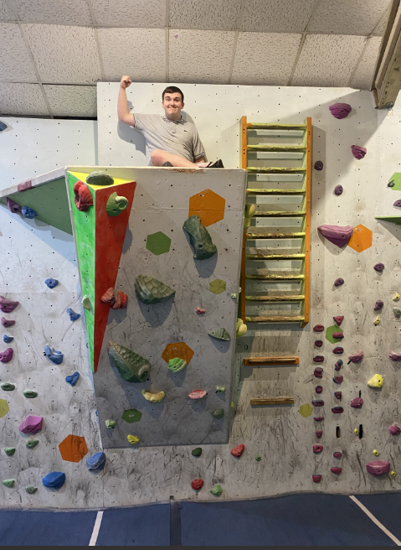
On Wednesday 13th March some of the Sixth Form pupils visited The Boulder Bunker as part of their fitness session. On arrival it appeared that we had some VERY confident climbers alongside some VERY unconfident climbers. Jake Braddish was extremely unsure of the activity and claimed to have a fear of heights. As the session progressed, Jake started to set himself small challenges and by the end of the session he had completed the ladder climb to one of the highest ledges in the room. Well done Jake!

Motor Vehicle
Charley Ross in W2 has been doing really well at TTS Tyres in Totnes, after Nick the owner offered Charley paid part time work in October last year he has gone from strength to strength with his knowledge ,confidence and customer service . So much so Nick is happy to have Charley for an extra day after the Easter holiday and going forward looking to employ him on a part-time basis, well done Charley!!!

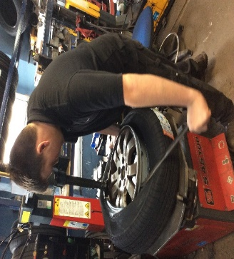

Successes!
Recently Lyamba Hornby learnt how to ride a bicycle. Through her persistence, repeated practise and trying hard, her efforts were rewarded. With help from Tamsin and Clinton she can now ride a bicycle and is looking forward to cycling as part of the Duke of Edinburgh scheme. “Lyamba was particularly good at looking all around her before starting cycling to make sure there was enough space, and also showed great observation during her cycling,” said Clinton.

English Functional Skills

Sixth Form students have been preparing and delivering some fantastic presentations for their Functional Skills English Levels 1 and 2 qualifications. They have covered a wide range of topics including Rap Music, The Incredible Hulk, Work Placements, and Family Businesses! The students’ enthusiasm has shone through and they have been extremely professional at all times, aiming high themselves but also supporting their class mates.

After several months of applying for jobs and many interviews, we are delighted that Cameron Fraser has been successful at interview with Sainsbury's. He has accepted a position at Sainsbury's Dawlish as a trading assistant, working 3 days a week.
Cameron has always been positive and motivated to find a job, despite a number of setbacks, and it is his positivity which has really stood out. Cameron has also actively encouraged his peers to keep focussed when looking for employment. Cameron, you are amazing!

Successes!

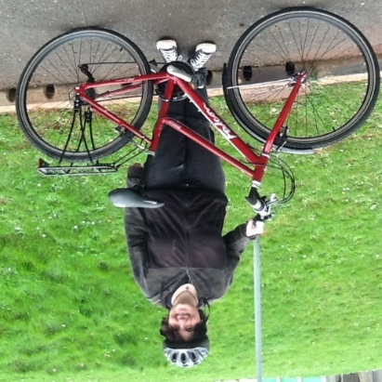
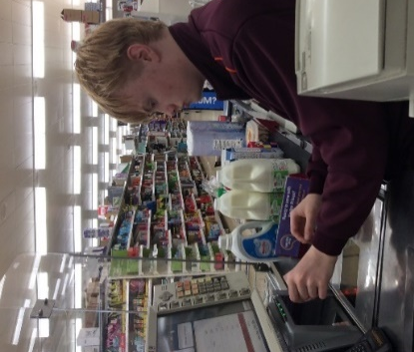

Sixth Form News
This half term, the sixth form have been doing a variety of grooming activities to include bathing the guinea pigs and bearded dragons and brushing the rabbit. They have specifically been working on maintaining the animal’s health and safety. They have been working in pairs to keep the animal and themselves safe throughout the process. There has only been a few splashes to the pupil’s faces!!
Grooming the guinea pigs and rabbit!
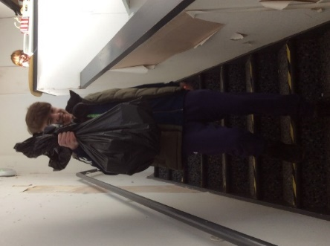

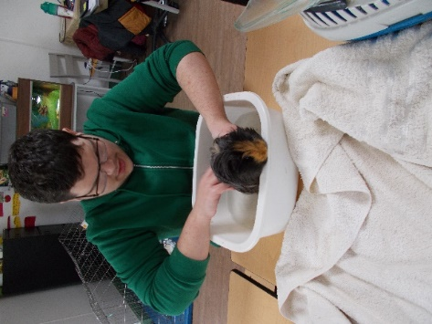
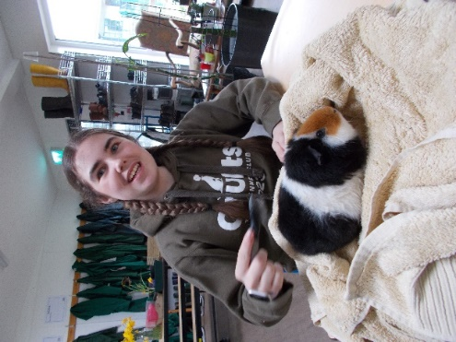
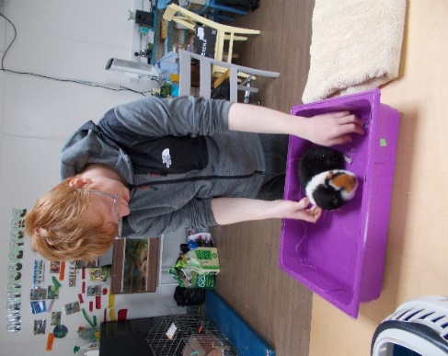
YMCA
Sheltered Job Placement 2024

With spring term came a new placement for the D groups.
The local Paignton YMCA charity shop works in partnership with us, helping to teach the pupils the ins and outs of running a successful business.
They have been fantastic at sorting, pricing and stocking any and all donations made to the shop.

Hadleigh Court
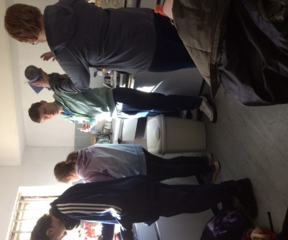
D1 and D2 began their community project at Hadleigh Nursing home, the task was to weed the extensive gardens and driveway. The home welcomed the school, providing us with drinks and cake. All D1 and D2 students worked hard making good headway and improving the appearance of the areas they worked in. The home was very grateful and was also impressed with the students, Talking to the management of the home, they are keen to form a relationship with the school and the possibility of having our students gaining work experience at the home.
This turned out to be a very positive community project.

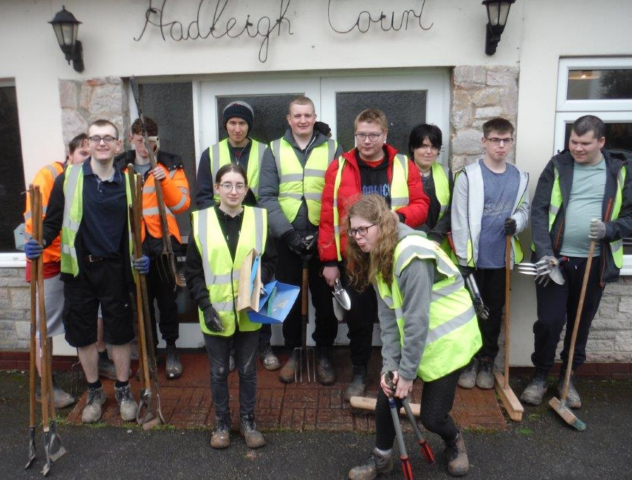
One of our own minibuses had developed a fault where one of the head rests had become detached from the seat. With the seat removed, Josh and Oscar set to work to repair the frame and rebuild the seat. It was then returned back into service.
Motor Vehicle


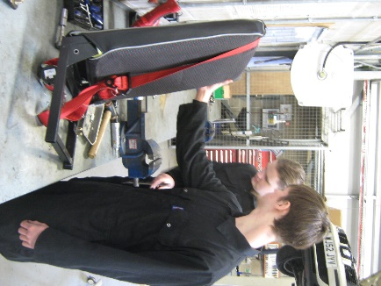

Sixth Form News
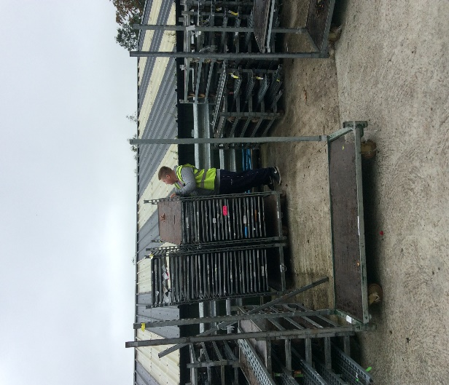
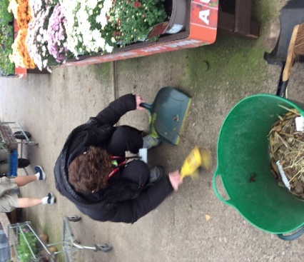
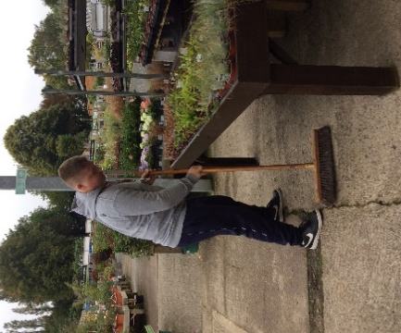

6th Form sheltered placement at Jacks Patch Garden centre.

Some of the students have had the opportunity to learn different aspects of horticulture .Their tasks have included re stocking sections of the plant area and general tidying tasks.
The manager and his team have commented on their hard work. Well done to Brandon, Morgan and Luke.

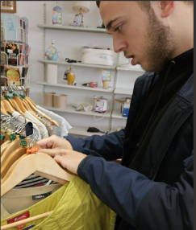


YMCA A Group

Three pupils from A1 attend the Y.M.C.A charity shop every Friday. Here they learn a range of skills from stock rotation, arranging new stock, labelling items and dressing the display mannequins. They all enjoy volunteering at the Y.M.C.A. Emma the Y.M.C.A shop manager is extremely pleased with their attitude and quality of work.
Successes!
Thomas has been working at Jack’s Patch as part of his sheltered placement programme and they were so impressed with his attitude and enthusiasm that they offered him paid employment on Saturdays and Sundays. Here are some photographs of the displays that Thomas created on his first weekend at Jack’s Patch.
We are very proud of you Thomas – well done!

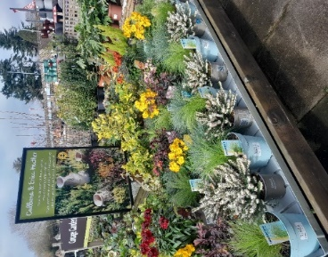
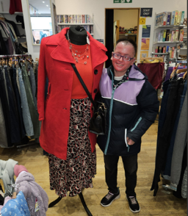

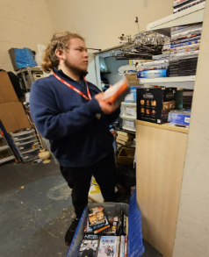

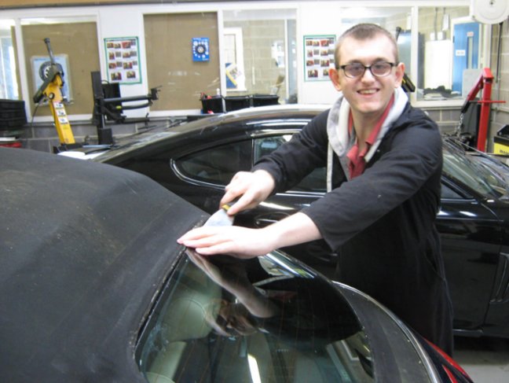
Motor Vehicle
A parent has very kindly donated a car for us to use in out Motor Vehicle training section.
As with all used cars there are things that are not quite right. Our ‘new to us’ VW Beetle convertible had a problem with the rear window that had become detached.
Tom Wood has removed the sticky tape holding the glass into the convertible hood and is cleaning up the residue ready for it to be rebounded.



Sixth Form News
Jordan has successfully passed his CSCS Examinations. CSCS is the leading skills certification scheme within the UK construction industry. The card provides proof that individuals working on construction sites have the appropriate training and qualifications for the job they do, thereby helping to improve standards and safety in UK construction.
Jordan has worked really hard to prepare for this certification and shown great resilience and determination after not initially reaching the levels required. His attitude towards this professional qualification has been rewarded with employment opportunity with DB Civils who have a number of sites in the southwest, which will provide Jordan with employment for the foreseeable future.


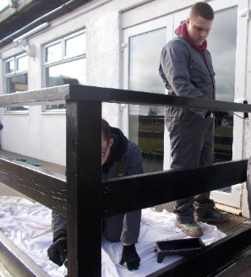
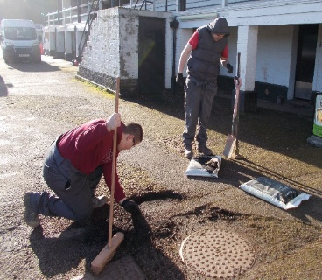
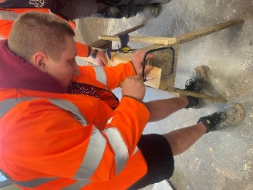
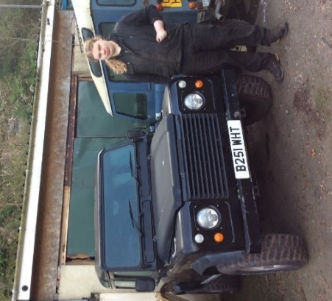
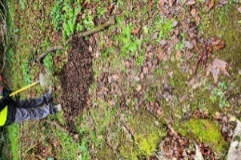
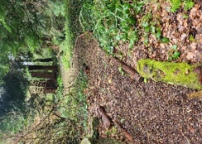
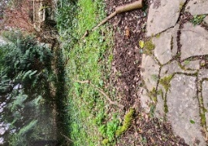
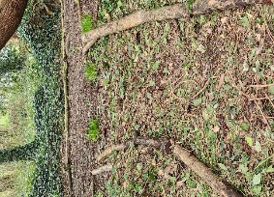
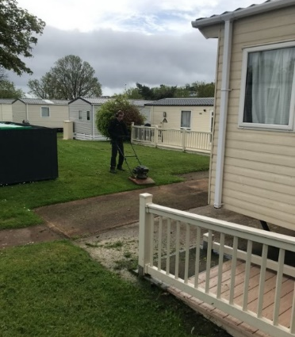
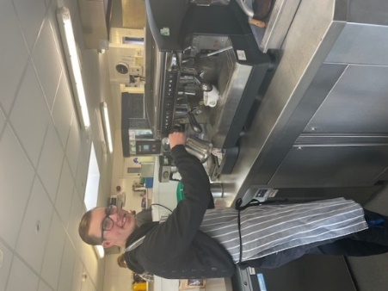
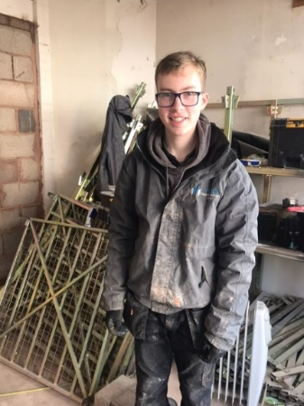
Bradley Kersey and his journey into paid employment is testament to his hard work and his range of employability skills. Bradley has always had an excellent work ethic, seeking and gaining employment for a number of years. His time spent with Hoburne at Devon Bay working with the maintenance department, as a work placement, has allowed him to show his new employers that he is a skilled and valued member of the team and this lead to his successful application to become a full time paid member of the Food and Beverage team at Devon Bay. Staff here at Combe Pafford are delighted that Bradley has gained this employment which is our ultimate goal for all our students.

Italian Gardens
As part of A1 work skills they have been working at the Italian Garden in Ippelpen. The students designed and constructed a path. All of A1 student worked very hard as a team to start this project.
Successes!
Tom Ralphs has been working at Highwell Landrovers as part of his work placement programme in the Sixth Form whilst completing his Level 2 Certificate in Vehicle Component Fitting. He has now secured a full time job working for Highwell Landrovers and will be leaving us at February half term.
A fantastic achievement Tom – well done!
Successes!

