SIXTH FORM AUTUMN TERM NEWS REPORT 2020

Teambuilding Days
The Sixth Form had to forego their annual Teambuilding Day at Ashcombe Adventure Centre this year as it was closed due to the pandemic, but made alternative plans to spend the day in separate P and W groups on Dartmoor. Both groups enjoyed a walk from Dartmeet (where the East and the West Dart Rivers meet) negotiating the tricky stepping stones and climbing up to Combestone Tor where students scrambling on the rocks. Some ventured on to Horn’s Cross before the whole group continued on the circular walk, crossing the river again by stepping stones and walking through Huccaby Farm and back to Dartmeet. All the students had a great time and commented on how much they had enjoyed it, unfortunately someone always ends up in the River Dart when we come here and this year was no exception! Poor Jake Vizard experienced the freezing cold waters of the River Dart, but was incredibly brave – Ben Collins showed his teamwork skills by helping Jake out of the river.

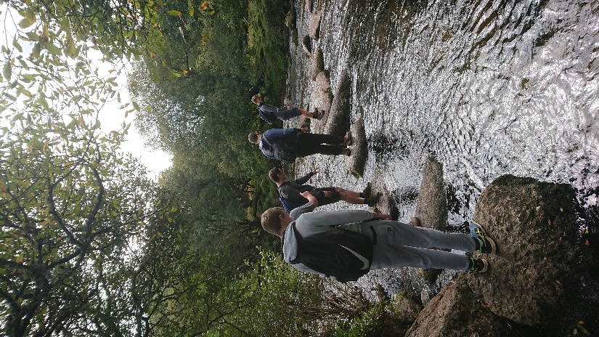
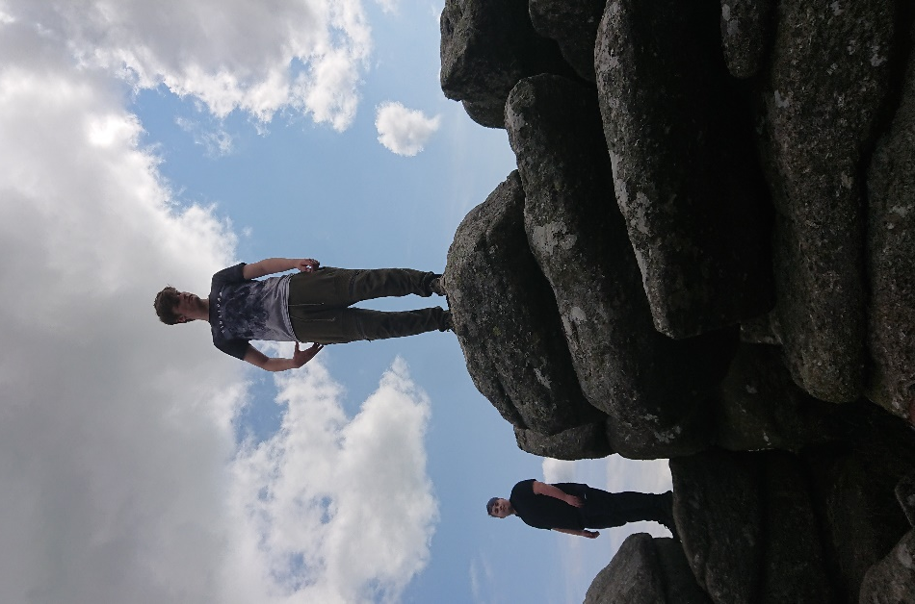
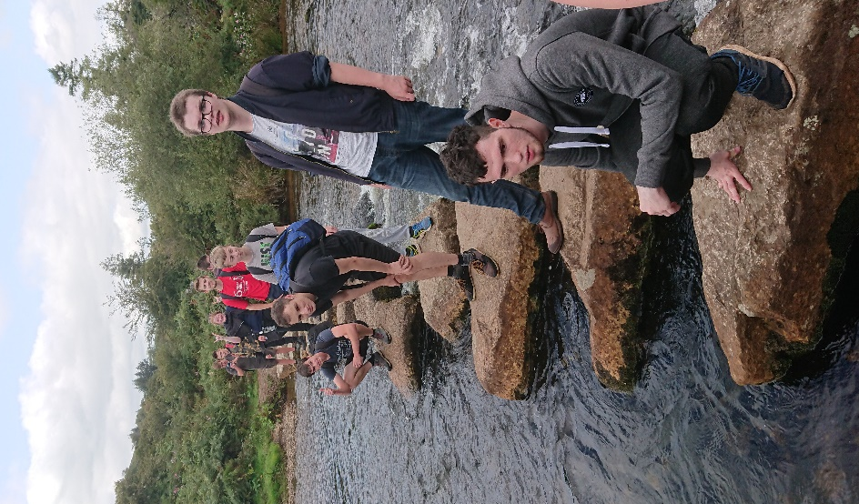

On the rocks at Combestone Tor Crossing the River Dart via the stepping stones
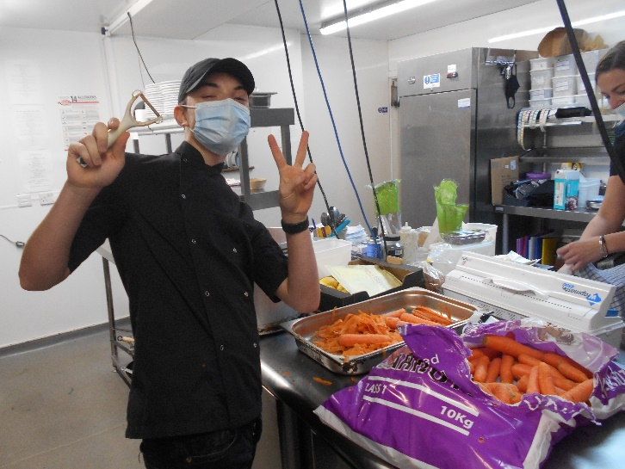
Students excel on Work Placements
It’s been a difficult term with work placements for obvious reasons, but most students got out to their placements eventually – until second lockdown came, that is! Retail students like Cameron de Groot, Joe Weiss and Liam Slack excelled on the Retail Pathway, making great progress at Sainsbury’s and are set to return after Christmas. Animal Care students who couldn’t go to their normal animal care placements went to Dawlish Gardens Trust instead and had a great time! Adam Prosser, Sam Whiteaker, Sam Tagapulot, Anastasia Bowles, Eli Mason and Connor Roberts all got a lot out of their time at DGT and hope to return at some point. Ellie Jackson and Oliver Taylor also attended DGT on Fridays and were very much enjoying their time there. Since second lockdown ended, several students have been able to return to work as normal –
- Kiemera Clark at Bow Wow Dog Grooming
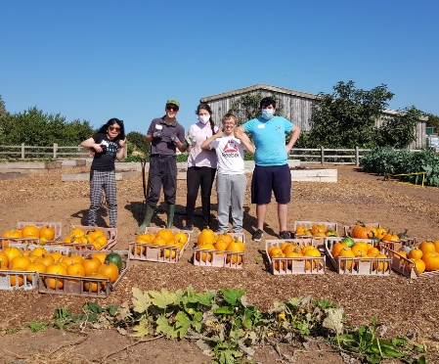
- Jack Drinkwater in the Yellow Frog Café
- David Leese at National Tyres
- Lily Rodaway at Hurley’s hair salon
- Jake Vizard at the Palace Hotel
- Kelley Behan at TTS Tyres and Exhausts
- Connor Johnson at Kenmart Ltd.
- Callum Taylor-Pratt at Rowcroft Hospice
- Ben Smith at the Palace Hotel
- Ben Collins at the Devon Dumpling
- Ben Barker at Coleton Fishacre National Trust
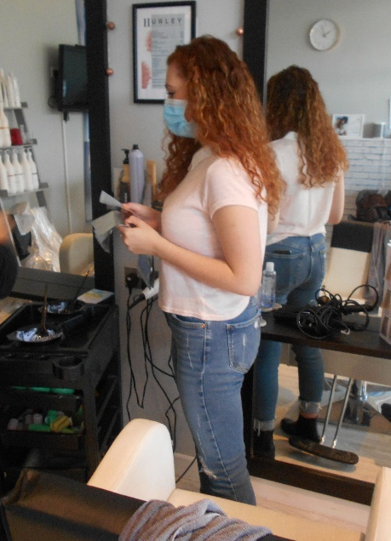
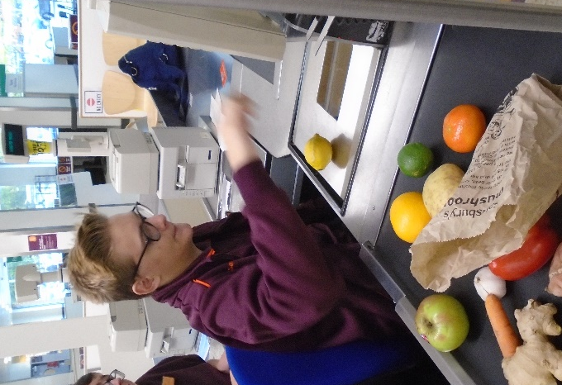
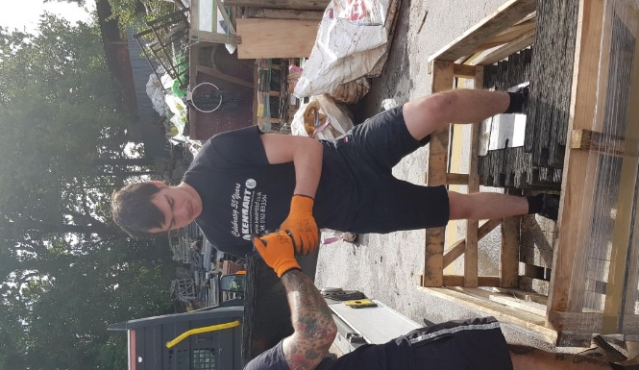
Students gain casual employment
Two students have excelled in obtaining casual paid employment over the Christmas period – Ben Collins at the Devon Dumpling pub, and Amy Weston at Sainsbury’s. In addition, Kiemera Clark has been regularly working at a local Chinese takeaway, and Lee Abbott has joined the school’s payroll by doing three cleaning shifts a week until the end of term to cover for one of the cleaners who is off work at the moment. Fenton Miller also left the Sixth Form in November to take up a cleaning position at a local care home.
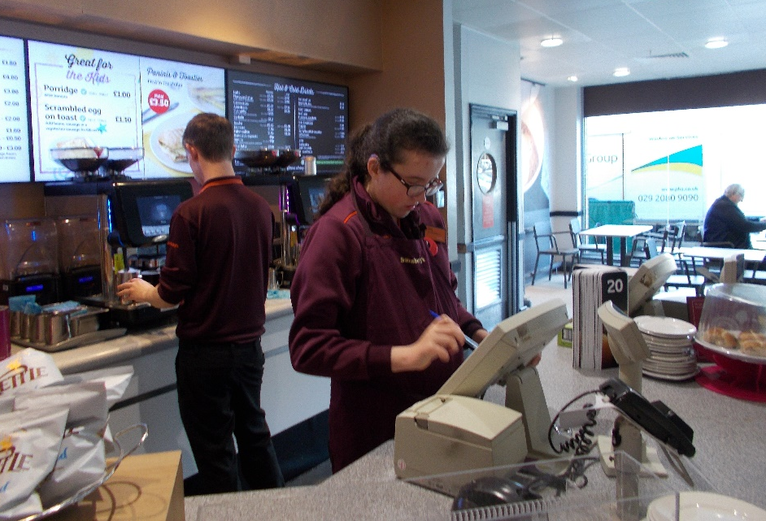

Amy Weston working in the café at Sainsbury’s at the Willows, where she has gained paid employment over the Christmas period.

New link with Stover bears fruit
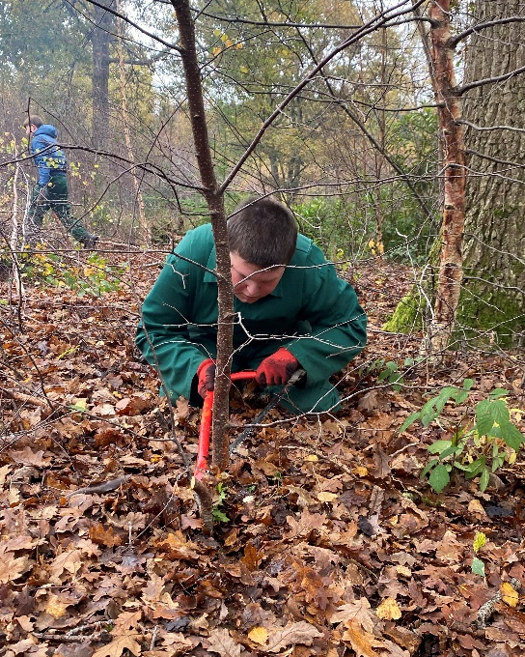
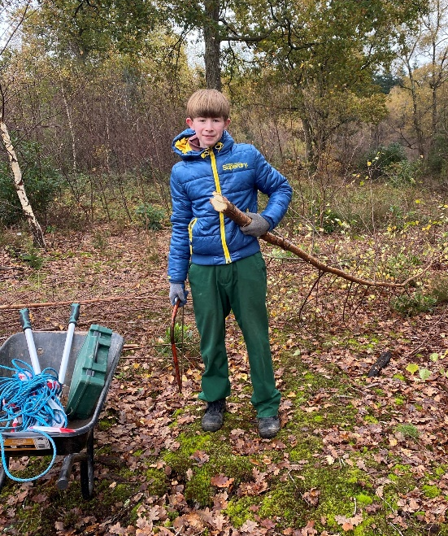
Whilst some of our existing links and partnerships are on hold until things return to normal, a new link has been forged with Stover Country Park involving four Horticulture students each week visiting on Fridays to undertake clearing work under the supervision of the park ranger. This has proved extremely popular and has given students the opportunity to gain some experience as a conservation volunteer, cutting down vegetation and burning it safely on site for example, and gaining an awareness of what the Park’s aims are.

Kieran Binmore (left) and Joe Francis (right) working at Stover clearing trees

Travel Training interrupted
At the start of term, two of the Sixth Form Job Coaches set about taking out between 2 – 4 students from the Preparation for Working Life programme every week to get used to catching the bus to nearby towns and modelling the skills needed to do this independently. Second lockdown interrupted this process, but not before we had taken 20 youngsters out for their first experience, visiting a range of places, including Teignmouth, Newton Abbot, Torquay, Paignton and Totnes. We hope to resume this later on in the school year as it provides an important first step towards being able to travel independently.
Damon branches out!
Damon Barlow has benefited this term from two new ventures we have been able to put his way. Firstly, he is halfway through a block of 6 days spent 1-to-1 with a tutor from Adelong Outdoor Education working on personal development skills such as mapreading and navigation. So far he has been to Berry Head Country Park and Coleton Fishacre National Trust property to put his skills into practice, and hopes to be able to gain an award for this. Damon has been an enthusiastic participant and is very much enjoying these sessions. Alongside this, Damon has attended two taster sessions at The Key at Seale Hayne on the KAOS Project – this is an expressive arts workshop which involves collaborative group work with other students on visual arts and drama, which is just up Damon’s street!! He has enjoyed the taster so much that we have decided to allow him to continue attending on Thursdays throughout the Spring term.
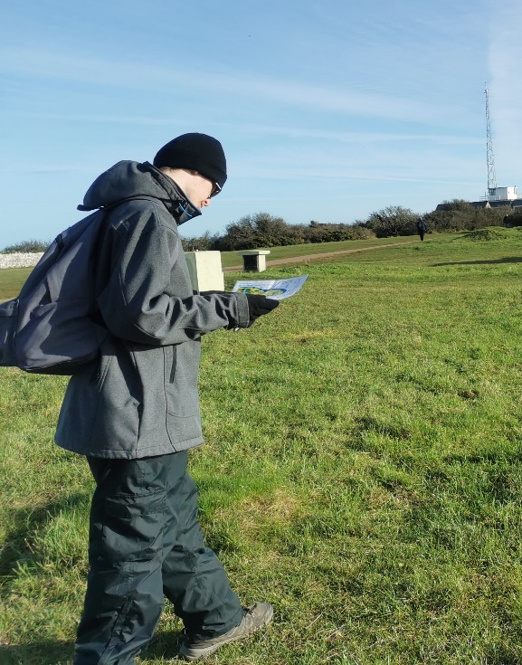
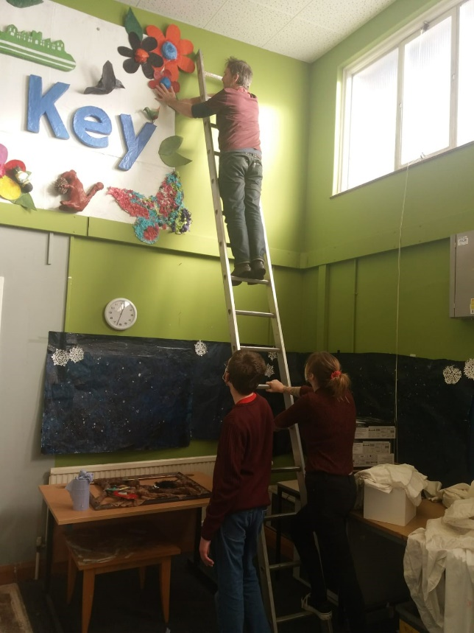

Damon practising his navigation skills at
Berry Head Country Park Damon helping with the KAOS Project at the
Key, Seale Hayne College

Ben all ready for the road!
Ben Barker has achieved one of his work-related goals by passing both his driving test theory and practical test at the first time of asking – no mean feat for anyone these days! Ben is a success of the scheme whereby we arrange for an assessment at the Devon Drivers’ Centre through Grant’s School of Motoring, and then pay for the first 10 lessons as an incentive to become more independent and therefore more employable. Ben is a safe, sensible driver and has already investigated what he needs to do to achieve his long-term dream – which is to gain his Heavy Goods Vehicle licence so he can become a lorry driver. It does also mean of course that he can apply for jobs as a delivery driver. Well done Ben!
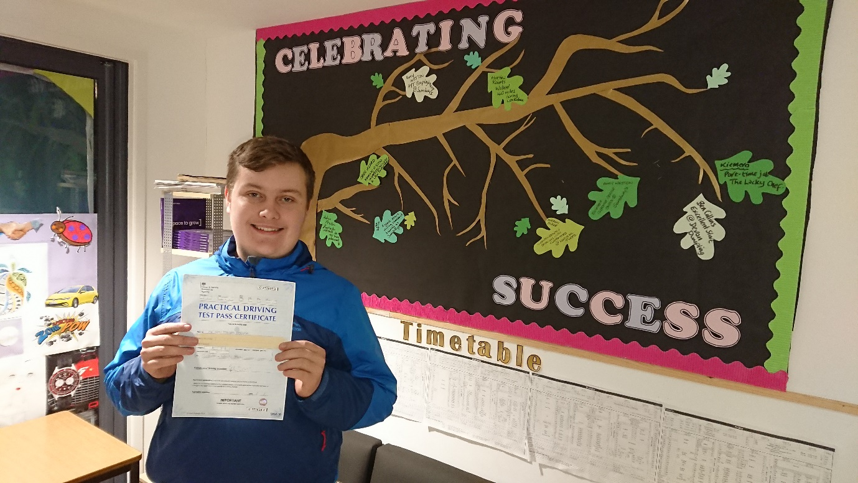

Employability
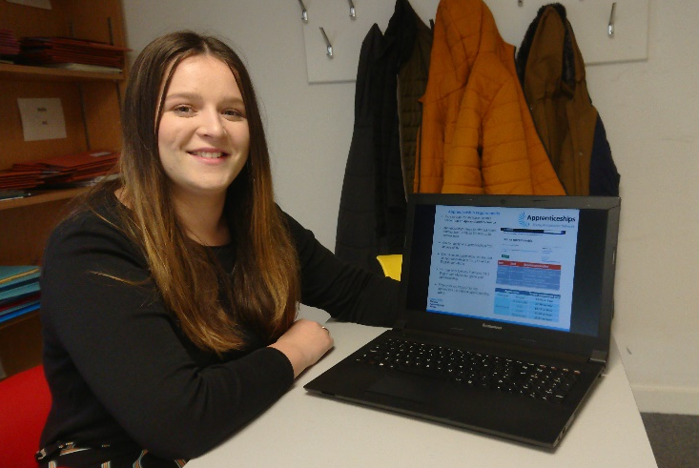
A new subject has appeared on the timetable this term for Work-ready students in the form of Employability, and is being jointly delivered by the W tutors Miss Monnington and Mrs Dolan. This subject has replaced I.T. and Work-related Learning, and the three lessons each week are dedicated to educating students about the workplace, and developing the skills and knowledge needed to look for, apply for and gain suitable employment and apprenticeships. We are confident in the long term that this will mean that more students will be successful in gaining casual part-time employment and more full-time jobs and apprenticeships. Rosie Underhill, our own apprentice in the Sixth Form, recently did her own presentation to W1 and W2 students about what life was like as an apprentice and the work she has to do on her college day at Exeter College. Sarah Ross, an ex-Sixth Form student, is also an apprentice lower down the school.
Work Skills lessons so much fun
A tour of Work Skills sessions on the Preparation for Working Life Pathway recently revealed that students were simply having too much fun! Everywhere I went students were busy involved in practical activity, often working on individual projects from upcycling and painting furniture, to sewing and needlecraft, to carpentry! Students really enjoy these sessions led by Wayne, Ursula and Linda, and benefit from the opportunities to practise and apply skills such as measuring, marking and cutting, painting etc., whilst at the same time allowing them to use their own creative flair. Very well done to all concerned!

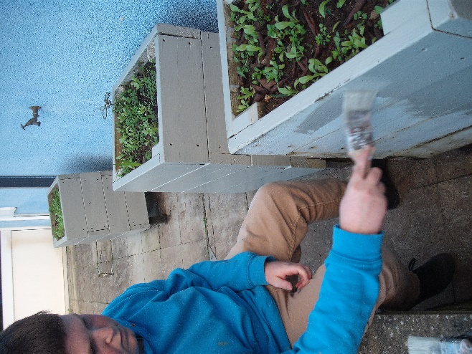
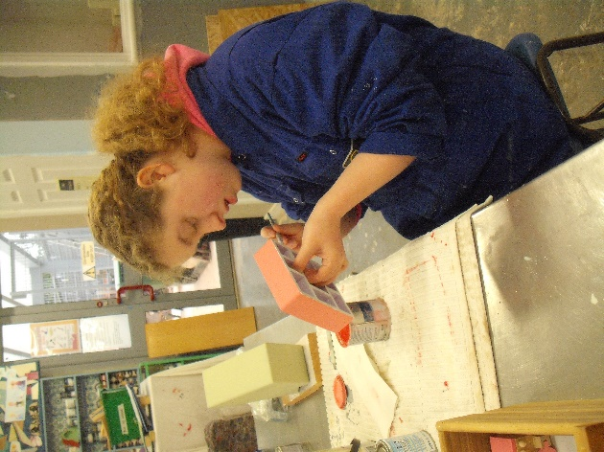

Ellie Jackson and Joe Francis working on various Work Skills projects

Christmas dinner is a hit!
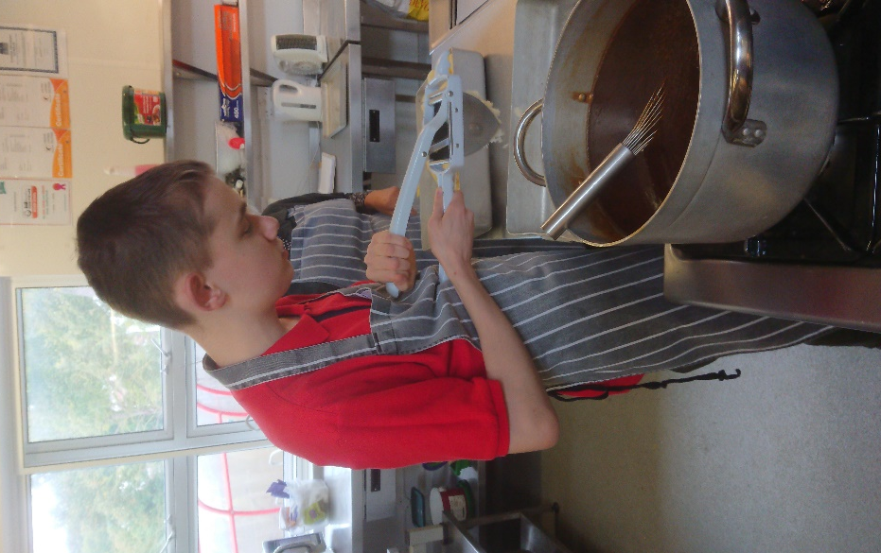
Prevented from going out to the Willow Tree pub this year for our Sixth Form Christmas dinner, we made do by setting up in the café classrooms and enjoying a very fine roast turkey meal laid on by Dominic in the Yellow Frog Café, ably assisted by James Bell and his team of Hospitality and Catering students. They did us proud as the meal was fantastic so many thanks to all who helped! After dinner, we did the ‘Lucky Dip’ Secret Santa organised by Jayne and Carole, followed by a review of the term and some interesting and funny quizzes about what Sixth Form staff got up to when they were in school! Proceedings were rounded off by the presentation of Love2Shop vouchers for effort and progress in Maths, English, Employability, Work Placements and Pathway Studies. Jack Drinkwater, who was awarded the prize for Personal Development, is pictured here working in the school kitchen.

Students raise money for Children in Need
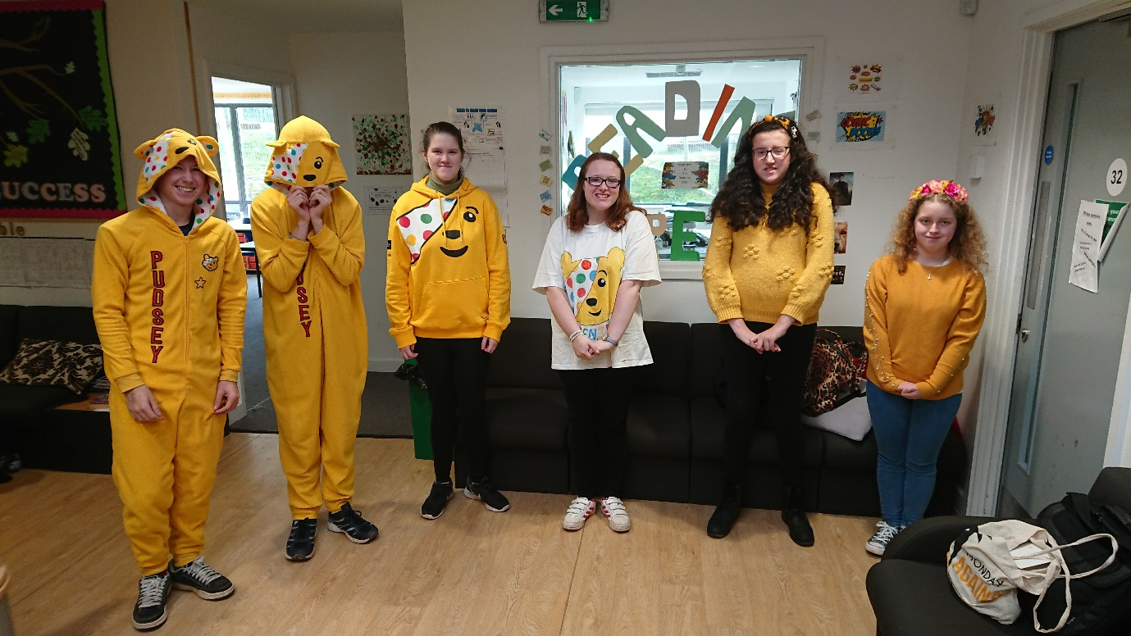
Sixth Form students raised just over £50 for Children in Need this term through donations and by dressing up for the day – well done for making such a great effort in difficult circumstances!

Sixth Form building work taking shape
The Sixth Form extension, which provides a new entrance, a large social area for students, and new office facilities moves slowly but surely towards completion. Staff and students have coped extremely well with the cramped space and alternative entrance whilst the work has been going on (especially with Covid restrictions limiting our movement) but we can now look forward to ‘moving in’ at some point in the Spring, and I am expecting this to have a big positive impact on how the students feel about their building. The Student Voice group, under Mrs Dolan’s guiding hand, has already started making suggestions about how we can use this space effectively and get the most out of it.

Finally, I would like to wish all students, their parents, carers and family a very Happy Christmas and New Year! Hope to see you all back healthy and safe and raring to go in January!


Edward W Thompson
(Head of Sixth Form)

