SIXTH FORM SUMMER TERM NEWS REPORT 2021

Thomas back from trip of a lifetime!

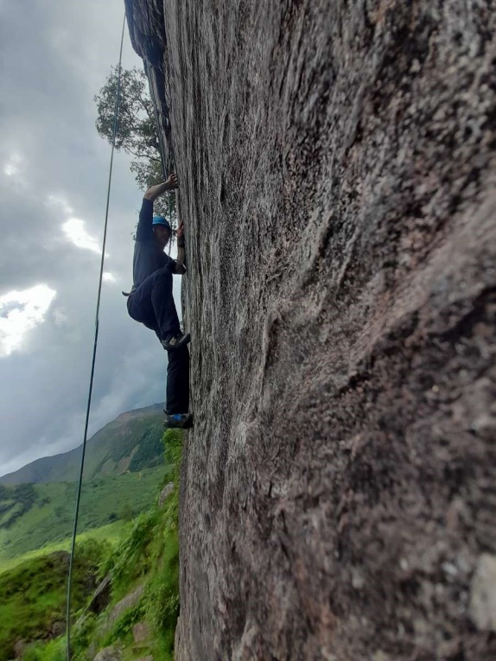
Thomas Hocking, who recently left the sixth form, has safely returned from his travels to Scotland where he attended a two-week outward bound course at Loch Eil outward bound centre near Fort William. Thomas successfully applied for a bursary worth around £1500 from the Sir Francis Chichester Trust in Exeter to attend the course, and grabbed the opportunity with both hands. Thomas travelled alone from Newton Abbot to Glasgow Central, changing in Birmingham and Carlisle, then stayed in a Premier Inn before meeting the coach laid on to take him to the centre the following morning. All went according to plan, and judging from the photos I’ve seen, Thomas has had an absolutely amazing time and made lots of new friends. He is now focused on resuming the selection process for entry to the Royal Marines, a lifelong ambition. Another sixth former, Joe Weiss, travels to the Lake District before the end of term for a similar course at the Ullswater outward bound centre.
Thomas rock climbing in Scotland
Dusk at Loch Eil
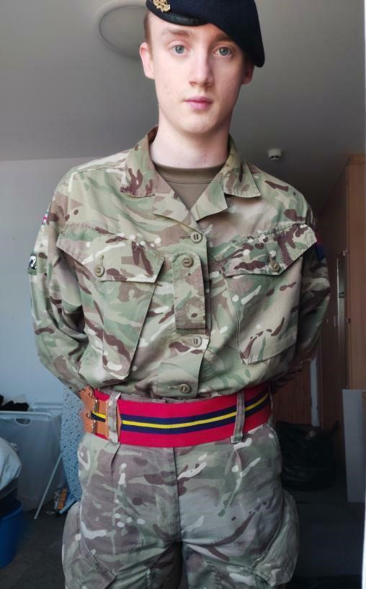

You’re in the army now!
Jessy Motteram, who successfully completed his basic training two years ago, has transferred from the now defunct tank regiment to logistics. By all accounts Jessy is getting on really well and remains one of our huge successes. Jessy was one of three sixth form students who completed the Three Peaks Challenge in 2018, climbing Snowdon (Wales), Scafell Pike (England) and Ben Nevis (Scotland) in a weekend. He is also a veteran of the Ten Tors Jubilee Challenge, gaining Bronze, Silver and Gold medals. Other students in bygone years who have successfully joined the army are Chris Cude, who served in the first Gulf War, and Jon Tandy. Several other students have at various times done taster weeks at Okehampton Army Camp, the most recent of these being Rupert Masters.
Goodbye and good luck!
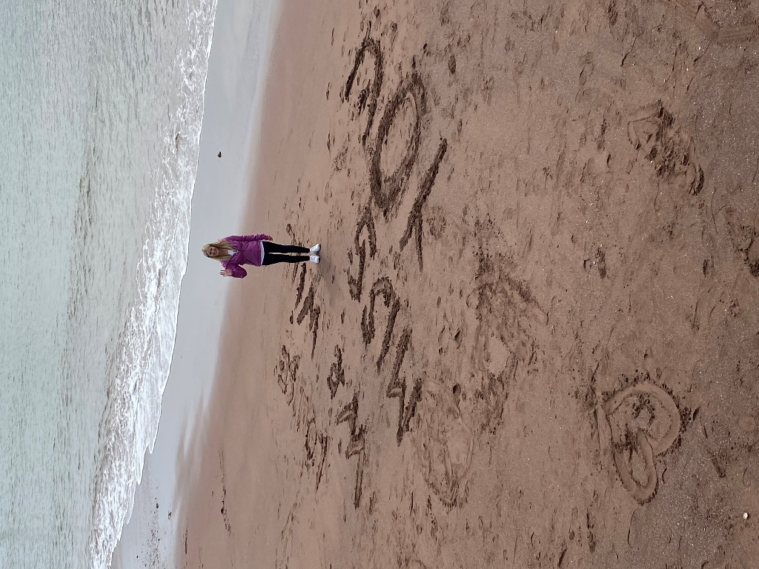
We have lost two popular members of staff this term, and are losing a third! Louise Davey, who has been at Combe Pafford for over 15 years, most recently in the sixth form as a teacher and also teaching the Horticulture pathway in Key Stages 4 and 5, has left to take over an exciting post at the Greater Horseshoe bespoke provision nearby. Following in her footsteps is Rosie Underhill, who spent two years in the sixth form as an apprentice Learning Support Assistant and Job Coach. Both were hugely popular with both students and staff and will be sorely missed – we wish them all the very best for the future. More recently, Sami Choudhury has decided to ‘retire’ at the youthful age of 37 to concentrate on his private counselling work and his garden. Sami has been hugely popular with students and has been a force for good in his role as pastoral support for sixth form students. He also helped out on Ten Tors training for many years, and led teams on the day of the event itself. He will be sorely missed. Mrs Davey alongside personal message from students
written in the sand on Teignmouth beach
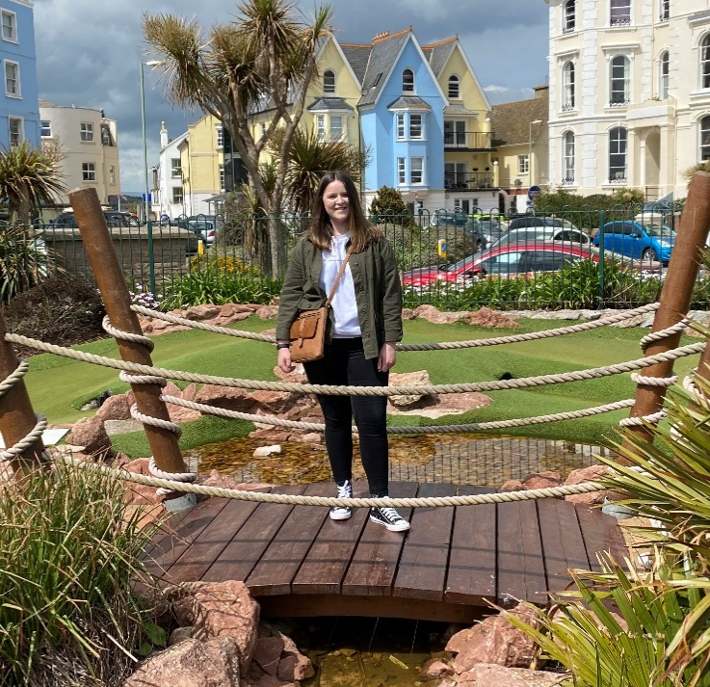

Popular figure : Sami Choudhury

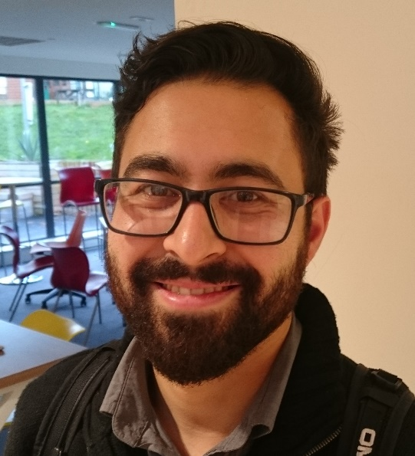

Apprentice Rosie Underhill, who has gone on to
pastures new, on a day out with the P groups

Work-ready students excel on Mock Interview Days

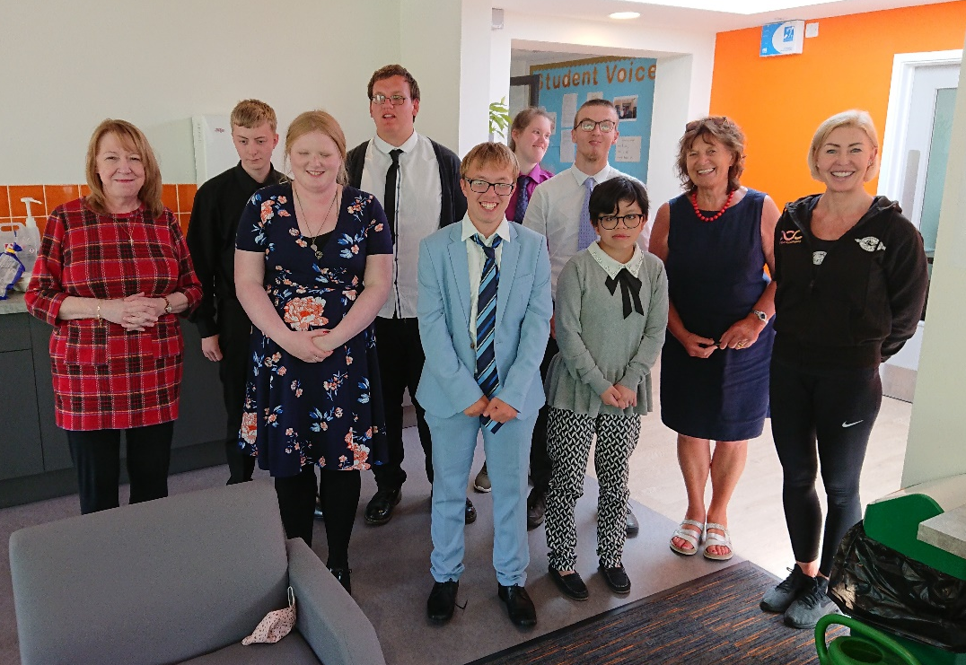
Students of both W1 and W2 excelled on recent mock interview days that were set up to put into practice what the students have been learning about in employability lessons. Research shows that employers start to form an opinion of candidates and their suitability for the position within 2-3 minutes of an interview starting, and a first impression can take as little as 30 seconds; so with this in mind, students had a minimum of 3 interviews with different employers during the day and students in W2 also had the opportunity for a virtual interview with an employer who was at their normal place of work. The students didn’t disappoint and when employers fed back to the group as a whole, it was obvious that they had been really impressed with what they had seen. Since the interview days took place, Liam Slack has picked up a summer job at KFC and Amy Weston has been accepted onto the Aspires programme at Torbay Hospital – both were in the list of award winners below. All winners gratefully took home a £10 Love2Shop voucher for their efforts!!
Students from W1 with employers Chris Meade from the Department for Work and Pensions, Jackie Redfern (former school nurse and governor), and Hannah Bryant from Winners Gym.

Best Dressed Best Interview
1st= Sam Whittaker and Cameron de Groot 1st Connor Johnson
2nd Lily Rodaway 2nd Ben Barker
3rd Amy Weston 3rd David Leese
4th George Turner 4th Liam Slack

Of the other award winners, Lily Rodaway is leaving to pursue hairdressing at South Devon College, Connor Johnson is now employed full-time by Kenmart Building Services, and Ben Barker is at an advanced stage of the selection process to become a Stagecoach bus driver. The other students are continuing in the sixth form next year.

Student Voice group gathers views of students

The enthusiastic Student Voice group meets every half-term under the guidance of Rosemary Dolan and continues to work hard to suggest ways of improving the sixth form – at their most recent meeting for example, they highlighted the need to improve the toilets in the sixth form. Other items they would like to purchase are a fish tank, table football and a table tennis table, and are prepared to participate in fundraising activities in order to contribute to these. We have already begun to furnish the new sixth form social area and make it look more inviting, and we have subscribed to the i-newspaper and various magazines as well.
Students pass motorcycle proficiency test

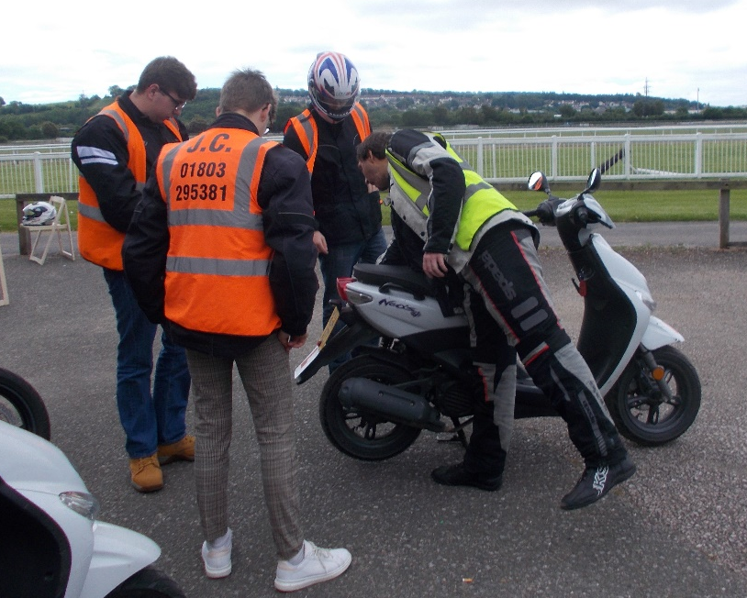
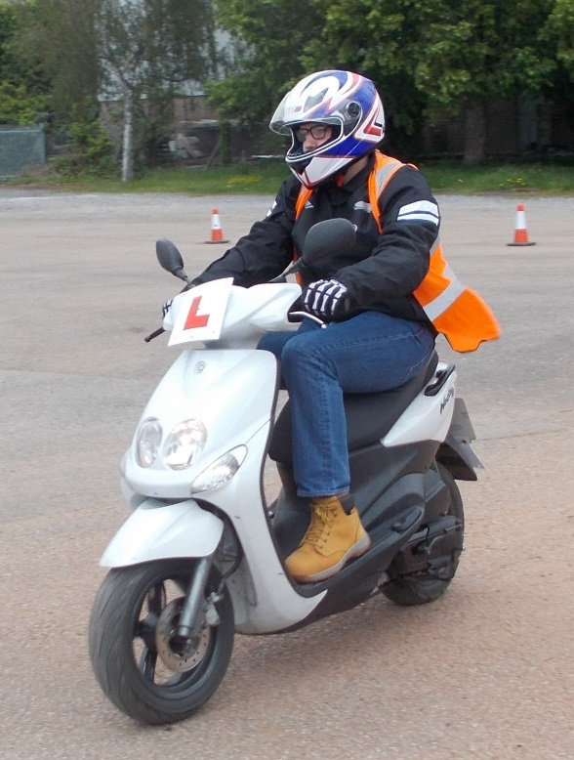
Earlier this term, three eager students spent the day at Newton Abbot race course where they underwent professional training for competency to ride a motorcycle, provided by JC Motorcycle Training. Two of the students were successful and came away with their CBT certificate of safety which allows them to ride a 50cc motorcycle on public highways. Cameron de Groot, who lives on Dartmoor, was one of the students who passed and he is hoping to be on the road soon, just awaiting for his bike registration to clear with DVLA. Bradley Lander from Brixham also passed, has now left sixth form, and I’ve heard that he is already mobile! Both students are hoping this is going to make them much more independent which will in turn make it easier for them to look for jobs, and get to and from work and/or sixth form. Well done to both!
Bradley Lander during the training, and the boys having an introduction to the bikes they were about to use

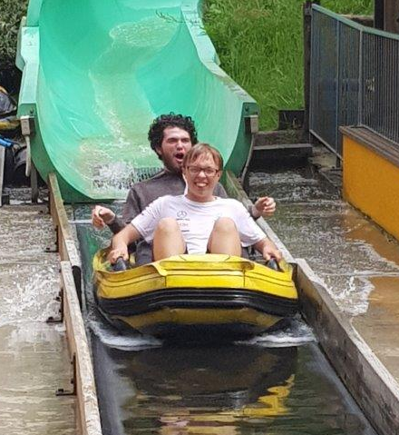
Activities Week a big hit with students

There was sadly no European residential this year because of the pandemic but students were able to partake in an activities week instead which saw them take part in a range of activities including archery, shooting, walking, ten-pin bowling, mini-golf and visits to Woodlands, Teignmouth, and Dartington. This culminated in a day at Meadfoot green with games and BBQ for all the sixth form on what was the last day for those students who were leaving. The behaviour of students was exemplary and all were appreciative of the opportunity to get out into the fresh air after the restrictions of lockdown. A leavers’ lunch in the Yellow Frog café a week before had also given those leaving the chance to say goodbye. All in all, activities was a massive hit with the students!
Sam Whiteaker and Connor Roberts
enjoying one of the water slides at Woodlands
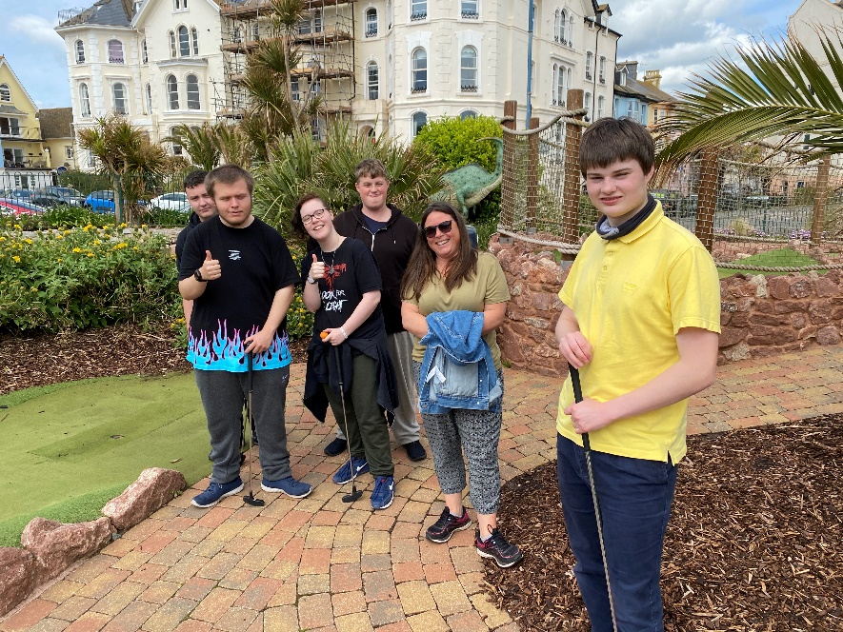
More fun on Activities Week!

The P groups enjoying the mini-golf on Teignmouth seafront

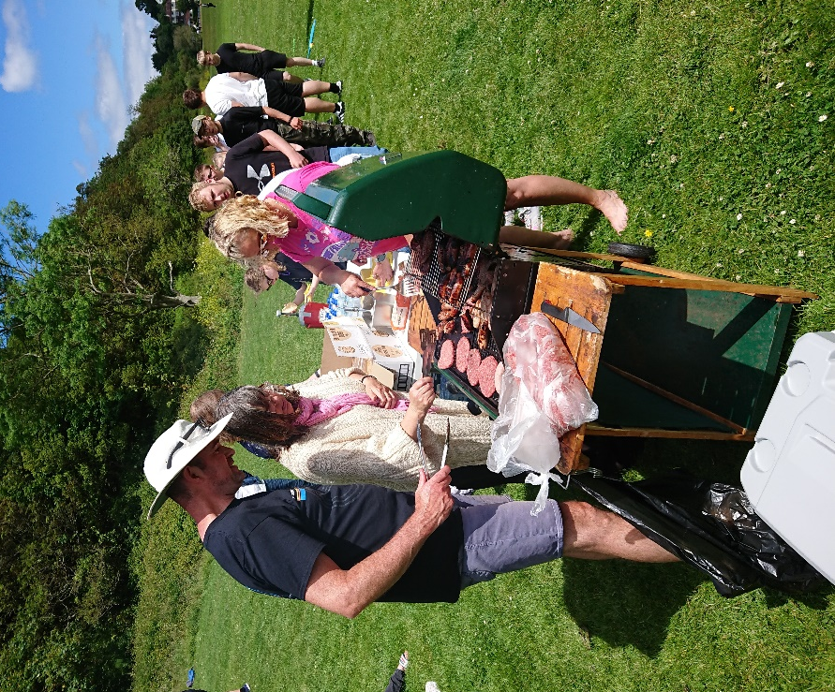

Students enjoying the fresh air and
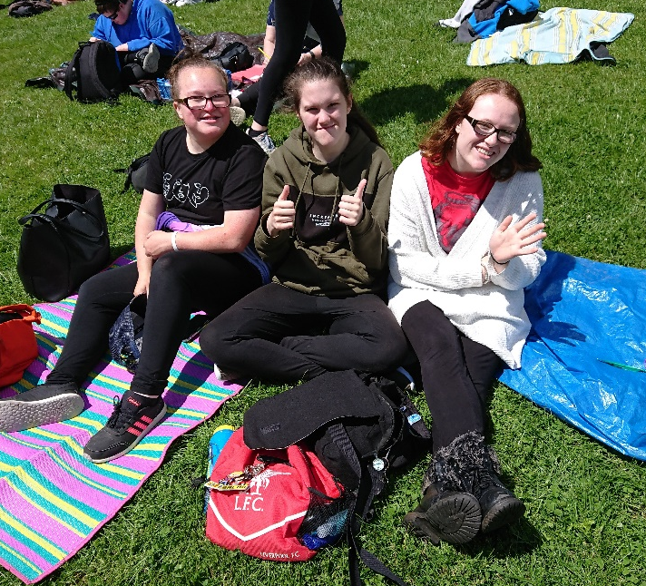
sun on Meadfoot green

Mr Bell on BBQ duty at Meadfoot green –
miraculously no one got food poisoning!

ACTIVITIES WEEK A BIG HIT!

Looking forward to September

Despite the problems and uncertainties caused by the pandemic, we have still had a very successful year in the Sixth Form and can celebrate that many students still managed to get jobs despite a very difficult job market. We’re very grateful to Mrs Curzon for filling in as P2 tutor when Mrs Davey left, and we welcome Miss Moor to the sixth form team in September as tutor for P2 and W3. Next year looks like being another very busy year with the sixth form full to capacity (60 students), and (fingers crossed) able to resume our full range of activities as we return to ‘normal’. Let’s hope so!

Edward W Thompson (Head of Sixth Form)

REPORTS FROM STUDENTS
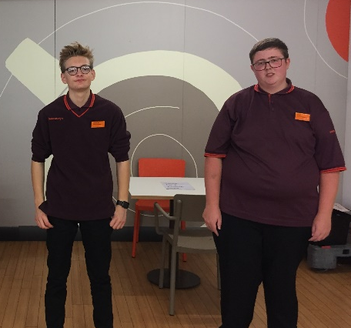
Retail
Our year in Retail at Sainsbury’s is coming to an end and we have now completed our Level 1 certificate in Retail Skills! We may be a little sad, but we are also looking forward to new opportunities, knowing that we feel ready for employment. This year, despite COVID 19 and the Government lockdowns, we have been able to complete training on the checkouts, in high risk food safety and general health and Safety.
We have worked extremely hard and now feel confident working on the tills serving customers. We have also both been in high risk food areas, Liam on the pizza and hot chicken counters and Cameron in the bakery. We have worked in many different departments on the shop floor and understand stock rotation, all about manual handling and safe working practices.
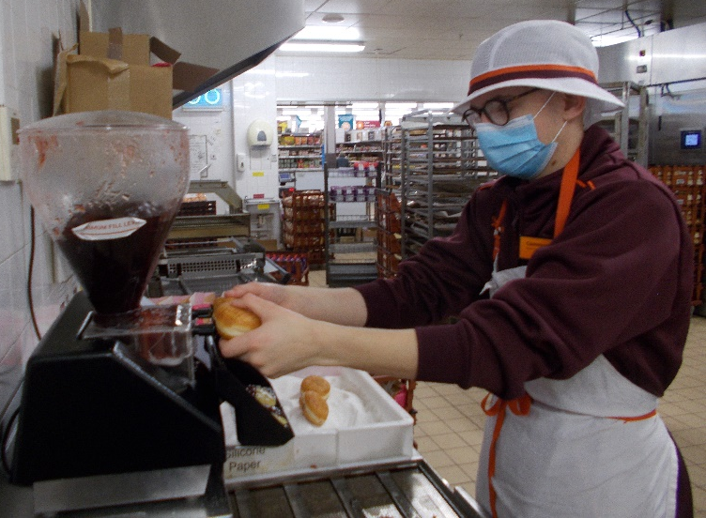
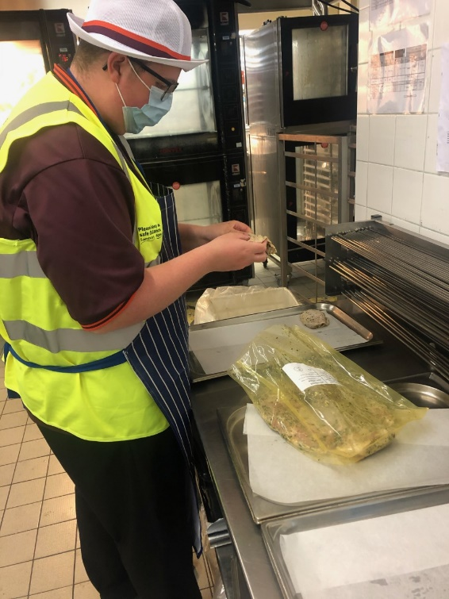

Next year we hope to experience a different placement to give us extra skills to complete our Customer Service qualification. We hope to be able to get part-time employment through the summer holidays and earn some money.

Liam and Cameron W2
Woodlands
We left school around 9.00am and we arrived at woodlands around 10.00am. We split ourselves into small groups and we were given a map of the park to navigate ourselves around the park. There were lots of different rides at the park for example, pirate ship, waterslides, bumper boats, high flyer and also the death slides. The reason why we went there was part of our enrichment week as we didn’t go on our residential to Italy. Many people enjoyed the waterslide because one, they were fast and two, we could go in pairs and get soaking wet!!! At the end of the day we had smiles on our faces because we all had a great day.

By George Turner and David Leese
Mock interview success

By Jake Vizard (W1)
A triumphant success for sixth formers during their mock interview week! 3 employers came to Combe Pafford Sixth Form for the pupils to take part in a pretend job interview. In order for the sixth formers to get some training and experience, so that they feel much more confident when they apply for a job.

All 3 of the employers were quite surprised in how brilliant they all were. The sixth formers were very expressive, well-mannered, very cheerful and above all showing great initiative. A massive congratulations to all of the sixth formers for attending and giving it their best effort dressing up for interview day looking very sharp and proper.

UPCYCLING NEWS by Linda Sampson
Sixth formers have continued their good work upcycling school furniture, this time it was the turn of a garden bench donated to the school in 2002. As the bench lives outside Mrs Cole’s class, she requested red, white and blue to go along with the British theme for 8C’s world war one garden.
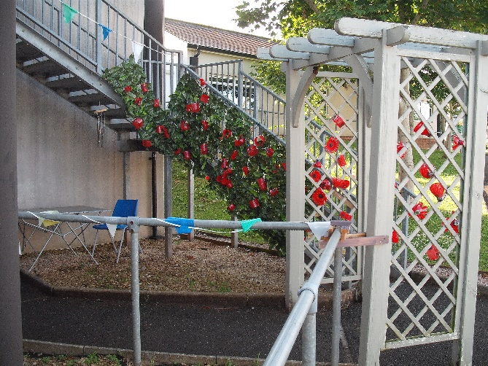
The bench needed some repairing and was then undercoated ready for the twins, Phoebe and Mia to work their magic and show off the painting skills they have developed over the past year. It wasn’t an easy job, trying to keep the areas where the different colours meet looking neat and remembering not to lean on the finished slats with the other hand, as this normally had wet paint on it!
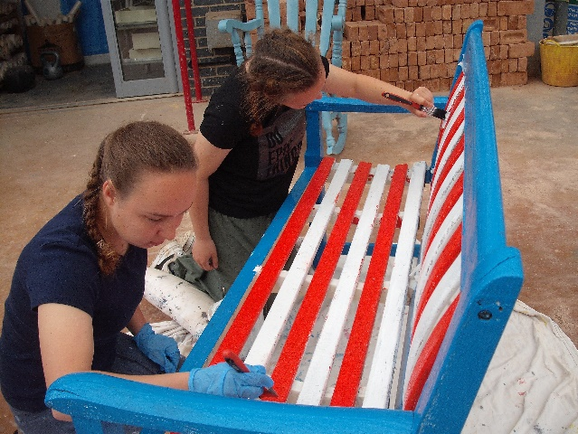
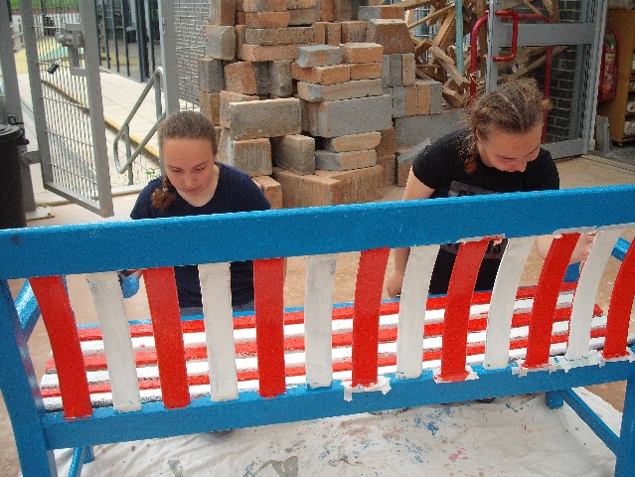

I took some time but now it looks amazing. Next year the bench will be 20 years old, it’s now weather proof for another 20!



