SIXTH FORM AUTUMN TERM NEWS REPORT 2021

Students rise to the challenge on Teambuilding Days
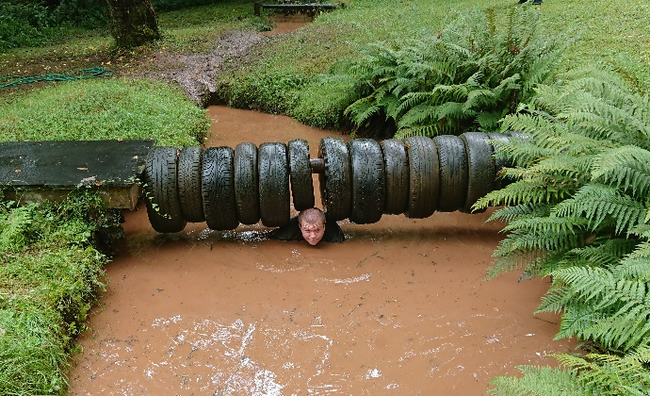
Sixth Form students showed their willingness to put themselves out of their comfort zone on the annual teambuilding days. These days, which always prove to be popular, are designed to bring out their sense of adventure and provide the ideal opportunity for students to display their problem solving skills, resilience and their ability to cooperate and help others. This year was again highly successful, with students not only enjoying themselves but showing their maturity and determination to succeed.

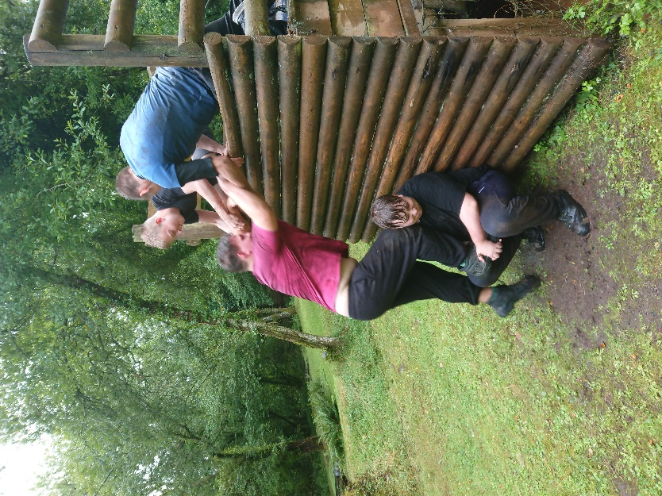
Students from W1 and W2 went to Ashcombe Adventure Centre for their day, and had to take part in a number of challenges in small groups, including moving a ‘bomb’ through a spider’s web without tilting it and making it go off! Students also took on the assault course, consisting of tunnels, nets, obstacles to climb or get over, a swamp and a muddy river! Students took to the challenge with gusto, and several were outstanding including Adam Prosser, Jake Williams and Luca James. Natasha Mildren and Keisha Brookes also deserve a special mention for the way they got round the course. I was also delighted at the efforts made by students working together to get up the wooden wall.
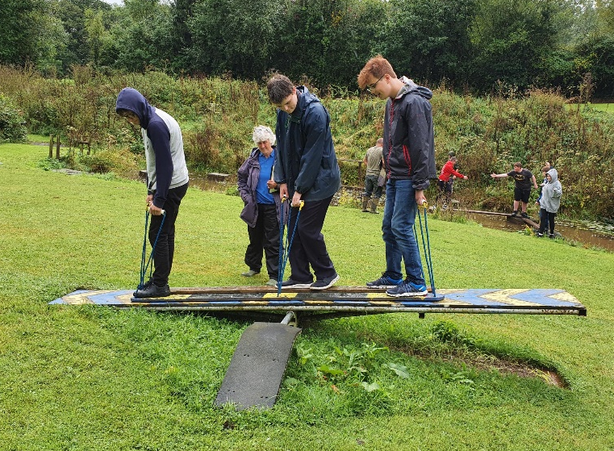
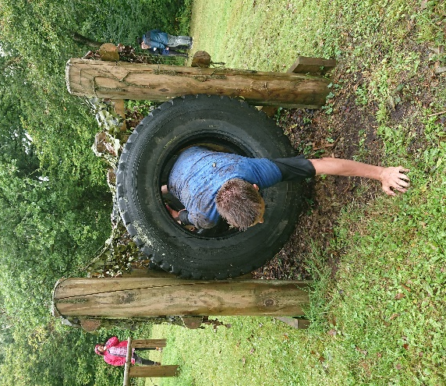
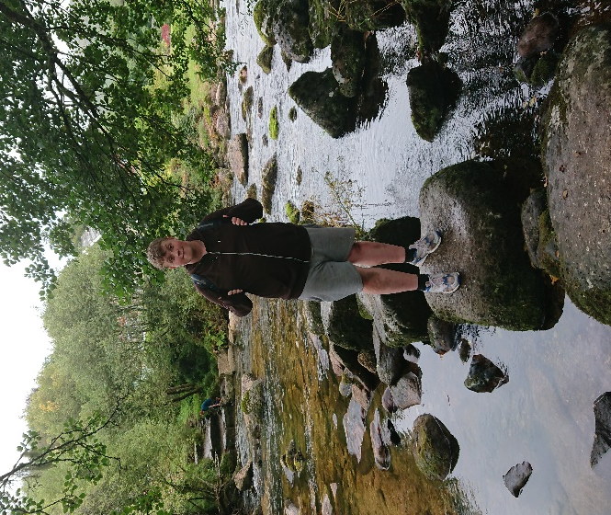
Students from P1, P2 and W3 went to Dartmoor for their teambuilding day and did a lovely (but in places, steep) circular walk involving two river crossings of the River Dart using stepping stones. Usually, at least one student manages to end up in the river, and this year it was the turn of Megan Mace. Megan showed great resilience however, and once changed into warm, dry clothing, was ready to continue! Another student who excelled was Connor Irving, who proved to be the proverbial mountain goat. He was soon standing on top of the rocky Combestone Tor, and climbing on the rocks with great ease and confidence.
Barrie Setchfield crossing the River Dart via the stepping stones on the teambuilding day on Dartmoor

Students take advantage of off-site fitness and leisure opportunities
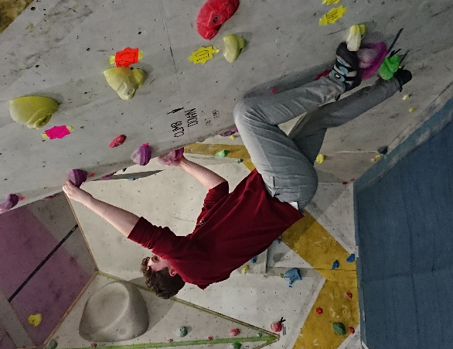
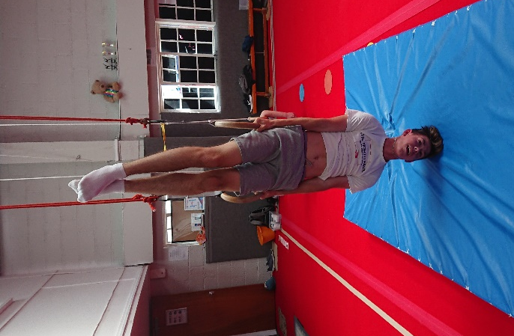
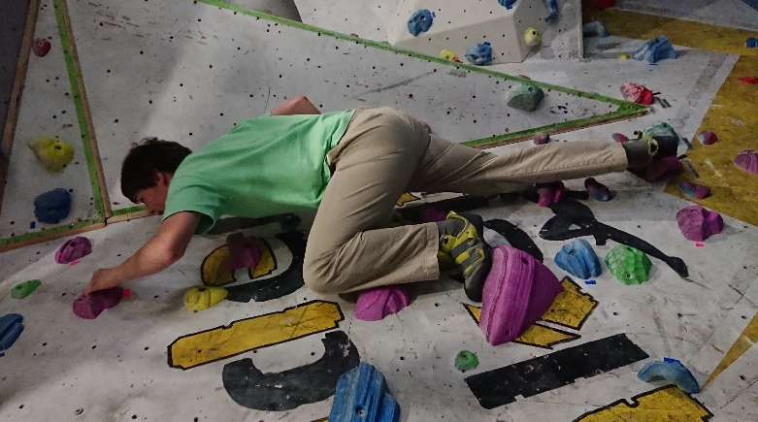
Sixth formers have enjoyed going off site for their fitness and leisure sessions this term to experience a range of different activities. The P groups have had the opportunity to go to Winners Gym every Monday afternoon, whilst students from W1 and W3 have been to Torquay Tennis Centre and Dainton Golf Club. Students from W2 have enjoyed going to Torquay Tennis Centre, Torbay Olympic Gymnastics Club, and more recently to the Boulder Bunker where they have tackled indoor rockclimbing. The effort shown by students has been exemplary.
Jacob Hughes climbing
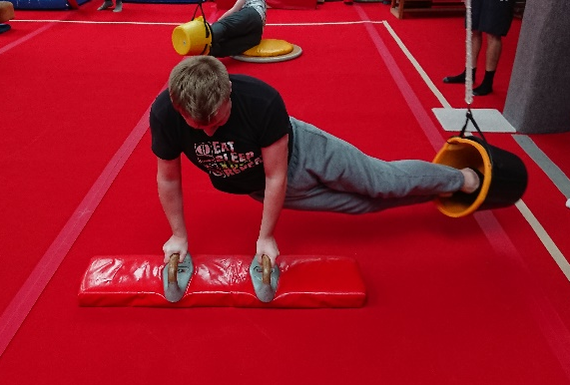
W2 students working hard

Several students have been visiting gyms independently – George Turner and David Leese to Winners Gym in Torquay, and Liam Slack and Cameron de Groot to PureGym.
Students excel on work placements
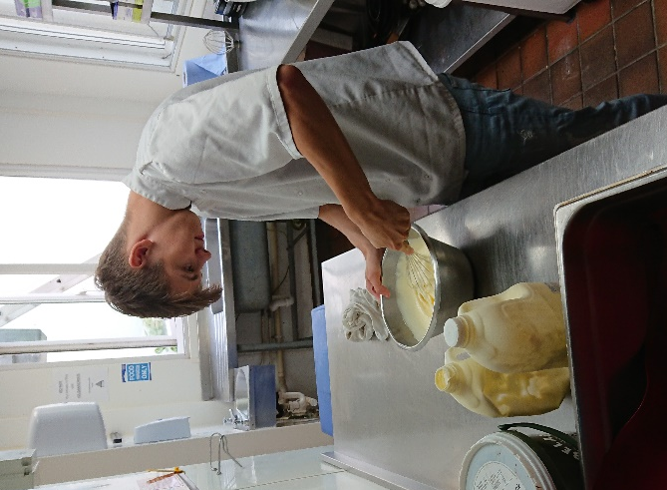
Despite the pandemic and the uncertainty surrounding employment, most work-ready students have been in a work placement during the autumn term, and have been accumulating several hundreds of hours of experience in a variety of workplace environments. As a whole the students have done very well, and many have excelled in their chosen pathways. In several cases students have been able to pick up paid work at weekends as a result of their performance. All have demonstrated many of the basic attributes looked for by employers – punctuality, reliability, willingness to learn and ability to work as part of a team.
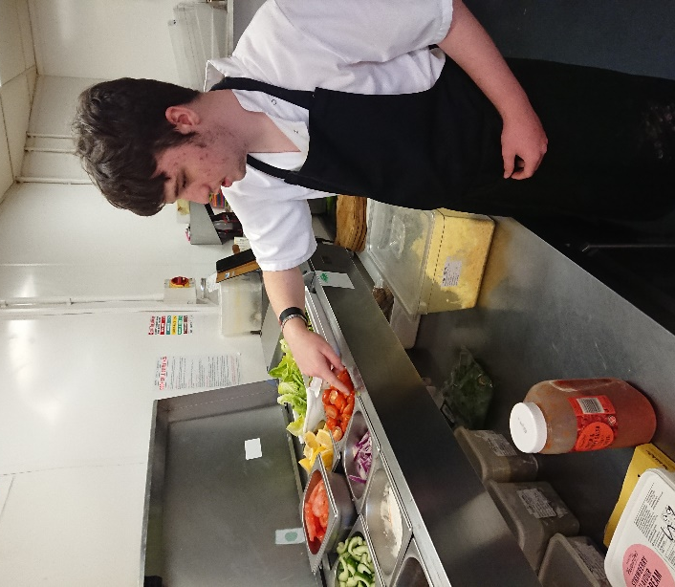
Jake Williams has done amazingly well in the kitchens at the Buckerell Lodge Hotel in Exeter, doing paid work there and at Oddfellows Restaurant at weekends. Morgan Quin meanwhile has been impressing his employers and work colleagues in the kitchens at the Ocean leisure complex in Exmouth, picking up paid work on Saturdays. Karl Hackett has been showing great practical skills on his placement at Westcliff Garage in Dawlish, and Ben Waymouth has been making great progress on his retail pathway at Sainsbury’s, picking up some paid casual work at Christmas. A member of the public rang us this week to compliment Ben on his outstanding customer service skills at the checkouts – well done Ben! Liam Slack has also picked up paid work at Christmas at Sainsbury’s, whilst Cameron de Groot has picked up paid work at weekends and Christmas at Fermoy’s Garden Centre.
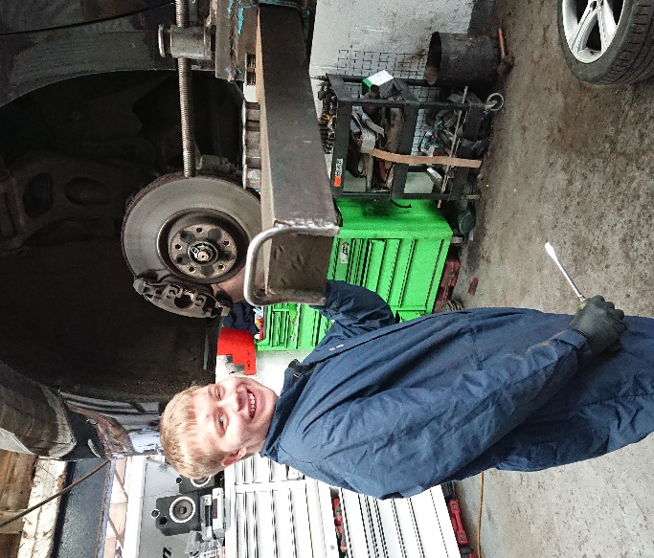

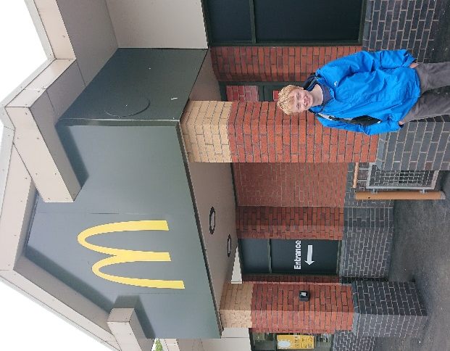
A special mention must go to Cameron Fraser, who on his own initiative applied to MacDonald’s at Marsh Barton in Exeter for a job there, attended for interview and induction, and is now working there at weekends, travelling from his home in Dawlish. Cameron isn’t even in the work-ready group yet so very well done on adopting such a positive attitude to seeking employment!
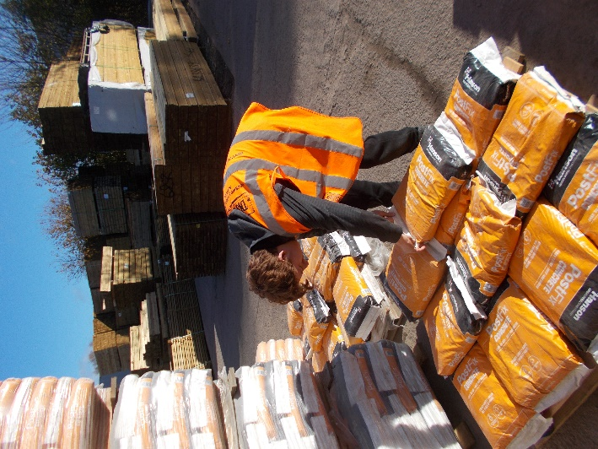
Cameron de Groot at the checkouts at Fermoys where he does paid work at weekends

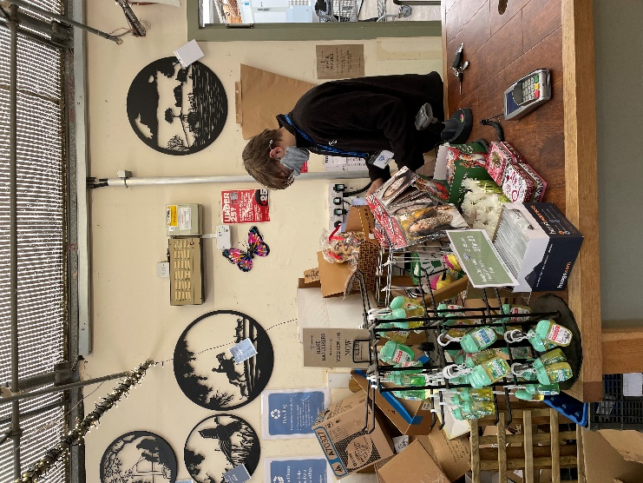

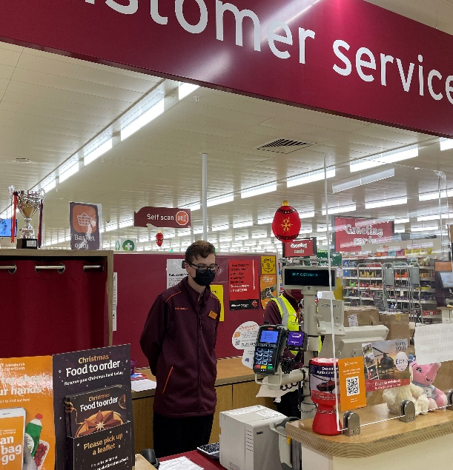

Bradley Cox, who has made a positive
start at Discount Decking
Ben Waymouth on the Customer Service desk at Sainsbury’s

SUCCESS AT WORK!

Jacob Hughes mucking out at the
Rare Breeds Farm in Totnes

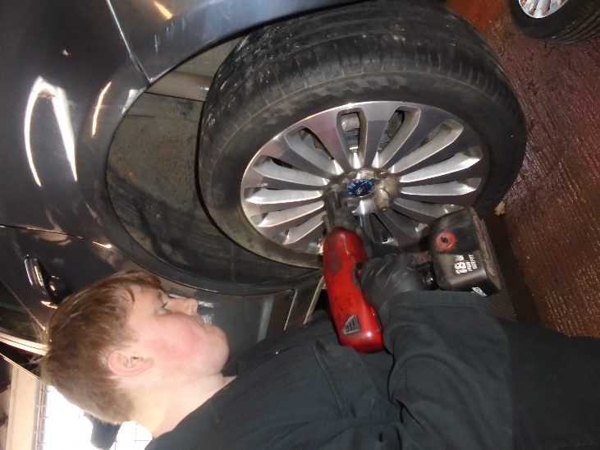
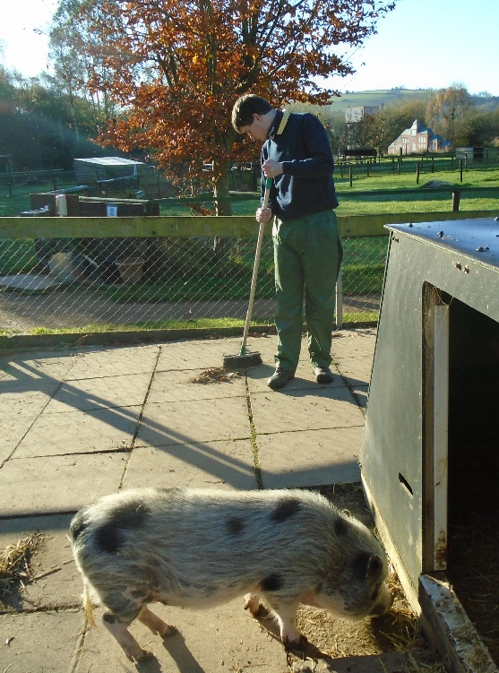

Ryan Knapman working hard at National Tyres
In Paignton

Other work placement successes
It is not possible to mention in detail every single student, but here are a few worthy of mention. From W2, in addition to those featured, Natasha Mildren (Southernwood Nursery) and Luca James (Torbay Clearance Services) have both made excellent starts with very good attendance and excellent feedback from employers. Bradley Cox has also made a positive start to his time at Discount Decking whilst Liam Slack continues to do extremely well at Fermoy’s Garden Centre.

From W1, Kieran Binmore has made a very encouraging start at the Cary Arms Hotel working in the gardens, whilst David Leese (National Tyres) and Jake Vizard (Palace Hotel) continue to build up their hours of experience in their respective placements. George Turner deserves great credit for his efforts at Winners Gym – George has made a very favourable impression on his employer with his mature approach to work, and Kiemera Clark continues to do great things at Bow Wow dog grooming parlour. Tommy Cresswell has been a revelation working at Powderham Castle, whilst Adam Prosser has been outstanding at Dawlish Gardens Trust.

W3 students who have been impressing their employers include Teddy Pritchard in the kitchens at the Cary Arms Hotel and Logan Taylor at Londis in Chelston. Chris Kaye has also done well working in the YMCA charity shop in Torquay, whilst Connor Irving has made a very favourable impression at the Rare Breeds Farm in Totnes. Bobby Abbot has been a useful addition to the IT team in school, whilst Chelsea Walters has done a very good job of helping out in KS2 with the younger children.

A special mention is deserved for Joe Francis (gardens) and Lee Abbott (maintenance) who have been working in school on individual programmes – they have both shown great professionalism.

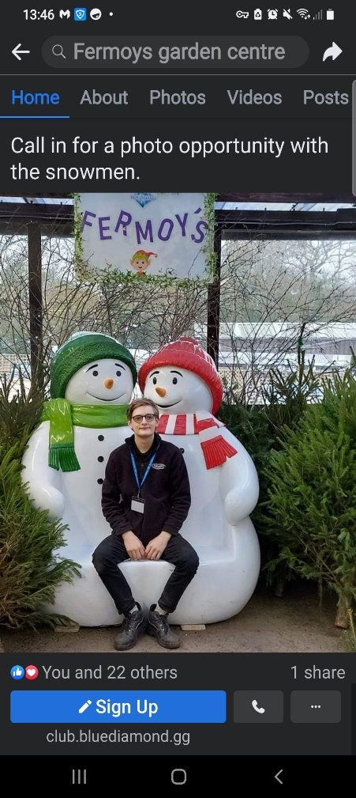
Seasonal & Part-time Paid Work for Sixth Form Students
It has been great to see so many of our sixth form students applying for and being successful in gaining part-time and seasonal jobs this term. Part-time working gives students valuable work experience that they can include in their CVs not to mention a wage to spend or save.
- Cameron de Groot (left, the face of Fermoy’s!), weekends
and Christmas

- Morgan Quin – Ocean Exmouth (weekends)

- Jake Williams – Buckerell Lodge Hotel, Exeter (weekends)

- Liam Slack – Sainsbury’s (Christmas work)

- Ben Waymouth – Sainsbury’s (Christmas work)

- Adam Prosser – Cleaning shift, Combe Pafford

- Cameron Fraser – MacDonald’s, Exeter (weekends)

Exciting opportunities at Dawlish Gardens Trust
Several students have been able to take advantage of working at Dawlish Gardens Trust for their work placement – here are some of the exciting things they have been up to!
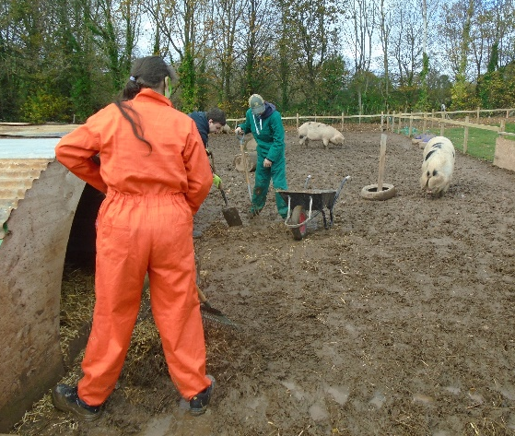
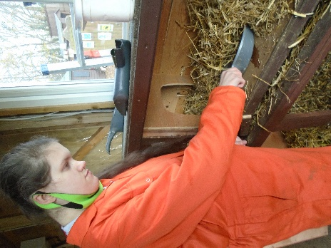
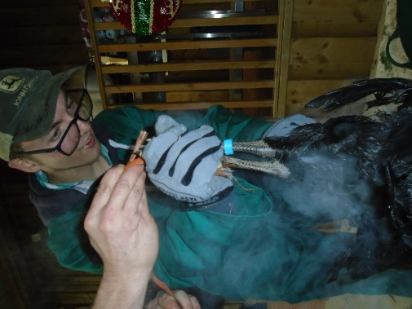
Sheltered work projects off to a great start
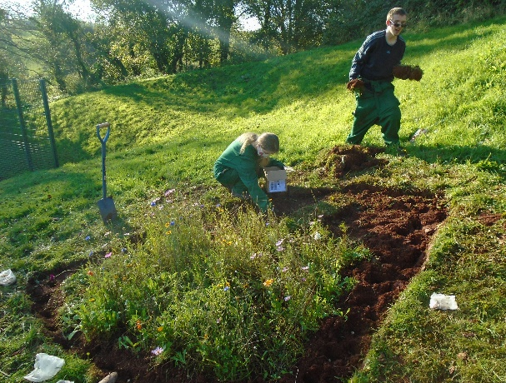
For the first time, P group students have been going out on a planned basis on Thursdays as part of their Work Skills curriculum. This has been arranged in partnership with Groundworks Community Project and Stover Country Park, enabling small groups of 3-4 students to go out regularly to take part in environmental activities including conservation, improvement and land management. The new projects set up at St Mary’s, Brixham and Westerland Valley in Paignton have been a huge success, opening the eyes of many students to environmental issues, at the same time as giving them an insight into what a hard day of physical work feels like!

Students hard at work on a re-wilding project

Chloe Hart next to the completed graffiti
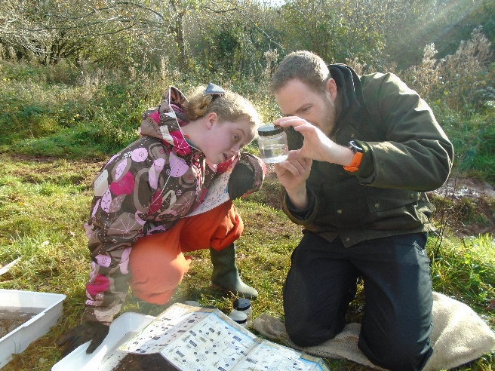
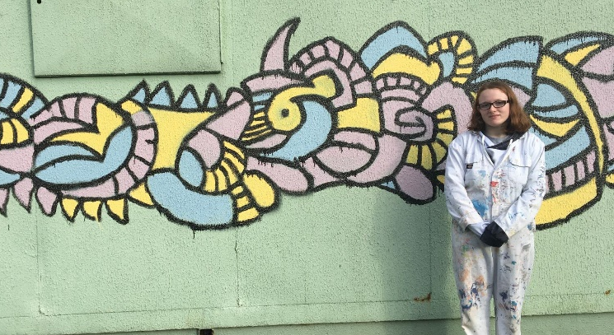
mural at St Mary’s, Brixham

Ellie Jackson examining stream water at Westerland Valley
Retail and Customer Services News : Student report
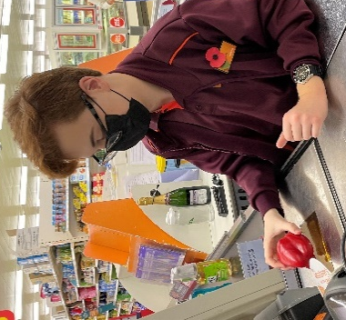
Last year I completed my L1 Certificate in Retail Skills at Sainsbury’s and this year I have been at Fermoy’s doing a Customer Service course. The two placements are very different but I have learnt new skills at both and feel ready to work in the industry.
I have been given seasonal employment at Sainsbury’s this Christmas and hope to be able to gain a permanent contract. I love working at Sainsbury’s and enjoy meeting new colleagues and customers.
Liam Slack

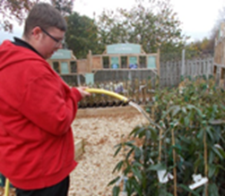
I am in my first year on the Retail course doing my work experience at Sainsbury’s. I have completed checkout training successfully and have received lots of positive feedback from staff and customers. I was extremely nervous about working at the checkouts, but I feel like I am really beginning to find my footing. I have also worked in many departments, such as: dry goods, frozen and fresh goods, stacking shelves and rotating stock. I am doing a Customer Service qualification and have been on the Customer Service desk, dealing with complaints, returned goods and general enquiries. I am hoping to be able to gain seasonal employment soon.
Ben Waymouth
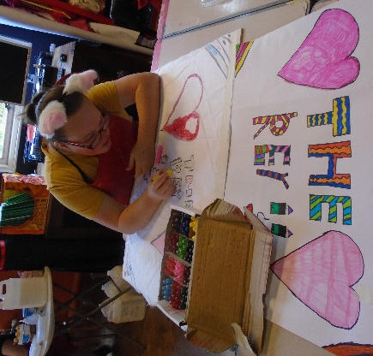
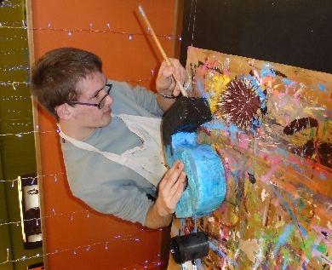
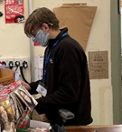
I am in my second year at sixth form, doing a Customer Service course. I do my work experience at Fermoys Garden Centre. I think Fermoy’s is amazing! I get on well with all the staff and customers and I was invited to the Christmas party this year.
When I was on my work experience I noticed that they were taking on part-time staff on the tills. I applied and after a short trial, I was offered the job. I love working there and feel part of the Fermoy’s Family.
Cameron de Groot

Students benefit from arts project

Damon Barlow and Tegan Brown hard at work on the arts project called the Illusion Shed at the Key at Seale Hayne College – they go all day on Fridays as part of their bespoke timetable.
Students learn how to socialise!

This term we were able to resume having social events every half-term, and students have been turning out in force to meet their friends in safe surroundings, with staff providing light-touch supervision. Our first event was a trip to AMF Bowling in Torquay for an evening of fun participating in ten pin bowling and the various other games on offer there. This was very well attended, but more recently 29 students (the highest number of students ever to attend a social event!) came to our cinema evening at the Vue Cinema in Paignton, meeting beforehand at the Harvester for drinks. Students were able to choose from four films showing on the night – Encanto, Ghostbusters : Afterlife, Venom (Let there be Carnage) and Gucci. A good time was had by all, and many students travelled independently to and from the cinema. I am hopeful that we can now run a social event every half term on a regular basis.
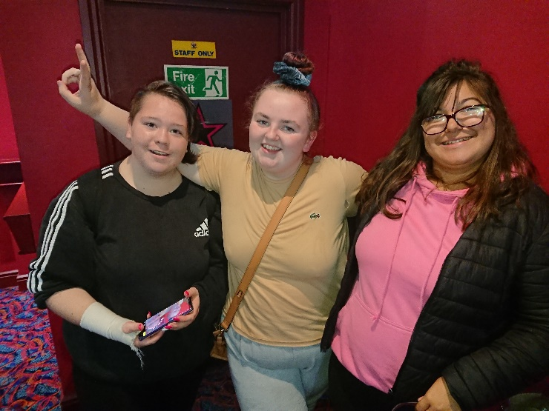
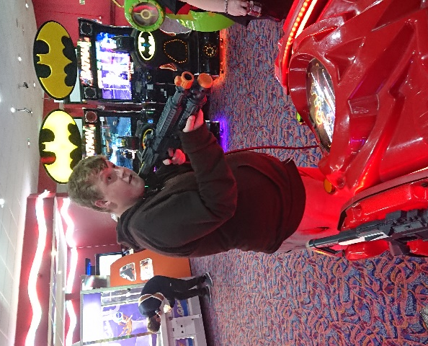

Chelsea, Tash and Bibi at the cinema evening Barrie taking aim!

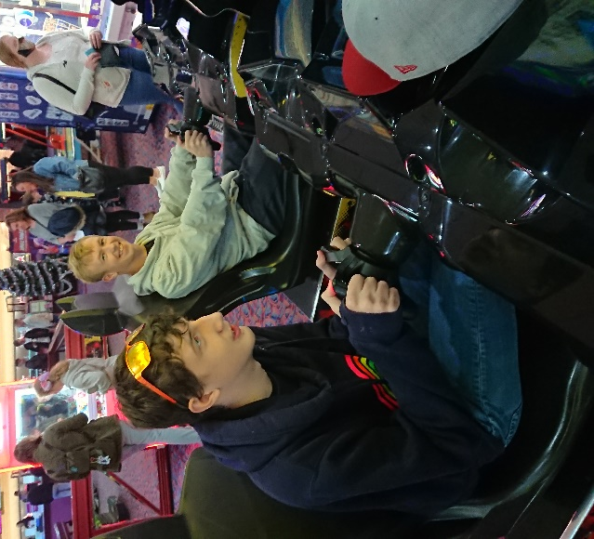
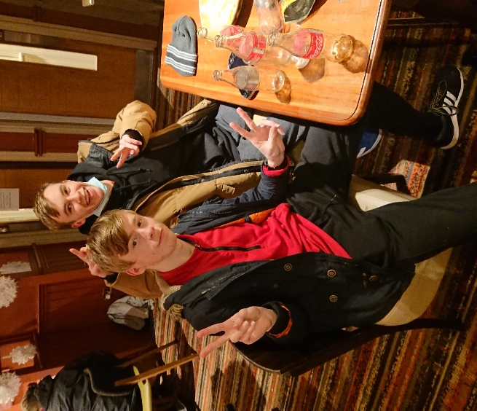

Jake and Daniel having fun on the games Lee and Owen relaxing!
In other news!

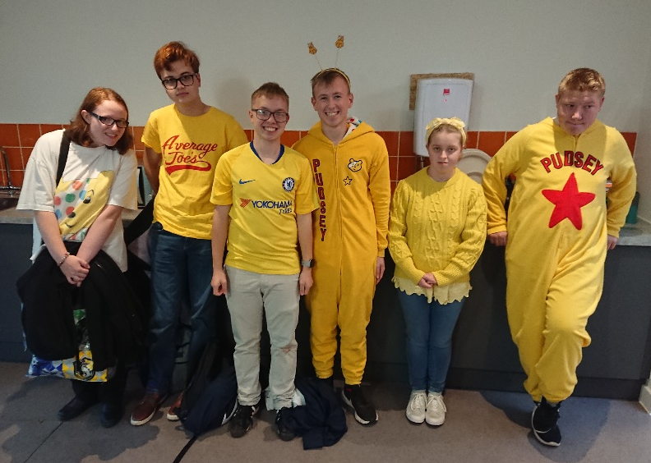
For Children in Need, sixth form students paid for the privilege of dressing up and doing a quiz about the staff and things that happened to them when they were children – students had fun trying to guess what had happened to which staff! Many paid good money to throw wet sponges at Mr Thompson and Jake Williams enthusiastically paid £5 to tip the whole bucket of cold water over his head! At lunchtime we also had a comedy club where students and staff paid money to tell jokes. In total we raised £60 towards the Children in Need cause. Well done everyone for having a go!

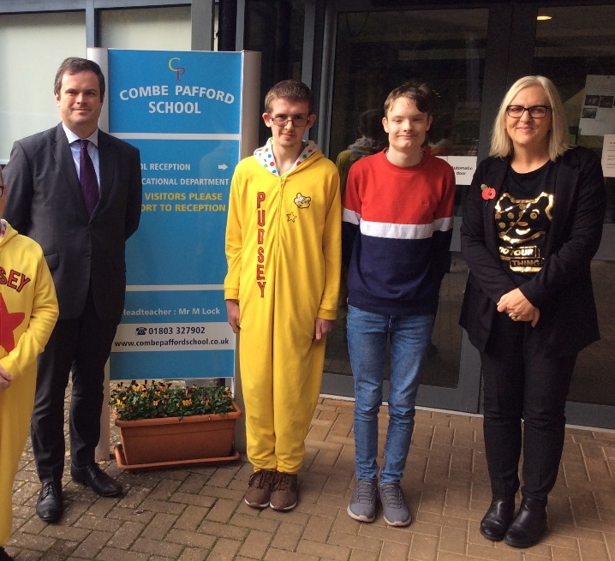
On the same day as Children in Need, we had a visit from our MP for Torbay, Kevin Foster. Two members of the sixth form Student Voice group, Damon Barlow and Jack Hallows, met Kevin and gave him a tour of the school. After this, the two were able to ‘interview’ him a bit like Question Time, and ask some topical questions about youth unemployment and other local issues. They also asked Kevin about what he enjoyed most about being an MP – he said the best bit was going out meeting people. Damon and Jack are shown with Kevin and Rosemary Dolan, who oversees the Student Voice group.

We have said goodbye to several sixth formers this term :
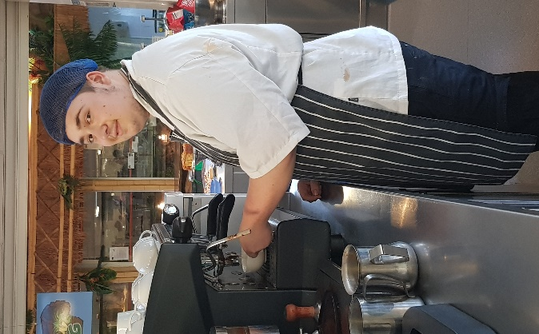
- Kieran Blake (right), gained an apprenticeship in Hospitality and Catering in the Yellow Frog Café

- Hannah Day and Charlotte Bullock have left and are hoping to engage in home learning

- Liam Hyde and Ella George have left and gone to South Devon College on the Vocational Tasters course

- Chloe Raines has left and is hoping to obtain casual employment
Students enjoy festive lunch out
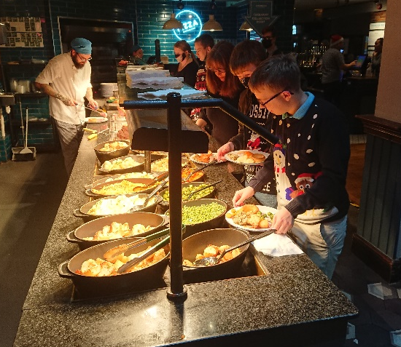
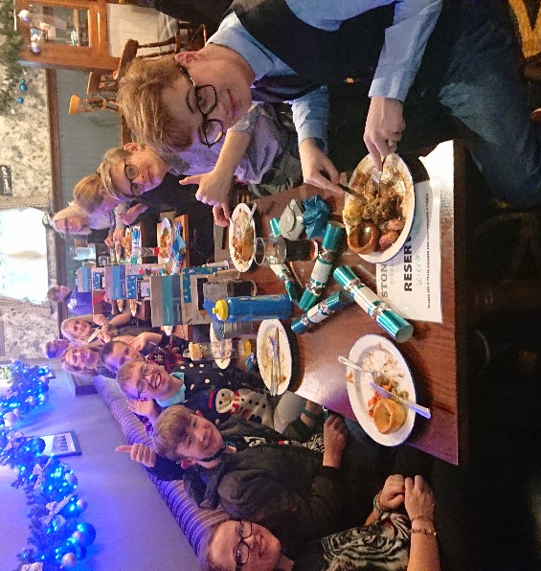
For the first time in two years, students in the sixth form were able to go out for their Christmas meal at the Willow Tree pub. No fewer than fifty-three students and staff made it on the trip, and they were not disappointed! The Willow Tree put on a great Christmas carvery of beef, turkey and gammon along with all the trimmings, plus vegetarian options and a choice of six desserts! The food was excellent and everyone present felt quite full by the time we returned to school for the Christmas quiz, giving out of reward vouchers, and of course Secret Santa.
Students tucking into Christmas lunch

News of former students
It’s always nice to hear about how former students are getting on, so it was particularly good to hear about the following recently : Thomas Hocking, who attended an outward bound course in Scotland this summer, has passed the Royal Marines taster course with flying colours and starts the serious training in January. Ben Barker is now driving Stagecoach buses between Teignmouth and Torquay, and Amy Weston, who works at Sainsbury’s, has been successful in becoming a Wayfinder Volunteer for the NHS. Ffion Shore meanwhile, who also works at Sainsbury’s, has added a cleaning job at the hospital to her CV.

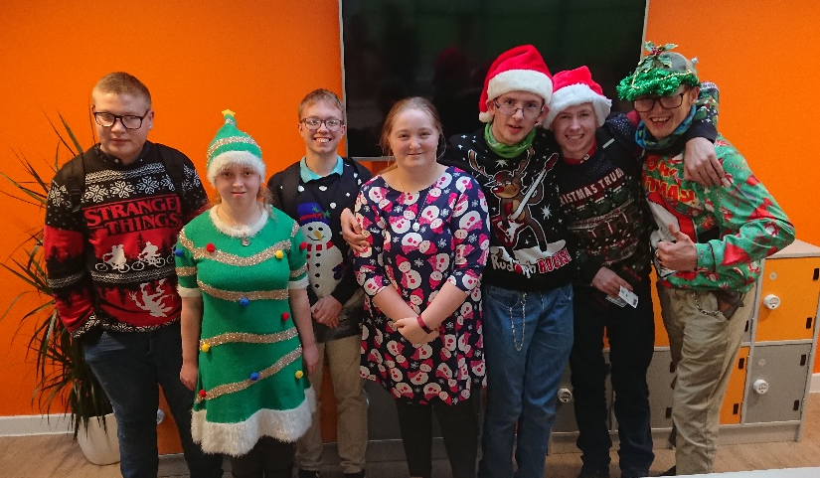
All in all, it’s been a challenging term but one in which we have collectively achieved an awful lot. The students and staff in the Sixth Form would like to wish all parents and their families a HAPPY AND PEACEFUL CHRISTMAS AND NEW YEAR!



Edward W Thompson
(Head of Sixth Form)

