SIXTH FORM SPRING TERM NEWS REPORT 2022

Students leave to take up employment
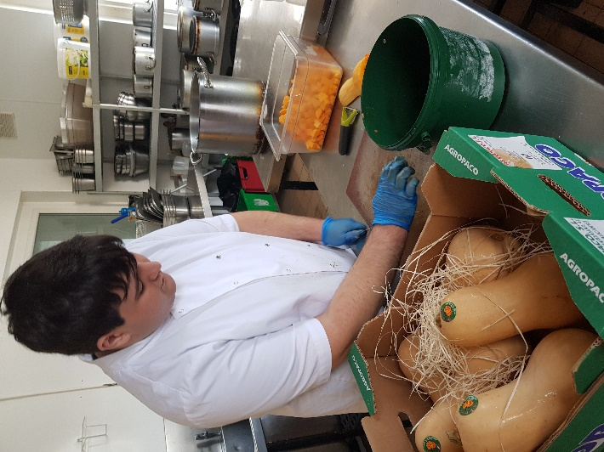
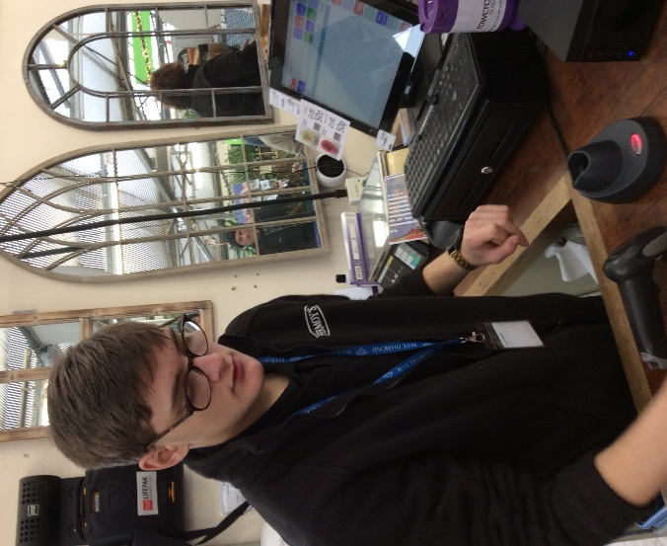
Two Sixth Form students have left recently to take up job offers with local employers. Jake Vizard (pictured working at the Palace Hotel, Paignton for his work placement) applied for a number of jobs, turning down a job offer from the Hare and Hounds in Kingskerswell before accepting a full-time position at the Below Decks restaurant in Torquay.
Cameron de Groot (right) who has been very proactive in searching for job opportunities, and who has been working at Fermoy’s Garden Centre for his work placement, was recently offered a 3-month rolling contract with the popular family business and has already started work with them. We wish them both well for their future careers.

Students excel in work placements
A number of other students have been excelling in their work placements this term - this includes our two Retail students Ben Waymouth (pictured below left on the till) and Liam Slack (below centre on the customer service desk) who are attached to Sainsbury’s at the Willows. Also performing well in their placements are Ryan Knapman (pictured below right at National Tyres and Exhausts in Paignton) and Bradley Cox at Babbacombe Cliff Railway Café.
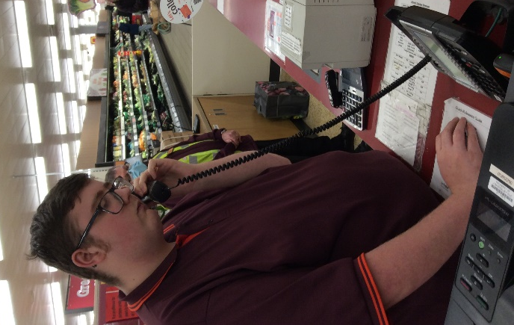
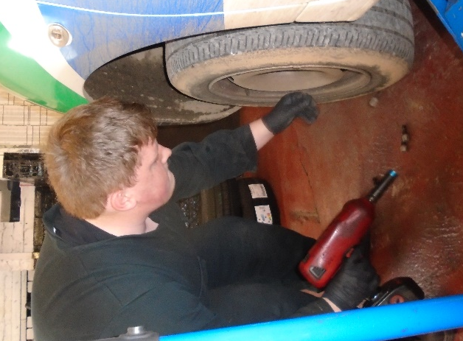
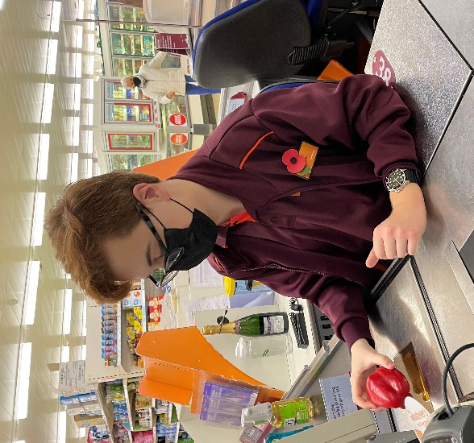

Post-16/Post-18 Options Afternoon
Earlier in the term we held our first Post-16/Post-18 Options Information afternoon for three years in our sports hall. A number of colleges and training providers attended, and students from Years 9-14 were able to talk to exhibitors about courses and apprenticeships, and ask questions. A large group of parents also had a tour and talk about the Sixth Form where parents were able to ask questions about our sixth form provision.
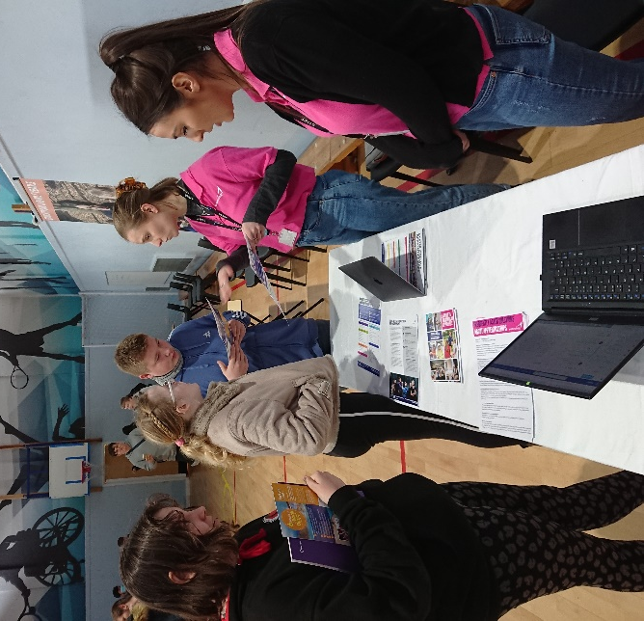
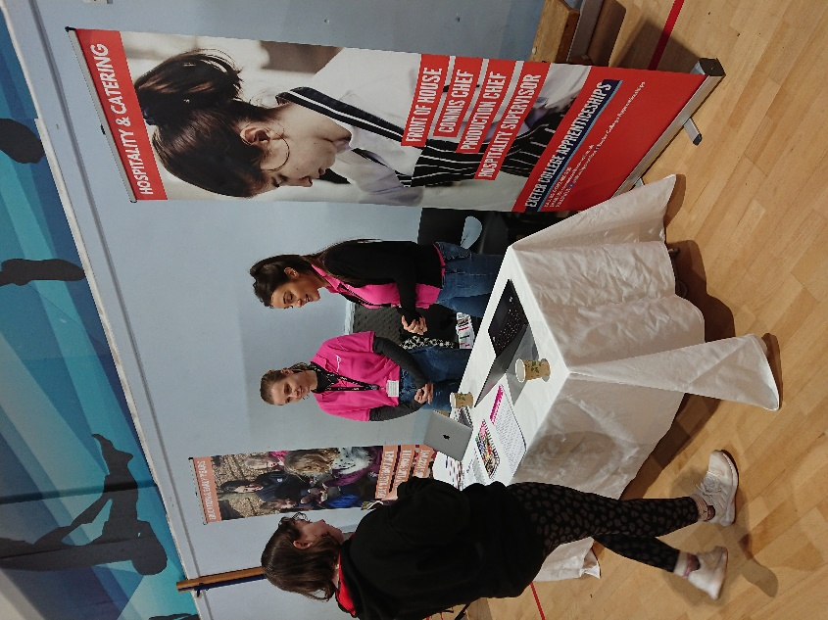

Sixth Form students talking to the Exeter College staff about training opportunities

The National Apprenticeship Show rolls into town
The National Apprenticeship Show came to Sandy Park, home of Exeter Chiefs, recently and all of Key Stages 4 and 5 attended, courtesy of coaches funded by the NAS. It was a busy event with many exhibitors present, ranging from the military to local colleges to large organisations such as South West Water and Exeter City Council. Students took advantage of the opportunity to speak to those present as well as sampling the ‘have-a-go’ activities on offer. As a result of the event, Bradley Cox has signed up for the Royal Navy recruitment process, and Kiemera Clark has applied for a residential Animal Care course at Bridgwater and Somerset College. There was an abundance of information on
apprenticeship opportunities.
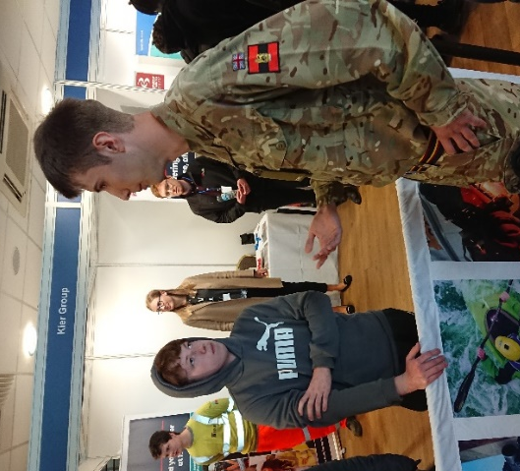
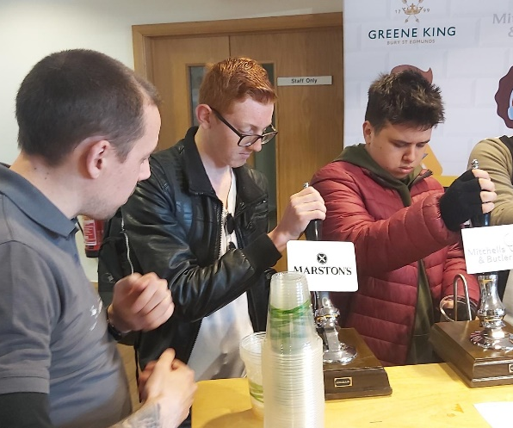
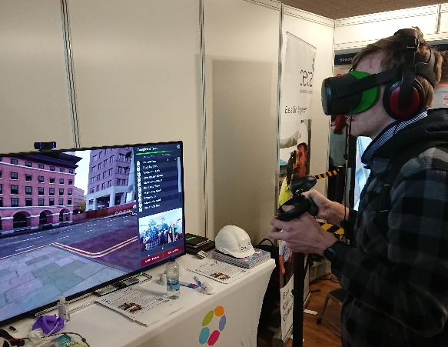
Trips for students designed to inspire
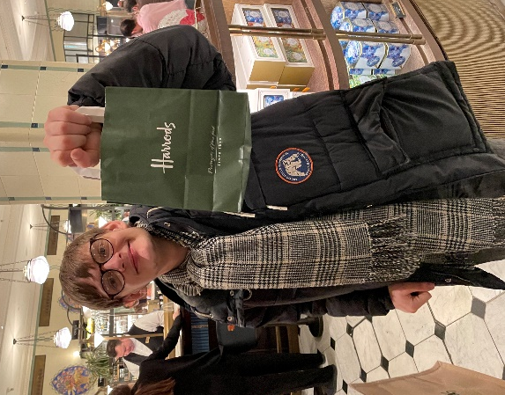
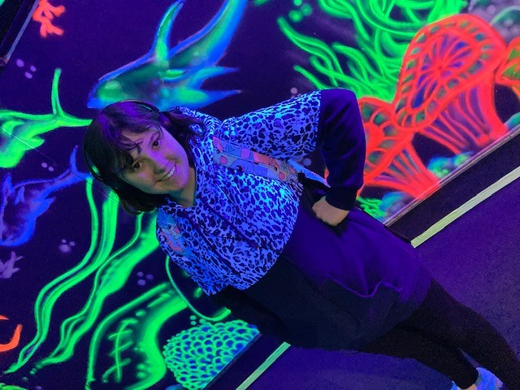
Students on their vocational pathways have been given the opportunity to go on an inspirational visit for a day, linked to their pathway, that is designed to motivate and inspire them. So far, three trips have taken place and more are planned for the summer term. The first group to benefit was the Animal Care group who visited the National Marine Aquarium in Plymouth and had a behind-the-scenes tour and chat with the aquarium keepers. Next up was the Retail group who travelled by train to London to visit Harrods, Fortnum and Mason, and Hamley’s to sample their legendary customer service first hand. The most recent trip a few weeks ago was the Motor Vehicle group, who visited the Haynes Motor Museum in Yeovil and enjoyed looking at vintage cars and the history of the motor car and the internal combustion engine.

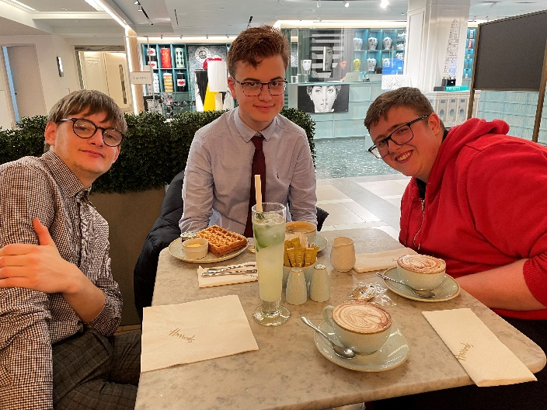

Cameron, Ben and Liam in Harrods’ cafe

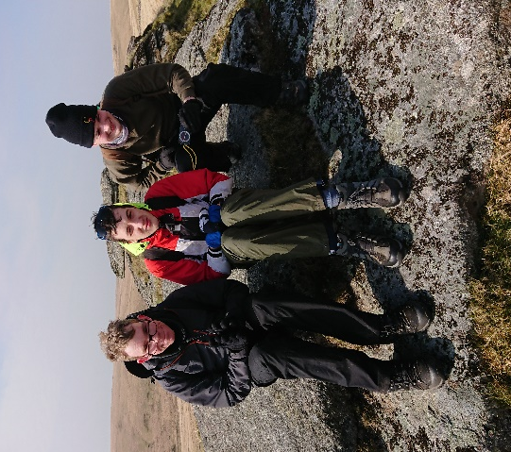
Sixth Formers training for Ten Tors Event
A small group of sixth formers are training on Dartmoor alongside pupils from the main school for the first Ten Tors event in three years which is due to take place in May. Recent training sessions have taken the group to Two Bridges and Okehampton; pictured are Matt Roberts, Jake Brimicombe and Jacob Hughes on the top of Lydford Tor near the West Dart river valley. On the Two Bridges training walk, students climbed nine tors and went to an old ruin, a significant feat in remote moorland with difficult terrain. All three students are fit walkers who should be well prepared for the event.

10 mile Sponsored walk raises vital funds for Ukraine
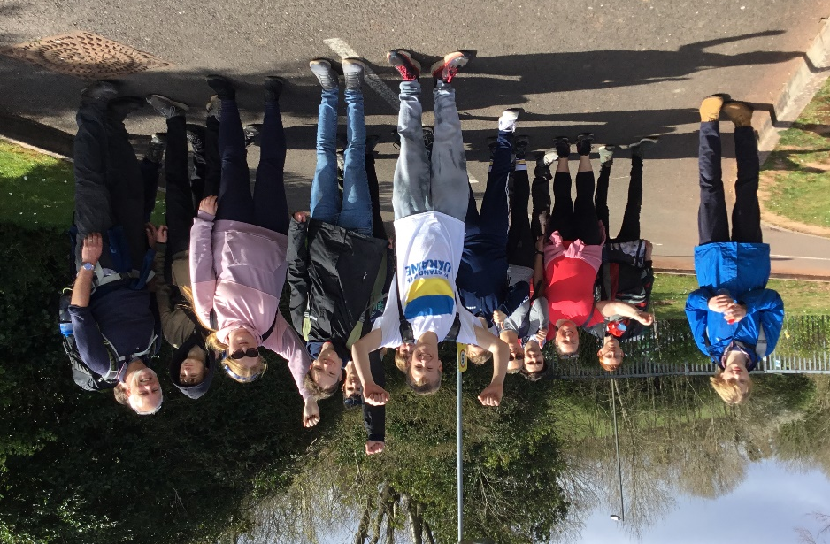
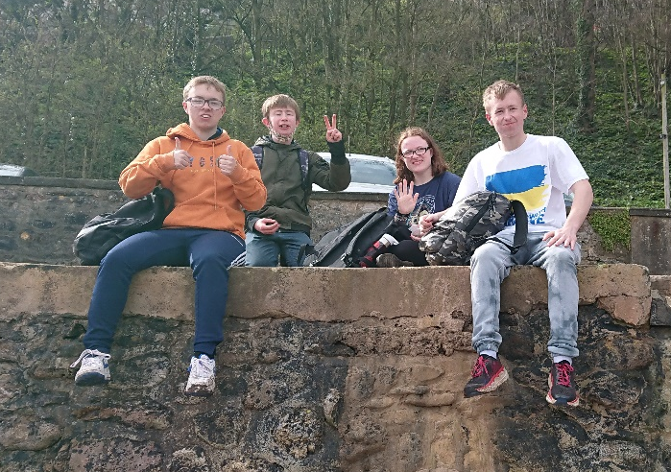
Students were at the forefront in suggesting a sponsored walk for Ukraine, and although time was short we managed to accomplish this earlier this week, 15 students undertaking and completing the hard route which started and finished at school via Watcombe Beach and the coast path to Oddicombe, Babbacombe, Meadfoot Beach and the Princess Theatre before walking back to school through Plainmoor and St Marychurch. At the time of writing the sponsorship target of £200 had been smashed and on-line sponsorship had reached £325 with some lovely messages from the 24 sponsors. All the students did really well to complete the route but a special mention must be made of Chris Kaye, Teddy Pritchard and Chloe Hart who did exceptionally well to complete the demanding route.

Social events give students time to relax and enjoy themselves

A great many students have supported the recent planned social events by signing up for them enthusiastically. In the first half of term, more than twenty attended the Chinese buffet meal at the Oriental Touch restaurant in Plainmoor, impressing staff with their mature and very grown-up behaviour. Everyone enjoyed themselves, many students travelling to/from the venue independently.



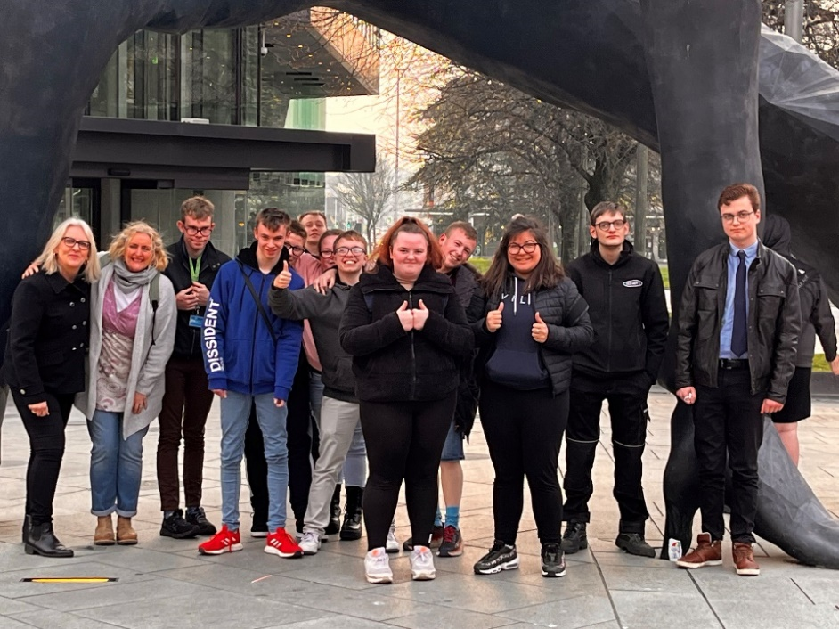
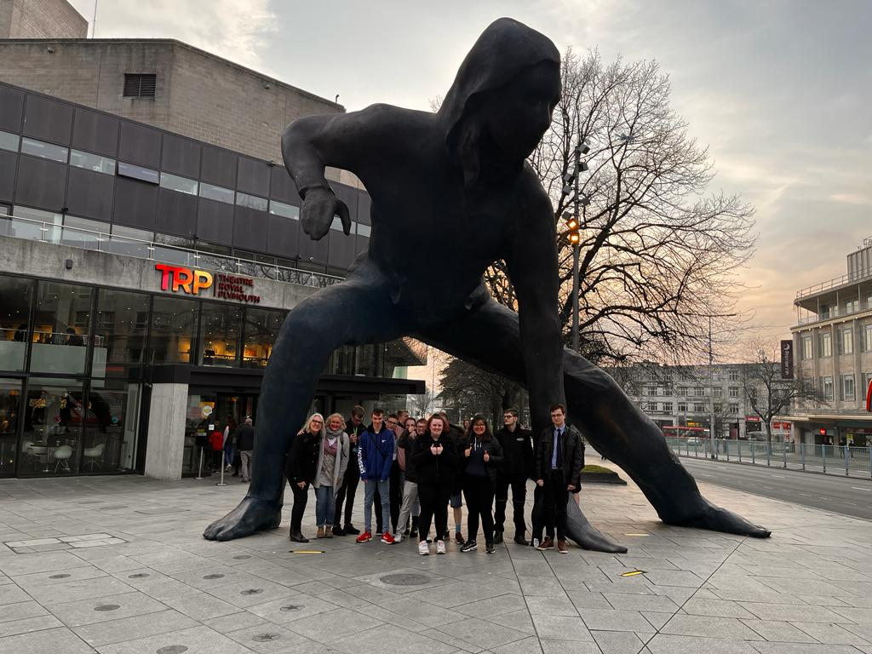
A couple of weeks ago, a group of 11 students met at school one evening to catch a lift to the Theatre Royal, Plymouth to see a performance of a play called Kerbs in the Drum Theatre. The play, a comedy aimed at teenagers, was about sex, dating and disability, and as well as being extremely funny, contained some serious messages about relationships which were well received by students. Several of them were in stitches throughout the performance! Thanks to the staff who gave up their evening to accompany them.

Students fit and active during Physical Activity for Health and Well Being lessons
Sixth formers have been enjoying a range of physical activities this term, many of them for the first time. The P groups have been going to Winners Gym for several months now, but have now got the added options of Torbay Olympic Gymnastics Club and Torquay United Indoor Bowling Club, the latter a new link only recently established. W1 and W3 have been going to Dainton golf driving range to practise their driving skills, whilst some have also been to the Carlton Hotel to do ten-pin bowling.

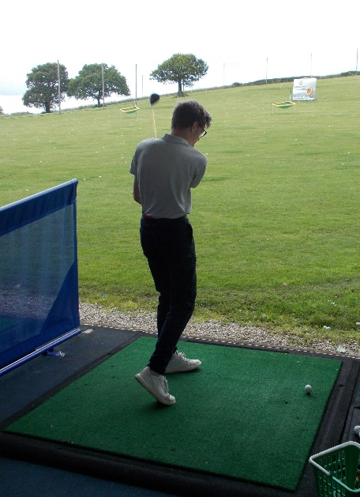
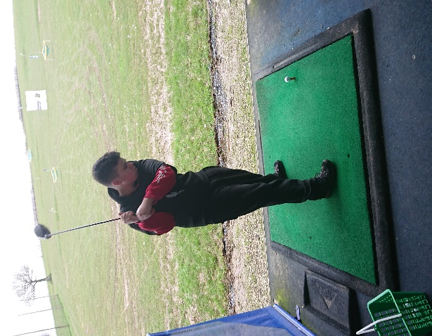
Ben Waymouth at Torbay Olympic Gymnastics on the pommel trainer
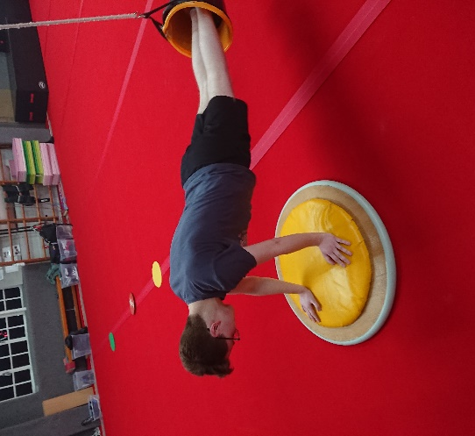

Teddy Pritchard at the
golf driving range

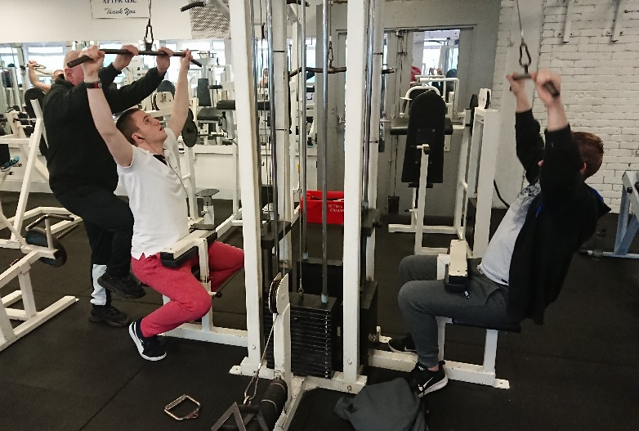
Students from W2 have been taking advantage of exciting new sessions at ParkView Fitness Gym (formerly Castle Gym) and Torquay Squash Centre. More recently they have been receiving self-defence sessions in school by Antony Lees, a qualified martial arts instructor and black belt – these sessions have proved especially popular.

Jake Williams and Ryan Knapman on the
bikes at Parkview Fitness
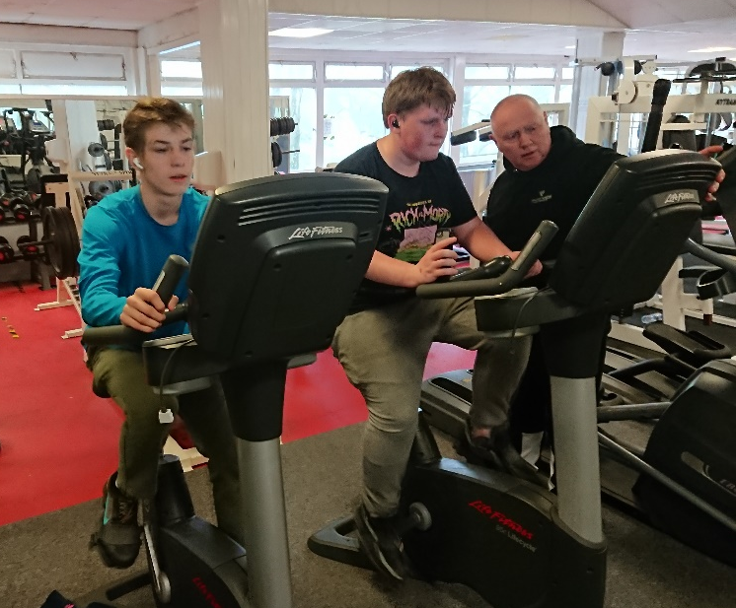
Morgan Quin and Karl Hackett on the
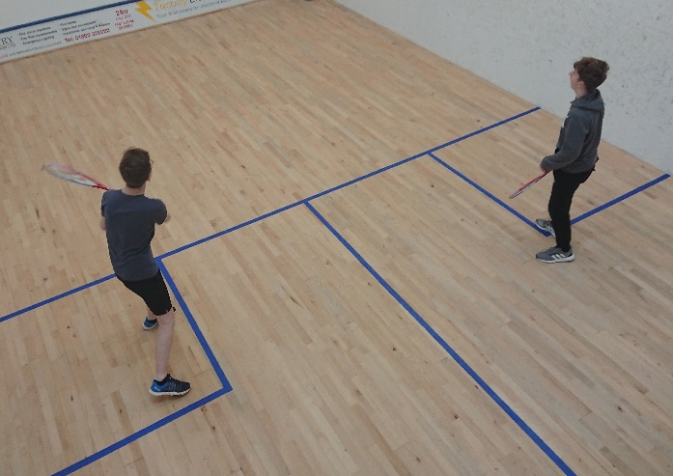
Multigym at Parkview Fitness

The end of an era and the beginning of a new one
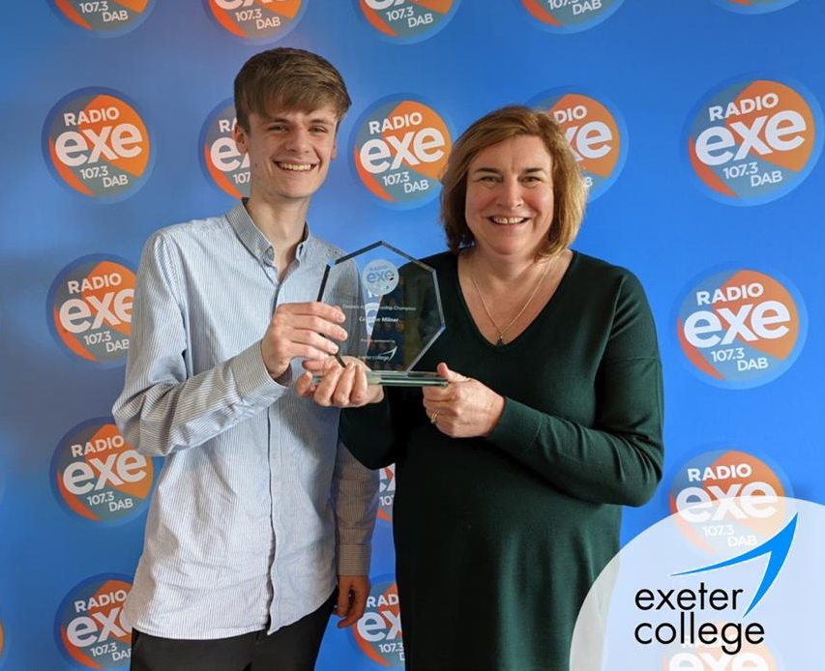
The Sixth Form has enjoyed a settled team for a number of years now with relatively few changes, but Easter marks the departure of four members of staff who have had a significant impact on the work of the sixth form. Ursula Henkel, who has taught core subjects, Like Skills and Work Skills to P students for a number of years, is retiring; whilst Caroline Milner (Careers Adviser), Miranda Stone (Care Tutor) and Jayne Orme (Job Coach) are leaving to take up new positions elsewhere. Heartfelt thanks go to all four staff for their contributions to the sixth form, and we wish them all the very best for the future.

New appointments include Kirsty Mills (right) in a new role of Sixth Form Manager, whilst Lewis Griffiths has been appointed as the new Careers Adviser for the school. We Caroline Milner at the Exeter College welcome them both to the team,
apprenticeship awards and it is hoped that we can add
more staff in the coming weeks.
Edward W Thompson
(Head of Sixth Form)

