SIXTH FORM SUMMER TERM NEWS REPORT 2022

Students excel on work placements
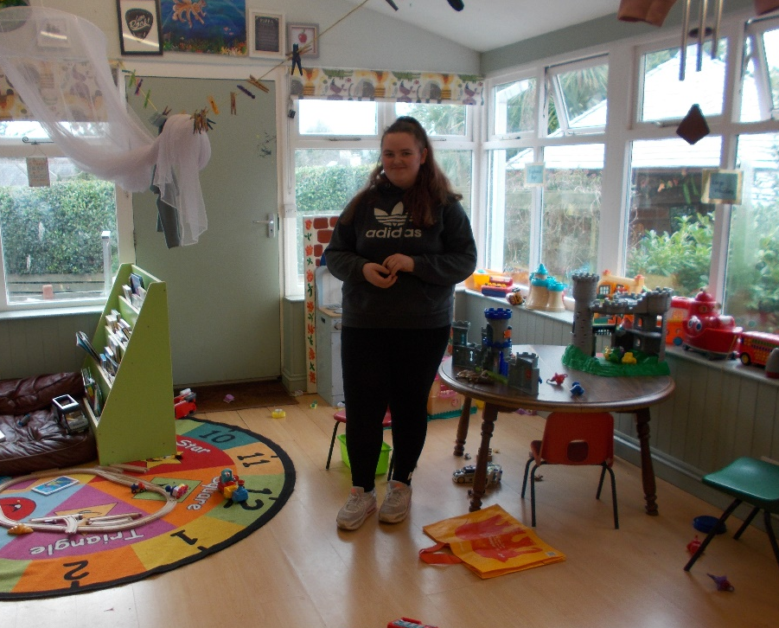
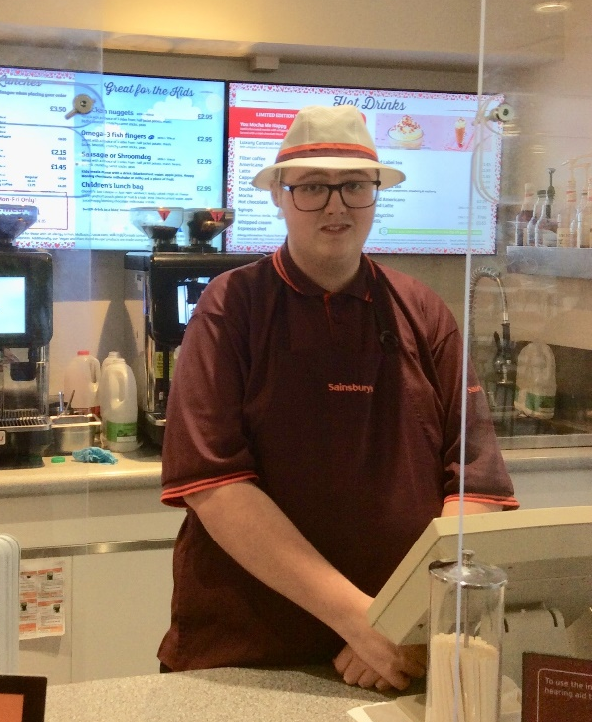
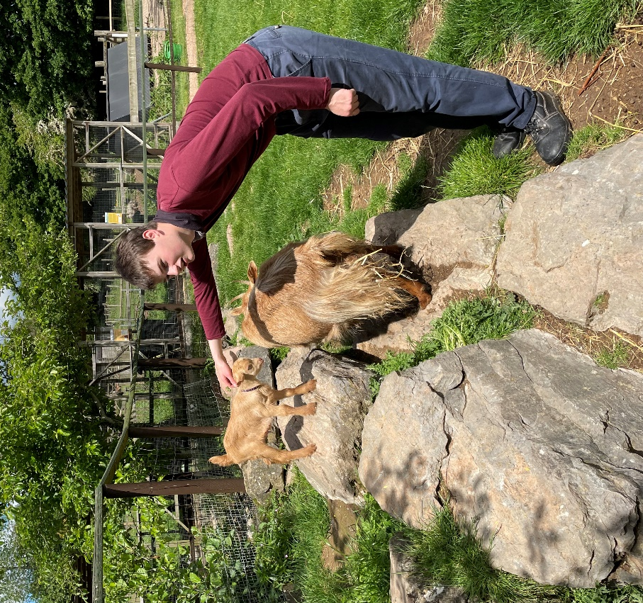
Despite the pressures placed on work placements by the pandemic, many of our sixth form students have still been attending work, and there have been a number of notable successes. Jacob Hughes (pictured with young goats) has been outstanding in his placement at Totnes Rare Breeds Farm, displaying reliability, independence and a strong work ethic, and his employers will be sad to see him go. Jacob has now left us to move to Dorset, taking up a place in Animal Care at Kingston Maurward College in Dorchester where he is looking forward to continuing his studies.
Another leaver, Liam Slack (pictured below, working at Sainsbury’s) has excelled in his work placement this year working in Customer Service, having previously worked at Fermoy’s. Liam has already been accepted onto the Aspires Programme at Torbay Hospital for September, but has now gone one better by securing a position with Sainsbury’s in their online shopping team.
Several students are continuing in the sixth form next year, and one of these who has excelled in her work placement is Natasha Mildren (left), who has received consistently good feedback from her employer, Southernwood Nursery on a regular basis. Her colleagues cannot speak highly enough of Natasha, and report that she has grown in confidence tremendously, and is now proactive in being able to work with children independently. Very well done to Tash for her efforts.
Trip to Edinburgh a huge success
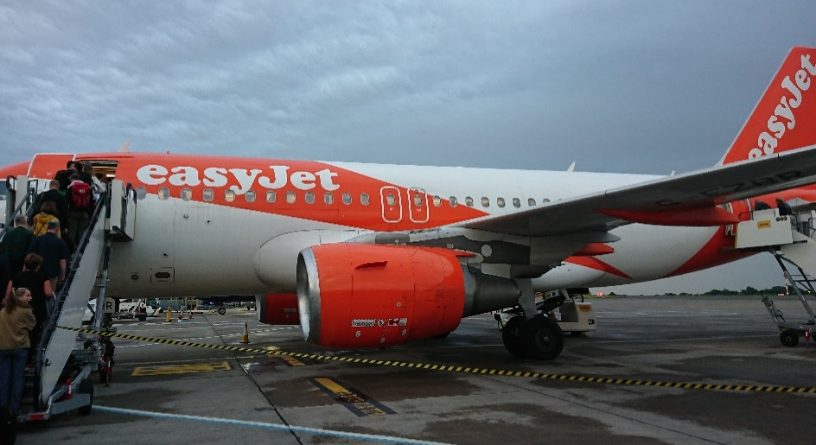
Although we were delayed at Bristol Airport for over an hour on our day of departure, our first residential in over three years was a resounding success. The plane to Edinburgh was boarded by 23 students and 4 staff, and we eventually arrived at the City Centre Hostel at 11.00 p.m..
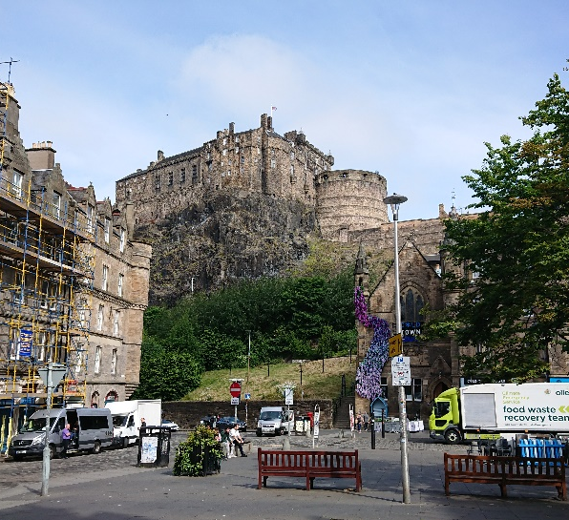
Next day we set about our itinerary in earnest, starting with a fascinating trip to Camera Obscura, a visitor attraction all about the world of illusion. Further visits over the next couple of days took us to Edinburgh Castle, The Edinburgh Dungeon (where Miss Moor was sentenced to death!), the Scottish National Gallery, St Gile’s Cathedral, and a fabulous visit to the Scottish National Museum. On Thursday the group split, the majority climbing the extinct volcano Arthur’s Seat whilst a smaller group had a look round the Scottish Parliament building. We then joined together to visit Dynamic Earth, a super attraction all about the formation of the universe and the earth.

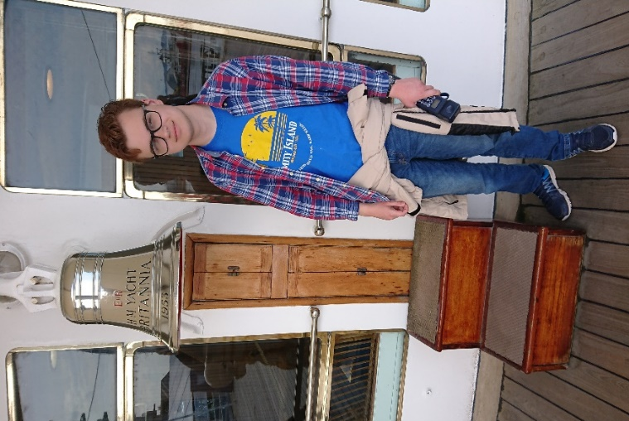
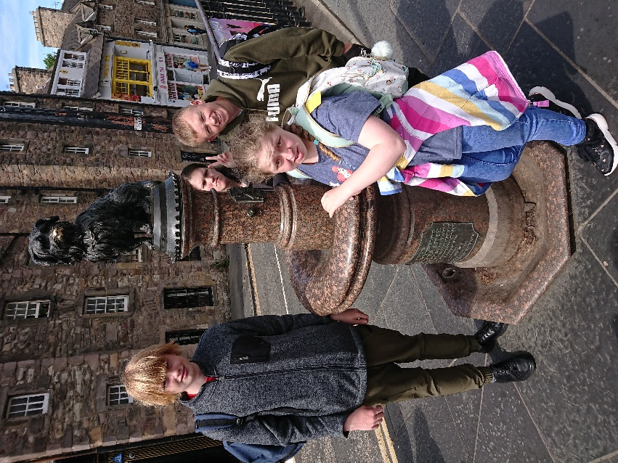
We had a busy final day, taking a bus out to Leith to have a tour of the Royal Yacht Britannia - all five decks of it - which was absolutely fascinating. Then a journey by bus back to the hostel to pick up our bags, then back on the bus to Edinburgh Zoo, the only zoo in the UK to have giant pandas and koala bears. Suffice it to say, we packed an awful lot in to the week, and the students, who showed great maturity and resilience during the week, all really enjoyed themselves.
Inspirational visits fail to disappoint
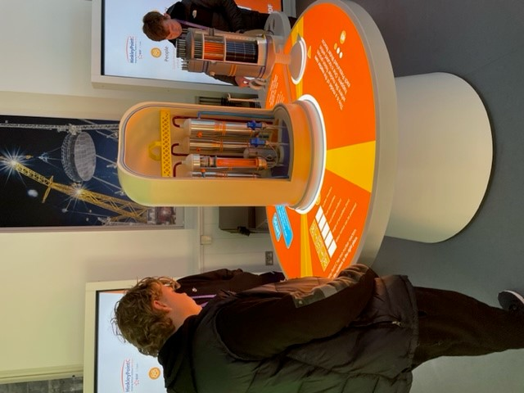
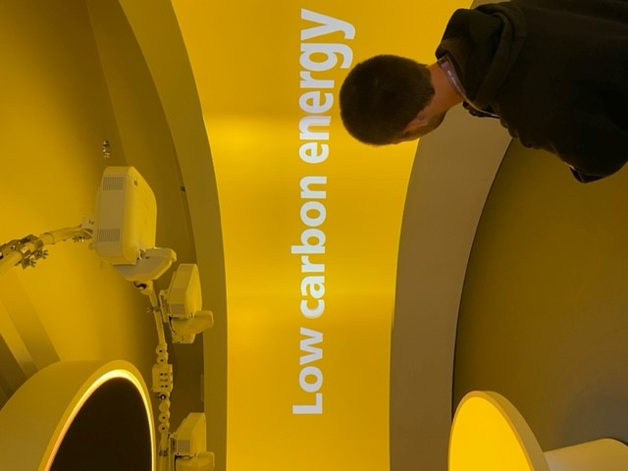
Following on from the visits last term to London (Retail), Plymouth Aquarium (Animal Care) and the Haynes Motor Museum (Motor Vehicle), a further three visits took place this term for sixth form pathway students. The first group to benefit from the inspirational visits idea were the Construction group, setting off early one morning for Somerset, bound for Hinkley Point C, the huge civil engineering project behind the brand new nuclear power station being built which when complete will boost the supply of electricity to the national grid. This was a fascinating trip which opened the students’ eyes to the sheer scale of the project. This trip was led by Mr James (Careers) and Mrs Eales (Premises).
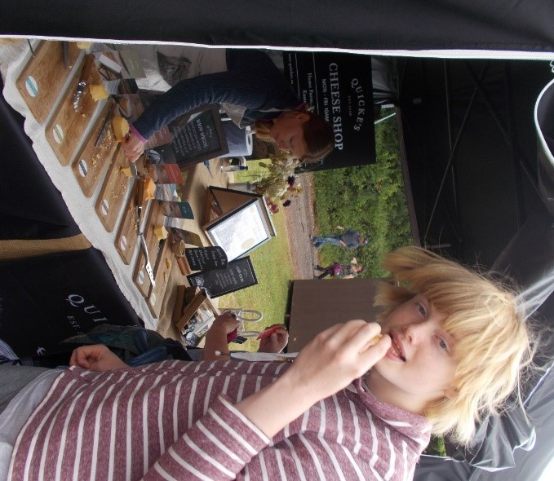
Next up was the Horticulture group, accompanied by Linda Sampson and Tamsin Moor, to RHS Rosemoor in Great Torrington. This was a very enjoyable trip which was thoroughly appreciated by all the students who went. The extensive grounds, boasting the most amazing floral beds, as well as the impressive vegetable gardens, couldn’t fail to delight and inspire! It is easy to forget sometimes that we have such beautiful attractions on our doorstep!
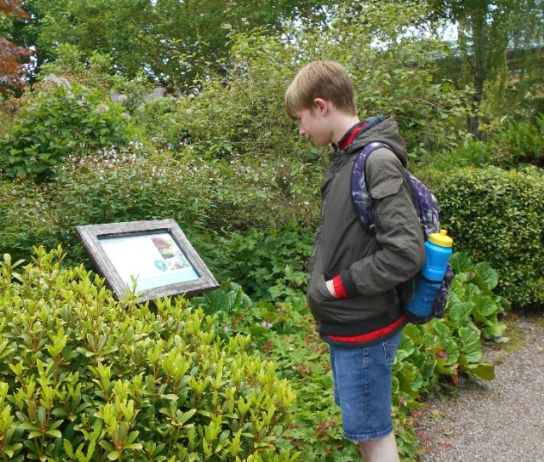
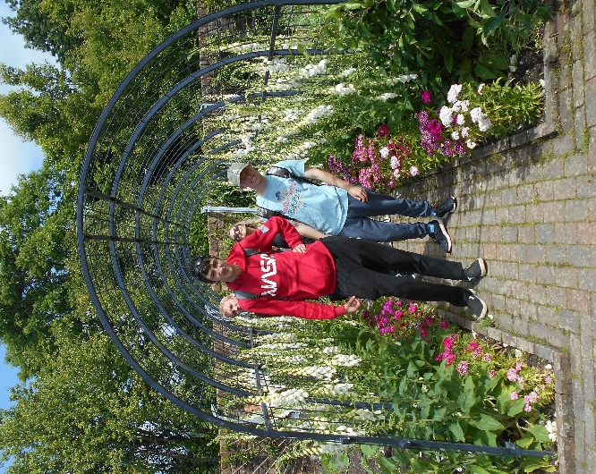
The most recent group to go out was the Hospitality and Catering group, who were led by James Bell to the Devon County Show. The group enjoyed visiting all the stalls, which included street food, artisan producers, local produce and live cooking demonstrations. None of the students had attended the County Show before, and it certainly got their attention and had the Wow! Factor!

Students get their wheels
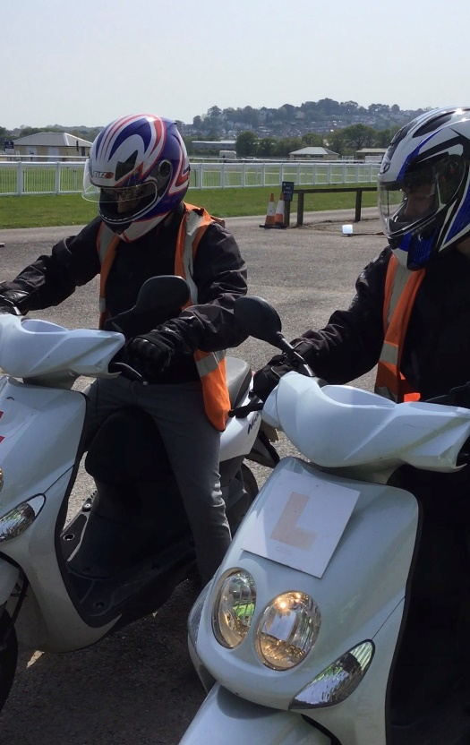
Three students plus Kieran Blake (Hospitality and Catering Apprentice) underwent the Compulsory Basic Training and assessment for motorcycles earlier this term at Newton Abbot Racecourse organised through PGH Motorcycles (now Davant Motorcycles). Three were successful in obtaining their certificate which allows them to ride on a public highway – Jake Williams and Bradley Cox at 50cc level, and Kieran Blake at 125cc level. This is viewed by us as a massive step towards achieving greater independence, and we are keen to encourage this where appropriate. Potentially it enables students to look for work much further afield and in more rural, hard-to-get-to places. Well done to all concerned. A number of students have also been taking driving lessons, either independently or through the Nick Grant School of Motoring, with whom we have a partnership.
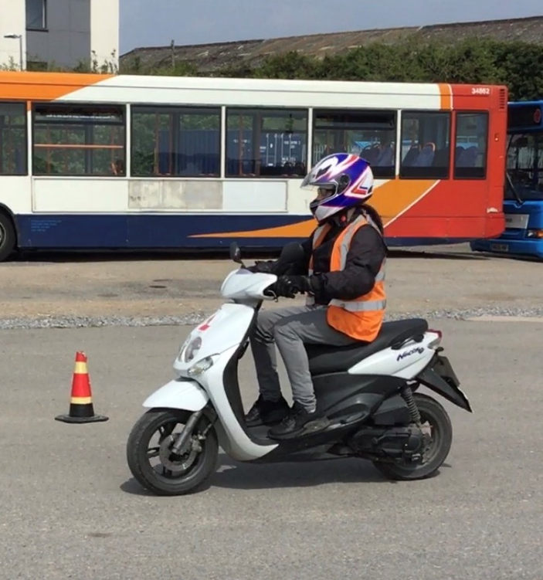

Ten Tors back again!
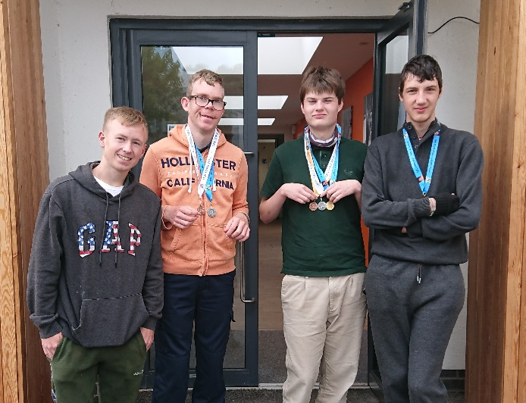
It was great to see the Ten Tors event back again and to see teams training on Dartmoor. Four sixth formers signed up for training and were successful in finishing their routes on the day of the actual event in May. The students, who all gained medals, can be very proud of their achievements, and for Jacob Hughes, it was a case of his patience paying off as he began Ten Tors before the pandemic but this year was successful for the third time, gaining himself a gold medal. The four students, pictured below were (L to R) : Daniel Lock (P1), Matthew Roberts (P1), Jacob Hughes (W2) and Jake Brimicombe (P2). It was job done for Jacob, who has now left the sixth form, but no doubt Dan, Matthew and Jake will be back again next year!

Employers in for Mock Interviews
Just before half-term we held a series of mock interview mornings for Sixth Form students, and around a dozen employers from the NHS, Groundworks, Winners Gym, TCS and elsewhere came in to put the students through their paces. This is always a useful exercise and for most of the W students this year included a ‘virtual’ interview as these are becoming more and more common. As always, the students acquitted themselves with great merit.
College beckons for some
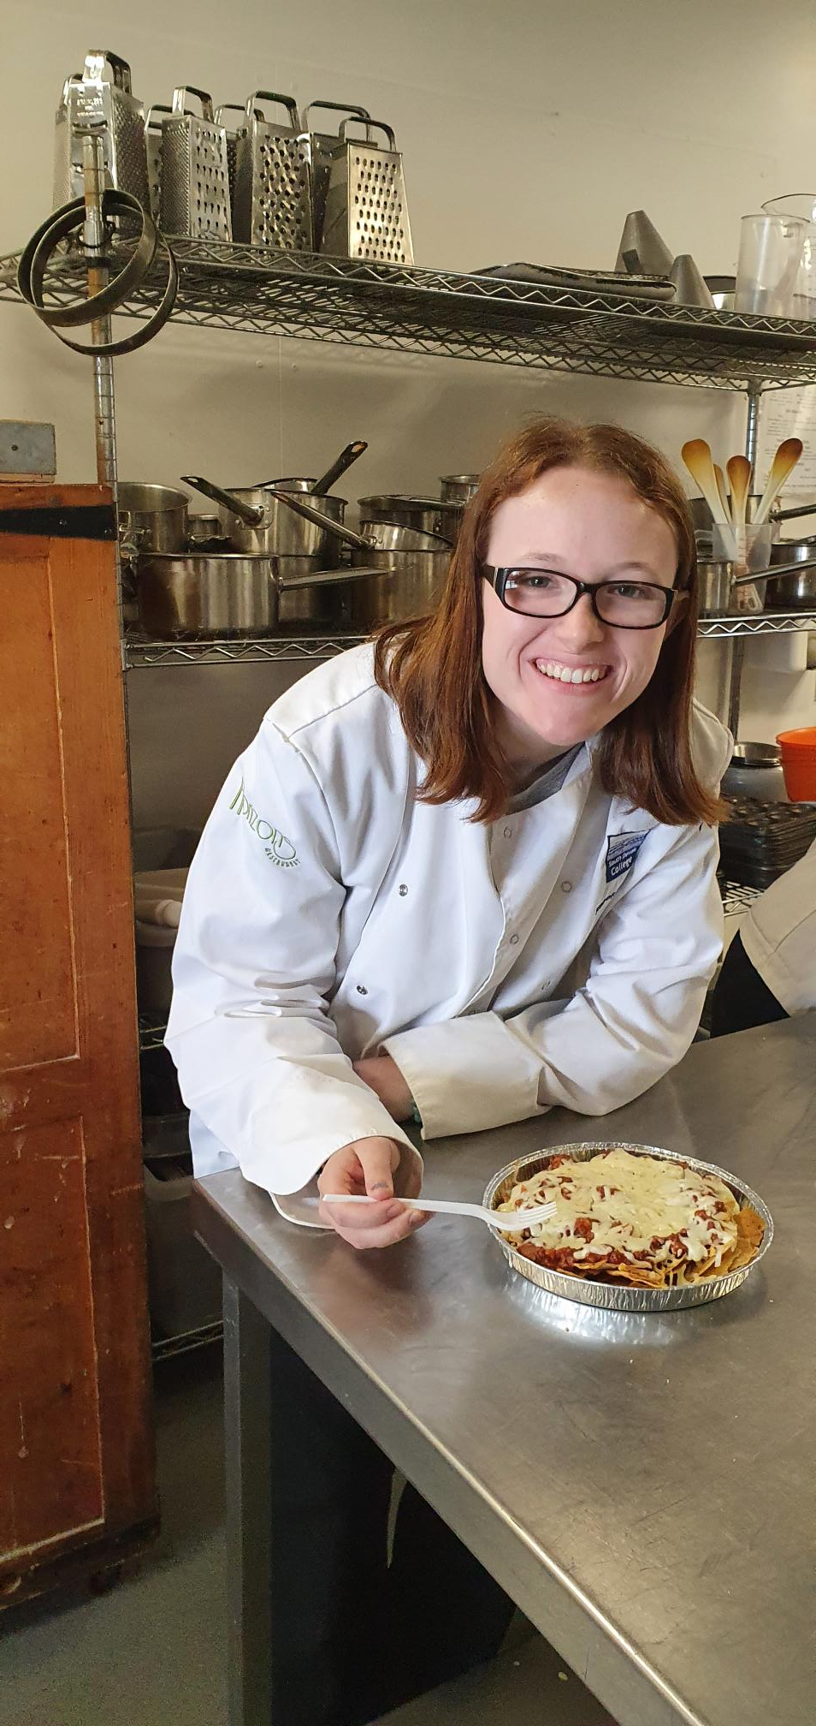
Several students are leaving us this year to go to South Devon College – Anastasia Bowles, Chloe Hart, Anya-Mae King, Ellie Jackson, Aimee-Jo Slade Duley, Chris Kaye and Luca James. Others are going further afield – Jake Williams (apprenticeship) and Andrew Carter to Exeter College, Eli Mason to Duchy College, Kiemera Clark to Bridgwater College, and Jacob Hughes to Kingston Maurward College in Dorset. We wish them all very well, and hope they are happy and successful in their new learning environments. Pictured right is Chloe Hart on one of her taster days at South Devon College. Several other students are going to be benefiting from specialist provision at ROC College (Robert Owen Communities) which we hope will help them achieve their next step.

News of Ex-students
Word on the grapevine tells us that Thomas Hocking is doing well in the Royal Marines, Jessy Motteram is still in the army having transferred from logistics to artillery; Kelley Behan meanwhile is getting on really well at ATS Tyres and Exhausts and hopes to become full-time when the manager steps down and takes a back seat. Tom Houghton is now doing labouring with MBS Building Services and Connor Johnson is full-time at Kenmart Building Supplies. Ben Barker is frequently seen driving a Stagecoach bus around Torbay and South Devon, whilst a quick visit to Sainsbury’s enabled me to run into Francesca Pym and Matthew Carpenter working. Great to hear!

Mini-work projects thrive
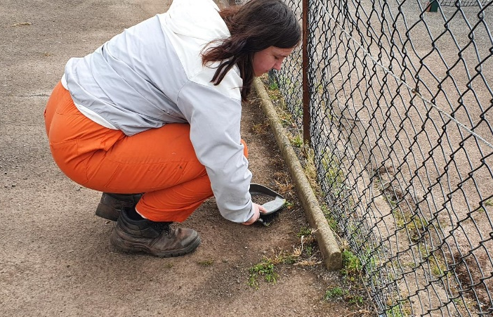
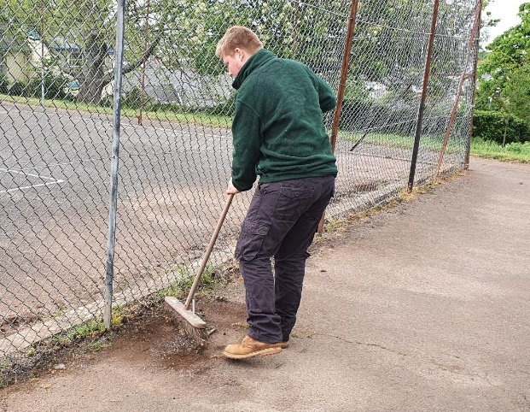
The mini-work projects for P students organised in partnership with Groundworks have continued to thrive this term. Students have worked on a regular basis at sites at Westerland Valley, Paignton, and St Mary’s, Brixham, on a variety of tasks including general maintenance, clearing, grass and hedge trimming, strimming, painting and litter picking. For those students who are not quite ready to go out on an individual work placement, these projects form an excellent starting point to undertake real work in a real work setting. We are very grateful to the partnership that has been established with Groundworks, and wish to work to maintain and further develop this link. Megan Mace and Brandon Breen are pictured here sweeping one of the areas at St Mary’s, Brixham. Students in the P groups will continue to benefit from this provision next year.

New partnership with SWISCO bears fruit
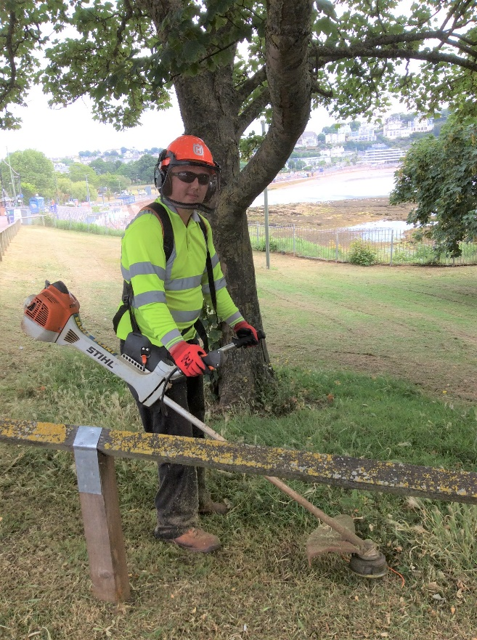
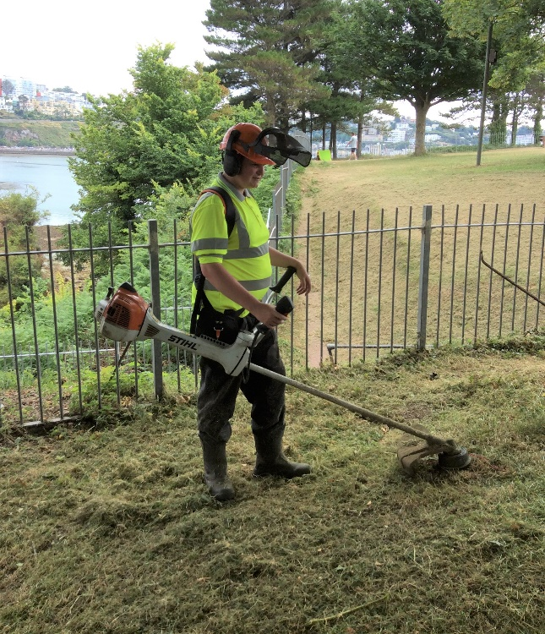
We are delighted to announce that we’ve entered into a new partnership with SWISCO (South West Integrated Services Company) and this is already bearing fruit. Joe Francis (Horticulture pathway student) and Callum Taylor-Pratt (Horticulture apprentice) have been working with their open spaces and grounds maintenance team two days a week, with a view to eventually being offered paid employment there. Joe and Callum have made a great start to this project, and have been reliable and enthusiastic about their new working environment. This is exactly the kind of partnership we need for our students. Pictured are Callum (left) and Joe (right) busy at work strimming some of the grass areas near Corbyn Head, Torquay.

Crazy Golf social a big hit!
A large group of students took advantage of the summer term social event at the Pirate Crazy Golf at Paignton held earlier this term. Students enjoyed their round of gold whilst socialising before having a bite to eat at a nearby café. As always, staff were on hand to provide light-touch supervision, but the students yet again displayed very grown-up and mature behaviour. Thanks to the staff who volunteered to help out on the evening.
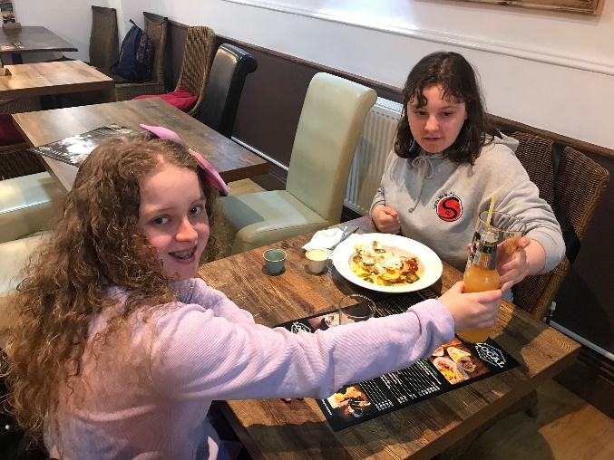
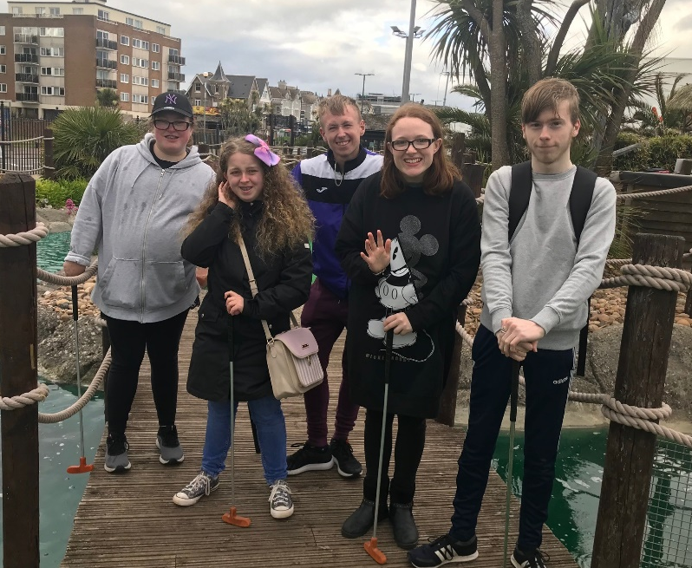
Ellie and Anya-Mae enjoying a bite to eat

Fitness activities prove popular
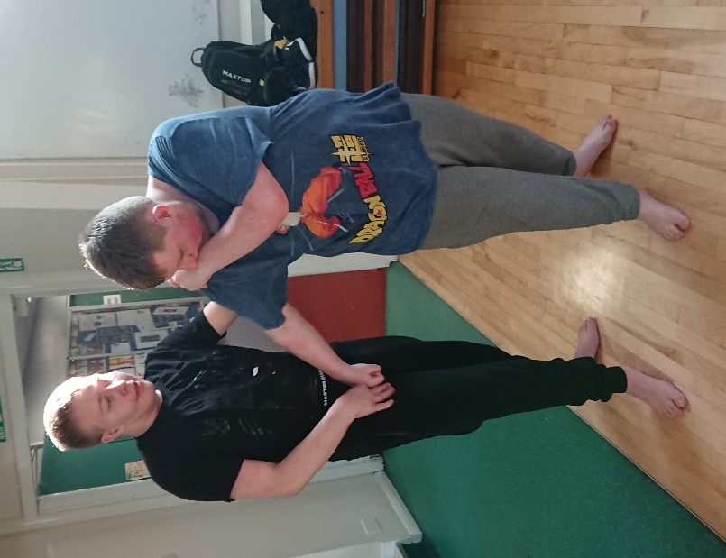
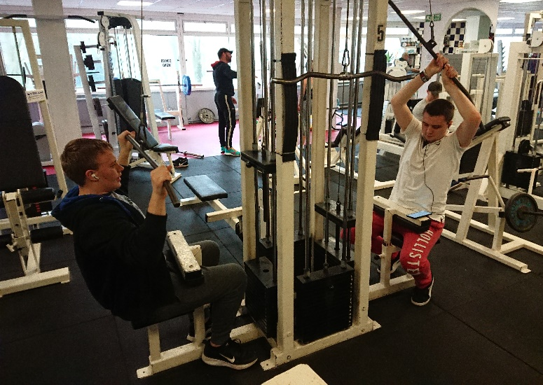
Sixth Form students have continued to benefit from the extensive range of choices offered to them off-site during their fitness and leisure sessions. The P groups have been visiting Torbay Olympic Gymnastics Club, Winners Gym and Torquay United Indoor Bowling in small groups in a half-termly rotation, whilst members of W1 and W3 have been accessing self-defence classes taught by Antony Lees, a local martial arts instructor, and visiting Parkview Fitness Gym in Torquay. Members of W2 meanwhile have participated in self-defence sessions, regular sessions at ParkView Fitness Gym and swimming at the Riviera Centre. Several students have been inspired to buy their own gym memberships as a result, and many have noted their fitness levels have improved. 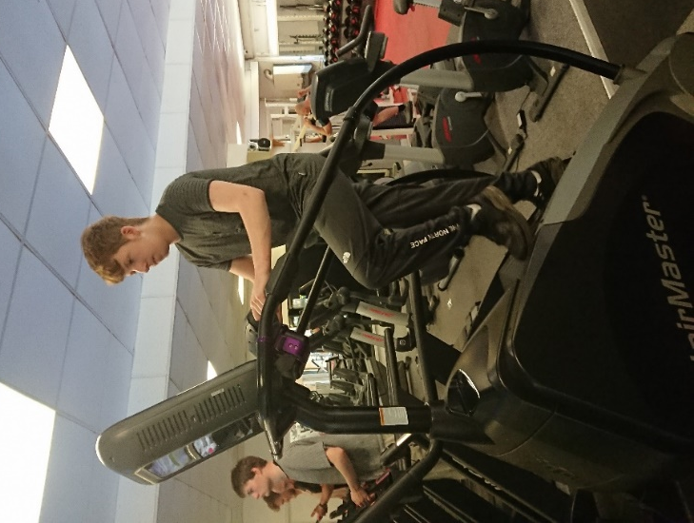

Farewell to popular teacher
The end of term marks the end of an era as we say farewell to Vicki Monnington, who has taught English at the school for the last 18 years. During her time with us, Vicki has also taught Employability, PSHE and Citizenship as well as being a form tutor, showing a great care and interest in ensuring that students leave school with something appropriate to progress to. Vicki has played an important role in the development of the Sixth Form, being the class teacher of the very first sixth form class when the Sixth Form began eight years ago, and led some of the early sixth form residentials to Europe. We are very grateful for all her hard work over the years and wish her all the very best of luck for the future!

Edward W Thompson
(Head of Sixth Form)

HAVE A GREAT SUMMER EVERYONE – SEE YOU BACK IN SIXTH FORM IN SEPTEMBER!

