SIXTH FORM SPRING TERM NEWS REPORT 2023

Apprenticeship show stirs interest

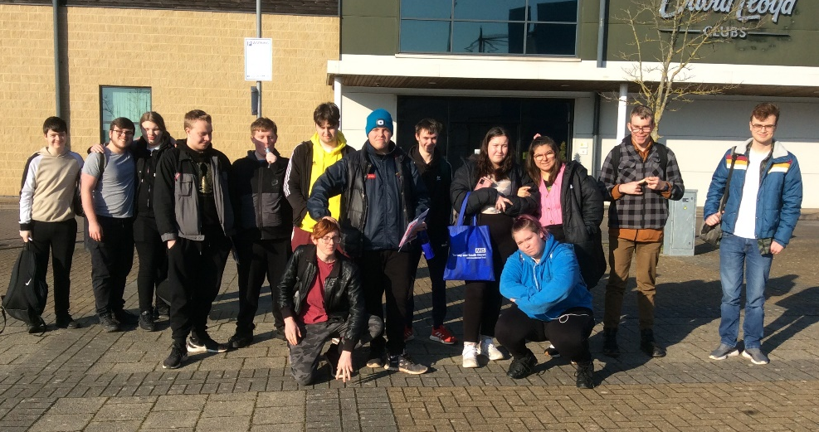
A group of sixth form students, along with a large group of students from Key Stage 4, ventured to Sandy Park, home of Exeter Chiefs, in January to take in the National Apprenticeship Show. This is a popular event with students and introduces them to a wider audience of colleges, employers and training providers than they would normally come across. The trip, organised by Mr James, came hot on the heels of our own Post-16/18 Information event for parents in school organised by our Careers Adviser, Steph Morgan. The aim of these events is to raise students’ awareness of the opportunities out there for them once they leave the sixth form. It certainly generated a lot of interest!

Trip to concentration camps proves life-changing
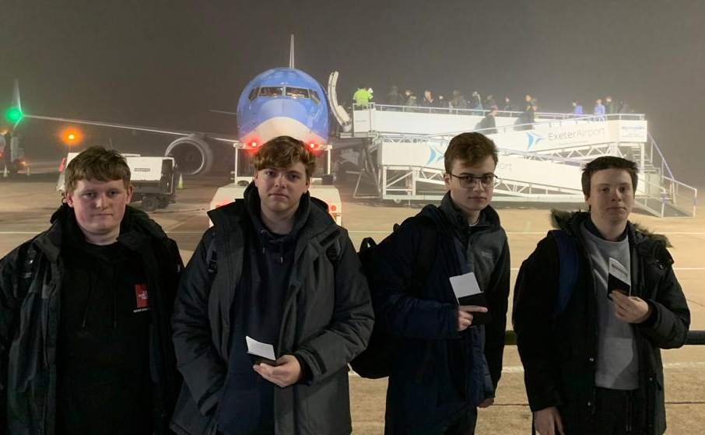

For the first time since the pandemic we were able to nominate students for the Lessons from Auschwitz project, a unique scheme run by the Holocaust Educational Trust designed to inform young people about the impact and legacy of Nazism in the Second World War. We were fortunate enough to have four students accepted onto the project, and on a cold morning in early February, Ryan Knapman, Logan Taylor, Ben Waymouth and Jake Burston met with Mr Lock at Exeter Airport for an early morning flight to Krakow for what proved to be a life-changing experience.

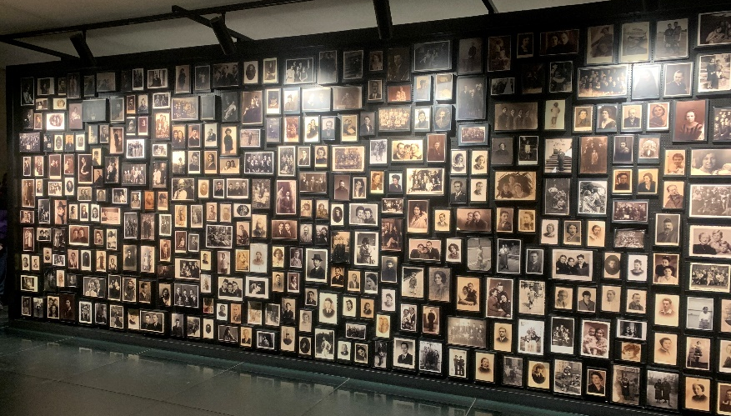
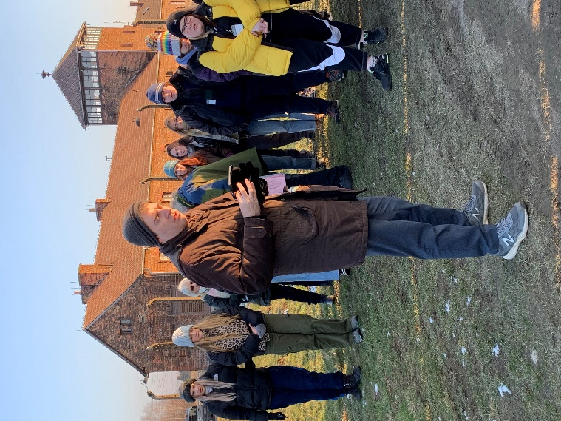
It is difficult to relate in words what the students experienced during their short stay, but suffice it to say that the visit to the Auschwitz and Birkenau camps contained much to focus the mind. There was an inspirational talk by a rabbi on the subject of love and hate (see left), there were collections of personal possessions confiscated by the Nazis, and displays depicting images and names of millions of Jewish people who lost their lives.

Having prepared thoroughly for the trip the students have, since their return, focused on their role as ‘ambassadors’, feeding back on their experiences to different groups – the sixth form, Key Stage 4 and finally the school governors. All four students deserve credit for their mature approach and the way they handled the experience.

Retail students flourish
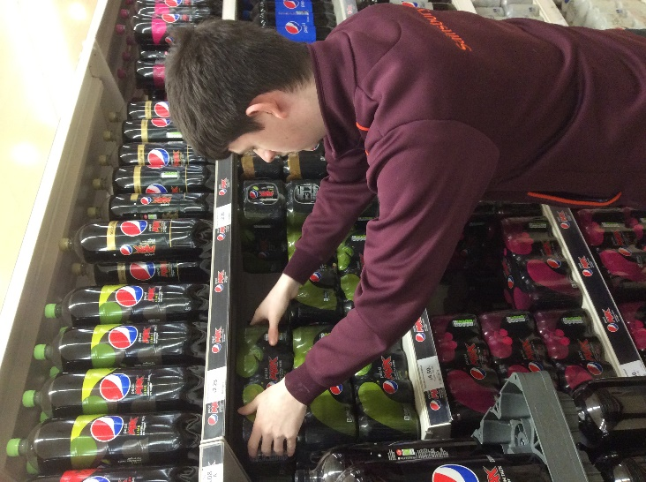
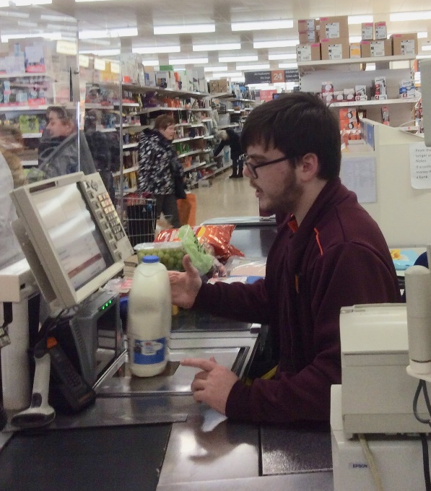
Our retail students continue to flourish as they work towards their vocational qualification and simultaneously gain the competencies necessary for working in a busy retail outlet. Logan Aldworth (pictured below working on the till), Riley Tooley (below left on soft drinks) and Oliver Taylor all picked up paid seasonal work at Christmas at the Sainsbury’s store at the Willows in Torquay, and are now building up their knowledge and skills across the whole range of departments in-store. This will put them in a great position if any part-time paid positions become available in the coming months. If successful, they will follow in a long line of former students to gain employment in the store including Matthew Carpenter, Coral Nelson, Ffion Shore and Francesca Pym. Retail remains one of the best occupational sectors for our students to gain jobs in – long may it continue!

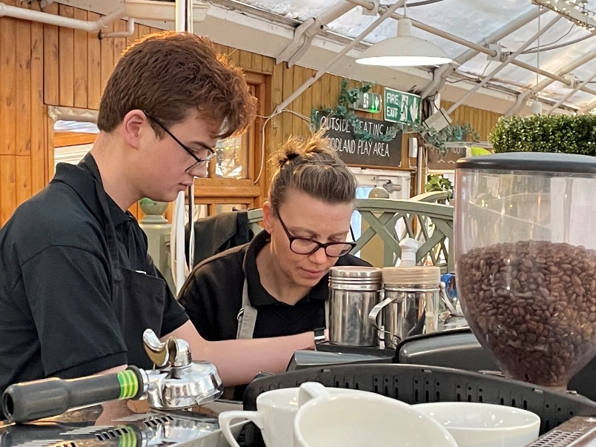
Another of our retail students, Ben Waymouth, who excelled at Sainsbury’s last year but now has his work placement at Fermoy’s Garden Centre
Has been adding barista skills to his portfolio of experience – a real advantage if he ever wants to apply for work at Costa Coffee, Café Nero or Coffee one. Ben’s outstanding customer service skills have been rewarded with paid work at weekends at Fermoy’s which he has been doing for several months now. Another ex-student, Amelia Savage, works in the same café.

Students gain paid work

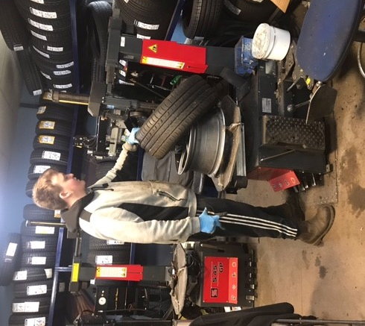
Around a dozen sixth form students do regular paid work in their own time. Chelsea Walters and Luke Marks (pictured below with his Employee of the Month award) already both work at Paignton McDonald’s, whilst Charley Ross (below right) has recently been offered Saturday work with his work placement employer, TTS Tyres and Exhausts. On top of this, Ben Waymouth (Fermoy’s), Bradley Cox (a club in Newton Abbot), Bradley Kersey (Hoseasons Holiday Park) and Morgan Quin (Ocean Leisure) all have regular part-time jobs. Some of the students have got these jobs as a result of performing well on their work placement, whilst others have independently gone out and applied for vacancies they have found.

We would ask all parents to consider whether their son or daughter is ready to take on this important step, and if so encourage them to keep their eyes open for suitable opportunities. It would be an amazing achievement if we could get half of the sixth form into part-time paid employment!

New work placements show promise
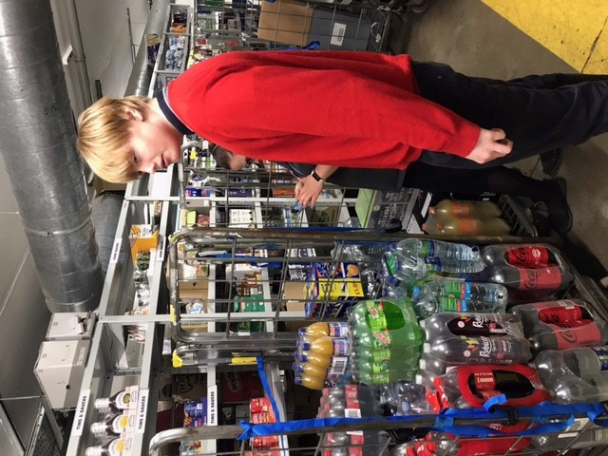
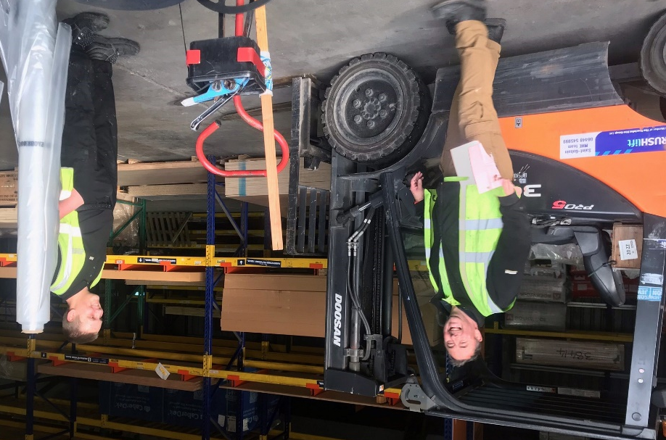
A number of sixth formers have got new work placements that they are attending, and the early signs are that things are going very well indeed! Jordan Orchard-Barker (below left) has settled in very well at Jewson’s, while Cameron Fraser (below right) has made a positive start at the Co-op in Dawlish. Other students embarking on a new challenge are Bradley Cox (bottom left) at Somerforde Residential Home in Newton Abbot and Ryan Knapman (bottom right) at Eden Vauxhall in Torquay.
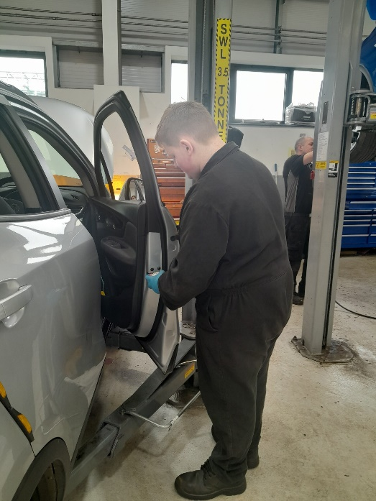
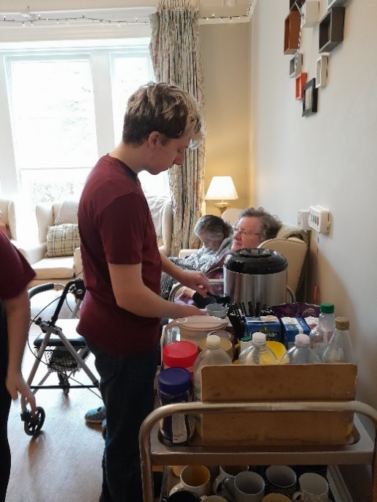
Well done to all students who are starting something new – hopefully they can build on their experiences in the coming months to become old hands.

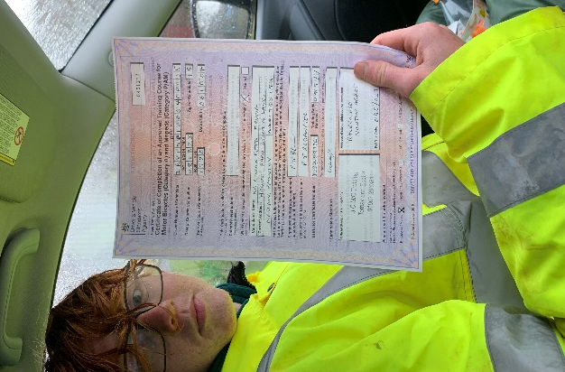
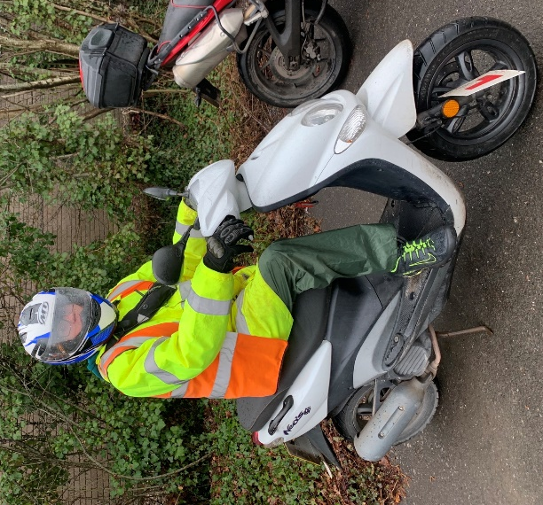
Connor gains CBT certificate
Connor Irving recently spent the day at Newton Abbot Racecourse on a 50cc motorcycle training and assessment course, and passed with flying colours. As the proud owner of a Compulsory Basic Training certificate, he is now legal to ride a machine of that size on the road.
Students love going to Dawlish
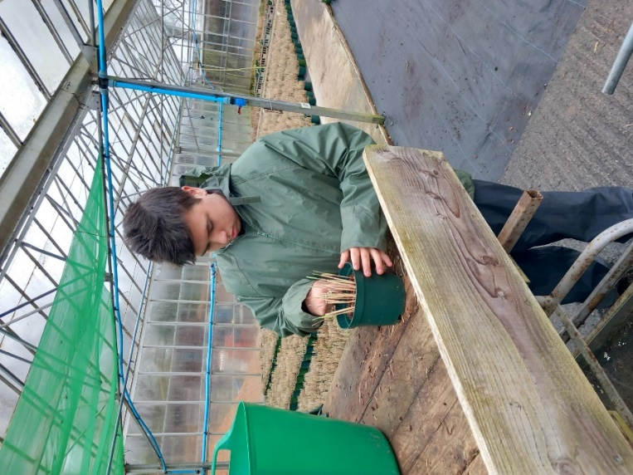
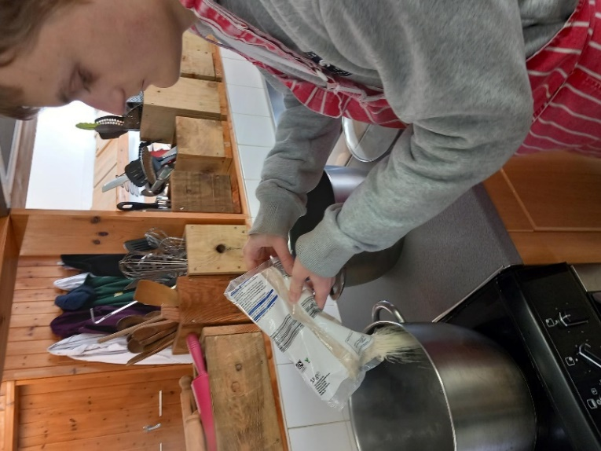
A dozen students on sheltered work placements have benefited from regular attendance at Dawlish Gardens Trust this term, and from having a go at the huge range of practical tasks on offer there. From Animal Care to Horticulture, from tractor driving to weeding, and from arts and crafts to small projects, there isn’t a spare moment to be had and the students have been actively engaged throughout their stay.

Clockwise from top left are Cameron Avery preparing animal feed, Teddy Pritchard potting, Logan Taylor driving the tractor and Matt Roberts pruning. In the centre is a wishing well made by Tilly Collett.

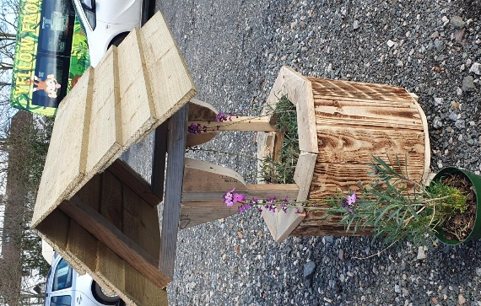
WELCOME TO
DAWLISH GARDENS
TRUST
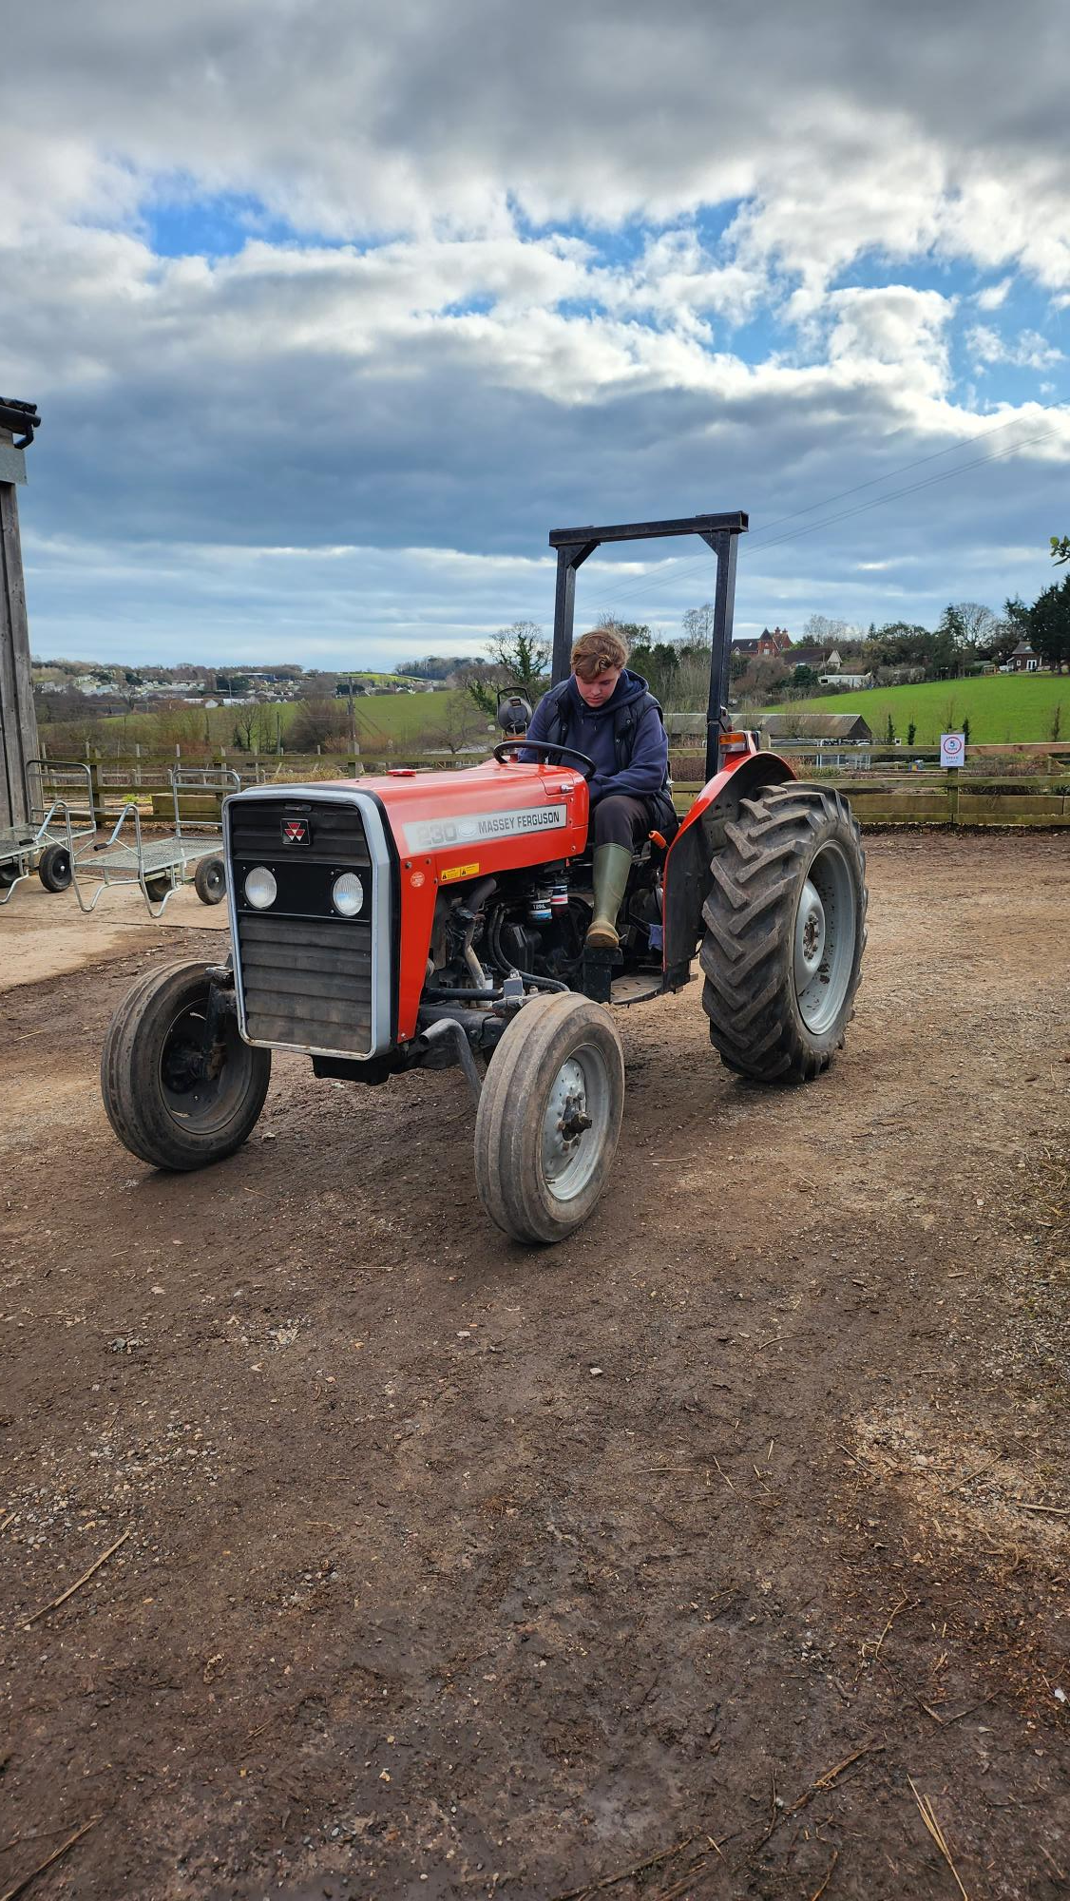
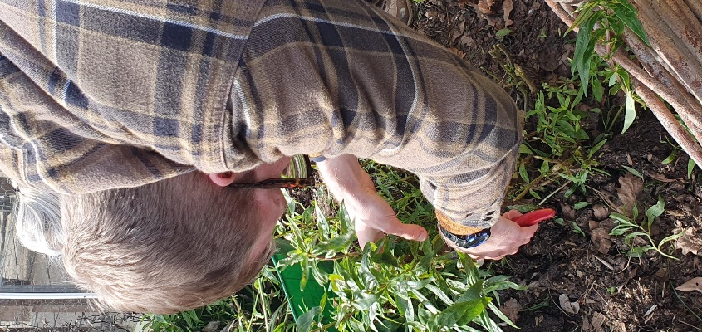

Partnership with Groundworks yields fruit
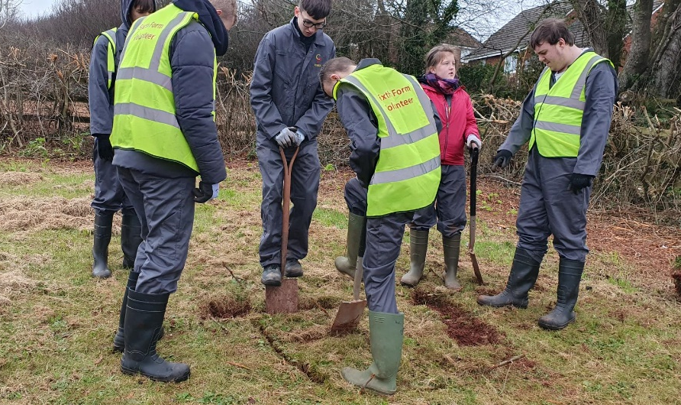
The Preparation for Working Life students going to Westerland Valley in Paignton to volunteer with the Groundworks organisation have been instrumental in completing a number of exciting and worthwhile projects this term.

Corey Pollard (right) is pictured with a spade digging the first layer of turf up for which finished up as a large hole in which to plant a tree.
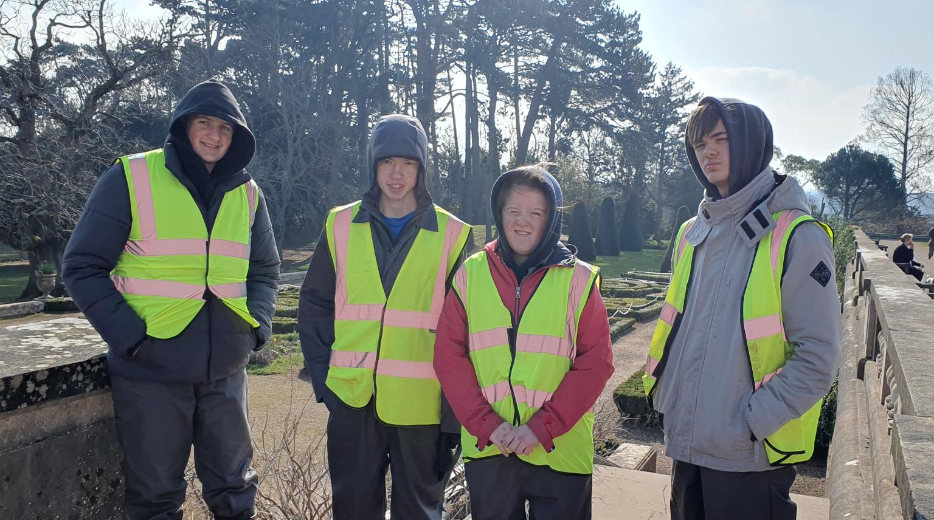

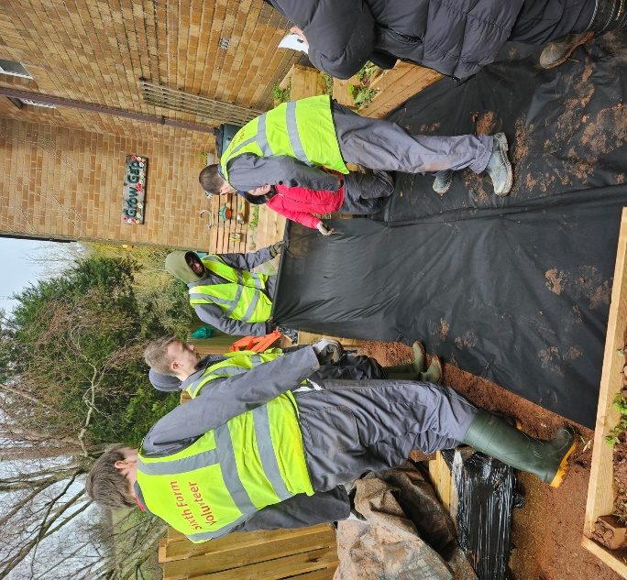
A group of Work Skills students checking out the work that needs to be done in future at a new site at Oldway Mansions in Paignton.

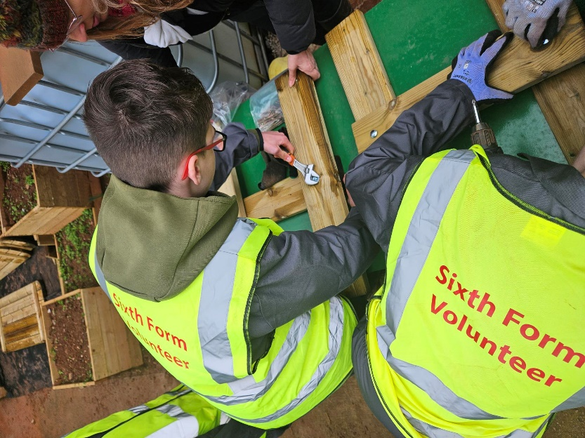
Some of the students laying down black sheeting to act as a barrier for weeds (right)

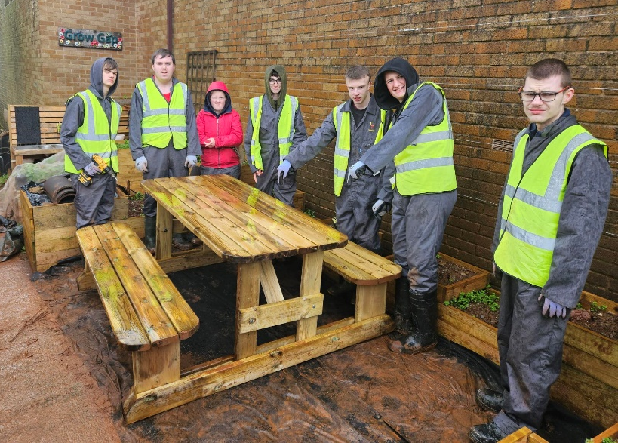

Corey Pollard and class mate getting stuck into assembling a community picnic table which can be seen finished right.
Social events well supported by students

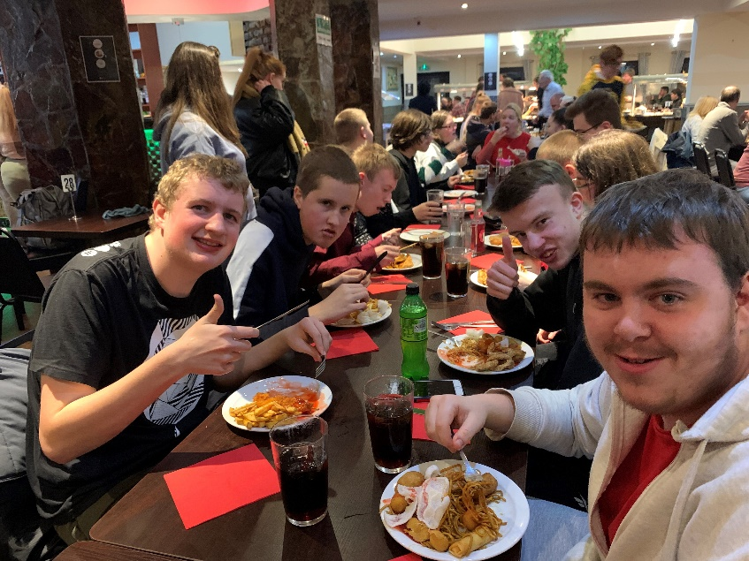
Sixth Form social events continue to be well supported by students. Record numbers paid their money and turned up for the Chinese buffet evening at the Oriental Touch restaurant in Plainmoor earlier this term. More recently, a minibus full of students travelled to the Theatre Royal, Plymouth to see a highly entertaining and fast-paced performance aimed at young people called Birds and Bees, covering issues such as consent, gender and social media. Students are benefiting hugely from these opportunities to socialise with their peers and widen their life experiences.

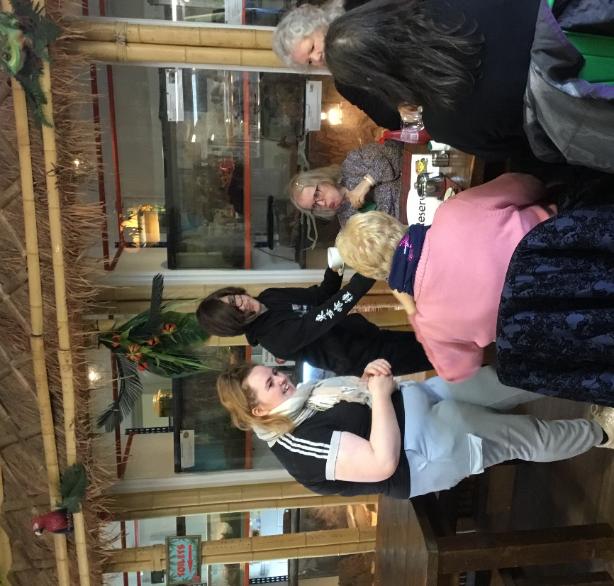
Care students host elderly folk
Our care students have been busy this term hosting elderly residents of a local care home on Friday afternoons. The first event consisted of a lunch of fish and chips in the Yellow Frog Café, followed by a game of bingo with coffee and cake for refreshments. Following up on the success of this event, a pamper session consisting of a hair wash and hand massage followed by a high tea was arranged. Natasha Mildren and Sam Redclift are pictured chatting to some of the visitors. The care pathway in the sixth form now includes a qualification in caring for the elderly alongside the course for caring for children as there are many jobs available working in this sector. Some of our students are very well suited to working with the elderly.
Ryan set for adventure of a lifetime!
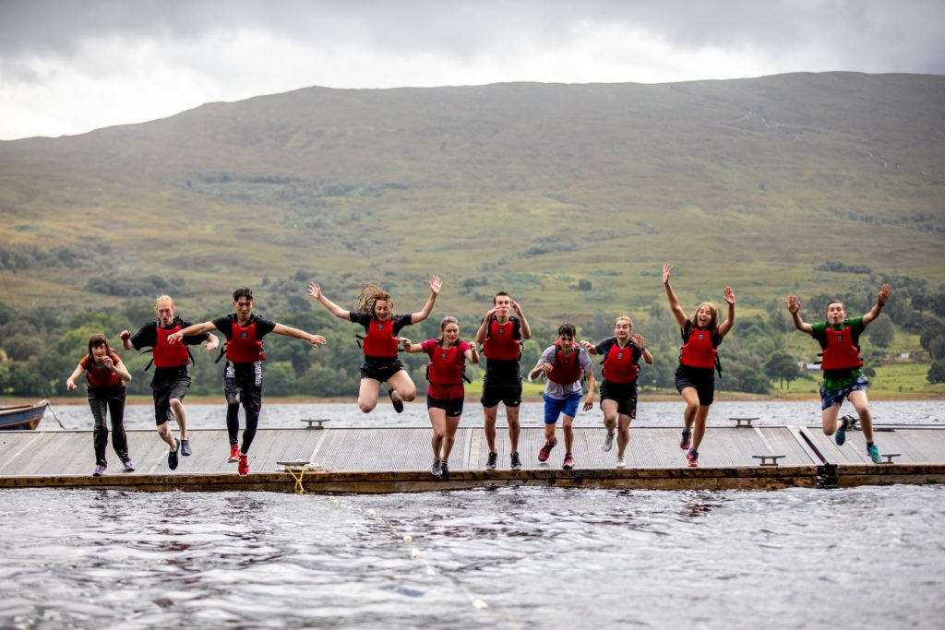
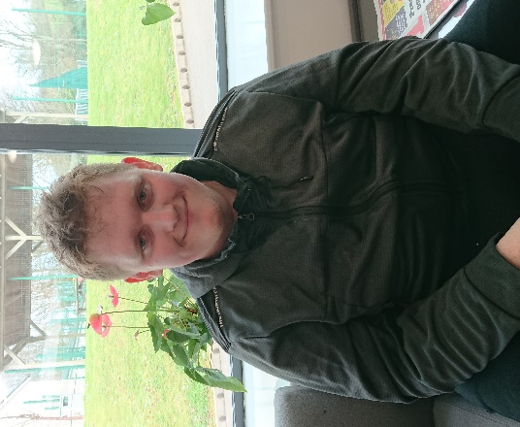
Ryan Knapman, who has not long returned from his trip to Poland for the Lessons from Auschwitz project, will be on his travels again soon – this time to the wilds of Scotland! Ryan applied for a bursary from the Sir Francis Chichester Trust to fund him attending a two week Outward Bound course at the Loch Eil Outward Bound Centre in July. Ryan, who applied last year but was unsuccessful, has been rewarded for his persistence by gaining the bursary second time around.

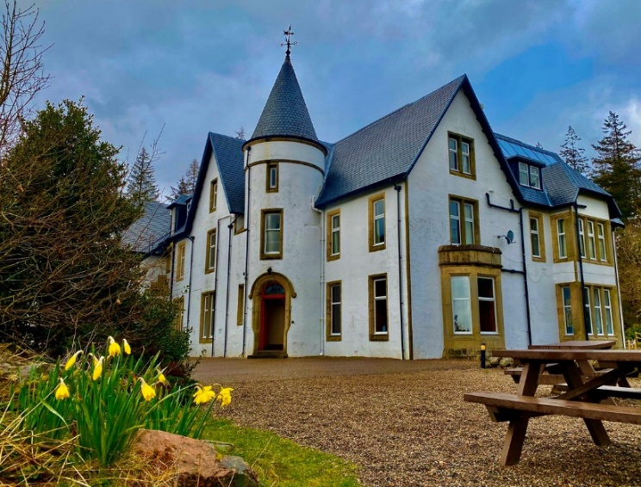
Because of the distance involved (nearly 600 miles from Torbay), Ryan will have to travel by train independently from Newton Abbot to Glasgow Central, changing at Birmingham New Street, and then stay overnight in a Travelodge before meeting up with the other course participants at Glasgow bus station the following morning.

Ryan will be meeting up with other young adults of a similar age and can look forward to a whole raft of outdoor problem solving challenges, water sports, rockclimbing and the highlight of the trip which is a self-planned camping expedition with his group in the Scottish mountains.

This is such a fantastic opportunity and we wish him all the very best of luck. Have a great time Ryan!

HAPPY EASTER TO ALL STUDENTS AND THEIR FAMILIES!

Summer term starts on TUESDAY 18TH APRIL

- Students in P1, P2, W2 and W3 please attend sixth form as normal
- Students in W1 – PLEASE GO TO YOUR WORK PLACEMENT AS NORMAL, unless you normally come to school first for a lift

