SIXTH FORM SUMMER TERM NEWS REPORT 2023

Students leave to make their way in the world
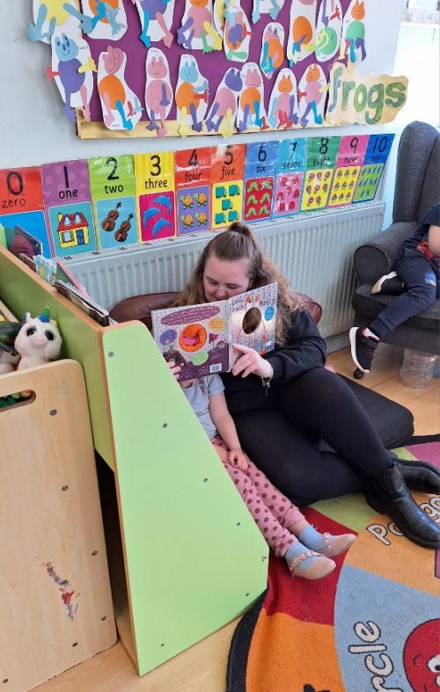
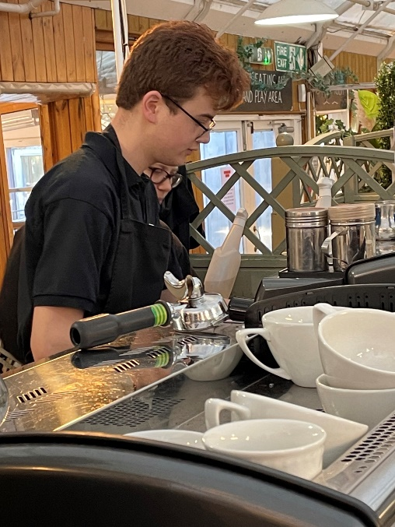
A total of 24 students have left the Sixth Form this summer, nearly half to take up courses at South Devon College of one kind or another. A significant number are leaving to take up paid employment whilst other destinations include ROC College, the Prince’s Trust, LifeWorks College and Mayfield Sixth Form. Students who have secured paid employment include Ben Waymouth (Fermoy’s), Oliver Taylor (Sainsbury’s), Morgan Quin (Ocean Leisure), Joe Francis (SWISCO) and Chelsea Walters (McDonald’s) – Ben and Chelsea have also been successful in obtaining internships at Torbay Hospital on Project Aspire. A few leavers are currently still searching for paid work and/or apprenticeships in their chosen pathway. It has been a year of real progress on the work front with many students excelling on their work placements whilst others have managed to get part-time jobs (Logan Taylor, Martha Minchinton and Luke Marks for example). We wish all the leavers all the very best for the future wherever they are headed, and invite them to keep in touch regarding their progress.
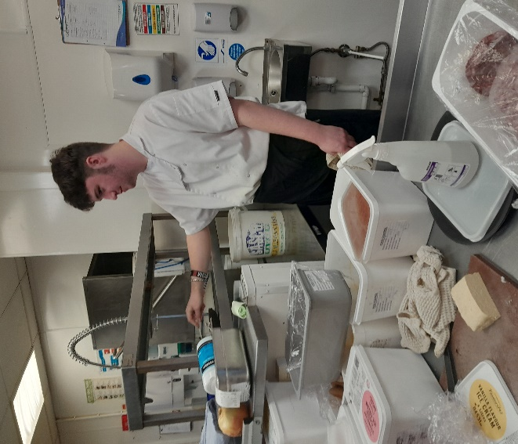
Pictured above are Natasha Mildren working at Southernwood Nursery – Natasha is headed for South Devon College, whilst Ben Waymouth (top right) has secured paid employment at Fermoy’s and has also gained a place on Project Aspire.
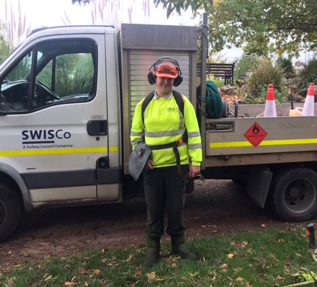

Pictured left is Joe Francis who has been offered
paid employment by SWISCO, whilst Morgan
Quin (above) has been taken on by Ocean Leisure
in Exmouth.

Outdoor adventure opportunities
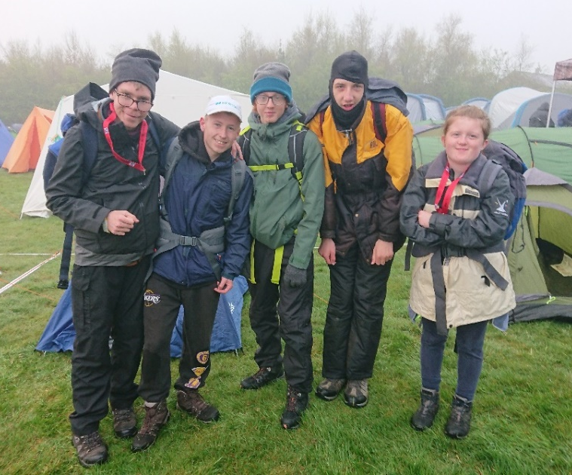
A number of students have taken full advantage of outdoor adventure opportunities that have come their way this term. In late April, five sixth formers took part in the annual Ten Tors Jubilee Challenge event on Dartmoor and successfully completed their routes (15 miles or 11 miles) in under six and a half hours. Pictured just before setting off are Matt Roberts (Gold), Daniel Lock (Gold), Connor Irving (Bronze), Jake Brimicombe (Silver) and Lexi Wilson (Silver).

Declan Harvey meanwhile has been getting a taste of what it is like to sail at sea when he took part in two days of sailing organised for Young Carers based at Plymouth Harbour. The group ventured out onto Plymouth Sound where they were able to experience open water conditions, and Declan apparently took to it like a duck to water and was soon steering the boat and working the ropes like an old pro!

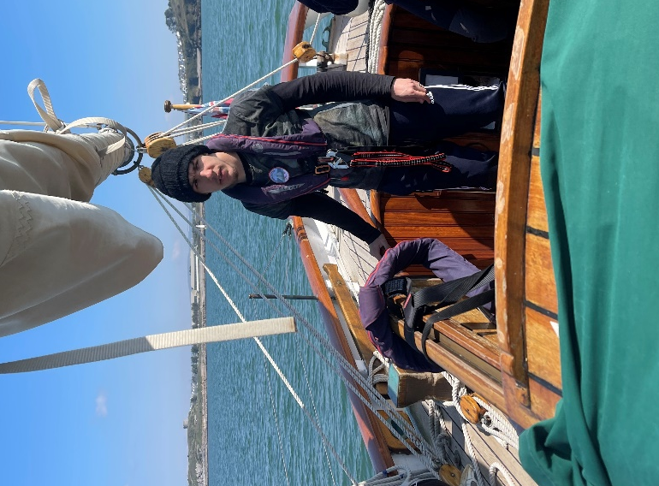
Ryan Knapman, who was also part of the group of four students who visited the concentration camp at Auschwitz back in February, has been on his travels again, this time to Scotland. Ryan, who successfully gained a scholarship from the Sir Francis Chichester Trust, has been on a two-week outward bound course at Loch Eil Outward Bound Centre.

Ryan had to travel alone, boarding a Mega Bus on the A38 near Bovey Tracey (see picture below) to Bristol Airport, taking a flight to Glasgow, finding his way to the Travelodge in the middle of the city and staying overnight before joining the party the following day – a fantastic achievement in travelling independently! The outward bound centre where Ryan has been staying is pictured below right.
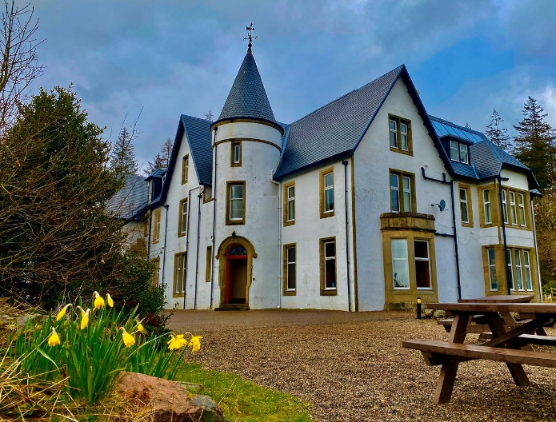
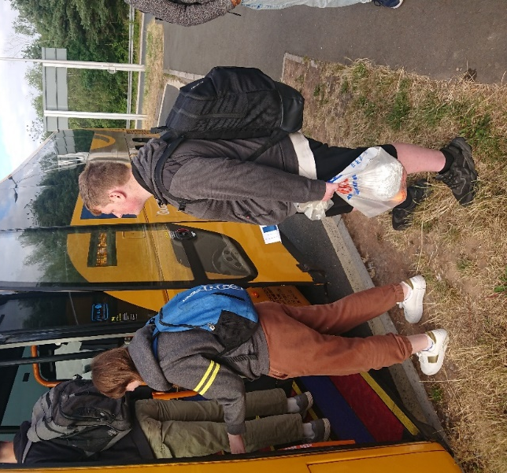

Mock interview days a huge success
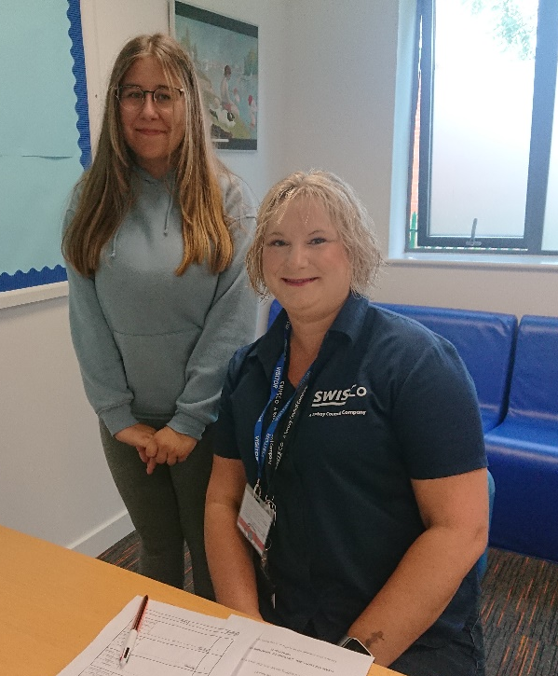
Students were put through their paces earlier this term when we held a series of mock interview mornings where a range of local employers came in and conducted interviews to give students an idea of what it is like to interview for a job vacancy. Students had two face-to-face interviews with different employers and also a virtual interview with another employer in an office that had been set up for the occasion. Not only did the students make a very favourable impression on the employers, one or two did so well that the employers wanted to follow up by offering them a part-time job!
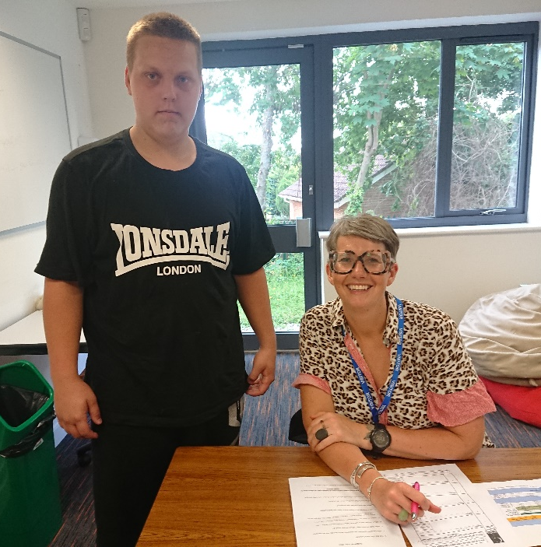
Kourtney Stolworthy is pictured with Donna Glover from SWISCO (above)

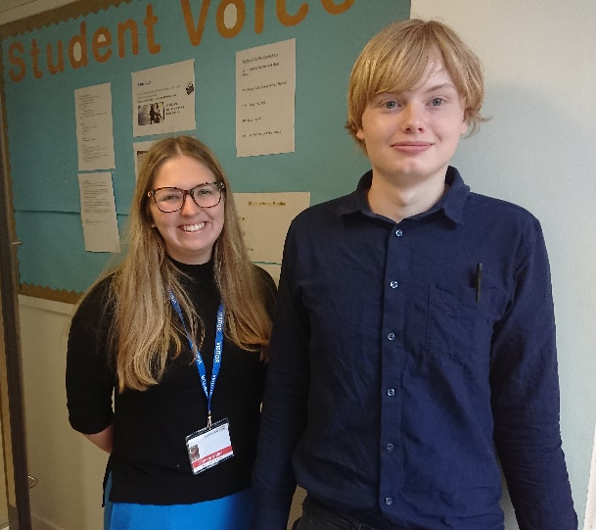
Pictured with Sarah Warrington from the NHS (right) is Jordan Orchard-Barker, whilst Cameron Fraser was offered a job by Amber Waring of McDonald’s (below).
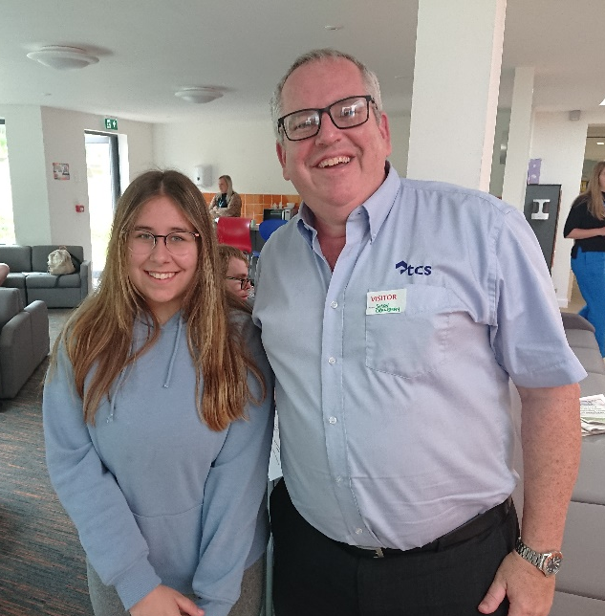
Kourtney Stolworthy (below) had her second interview with Simon Crawshaw from Torbay Clearance Services which is where ex-student Leon Mager works now.

Other employers who helped out on the mock interview mornings were Paul Burness-Moakes (Jewson’s), Beck Featherbe (NHS) and Jo Harris (Torquay United). We’re very grateful to them all for giving up their valuable time and we are delighted with the positive and constructive feedback they gave to the students.

Vocational trips inspire students
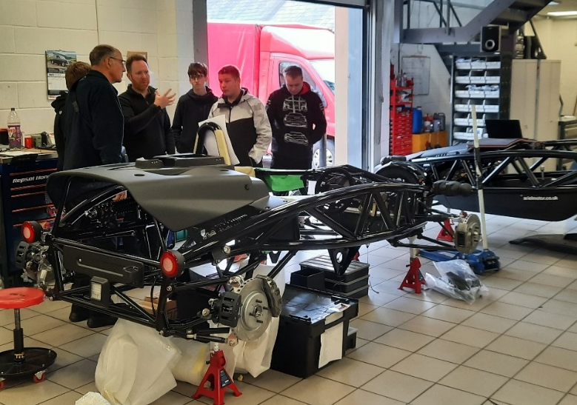
A number of ‘inspirational trips’ took place this term in which students from different vocational pathways were able to go with their tutor on a visit related to their pathway to inspire and give insight. These trips are very popular with students and provide the opportunity to see a different aspect or side of the area they have been studying.

Early this term the Motor Vehicle pathway group spent the day at the Ariel Motor Company in Somerset (right) where they had a tour of the factory. The company, which has been in business well over 100 years, is famous for producing the Atom, a road-legal car that is popular for track racing. The students were able to ask a host of questions about the production process and the business.

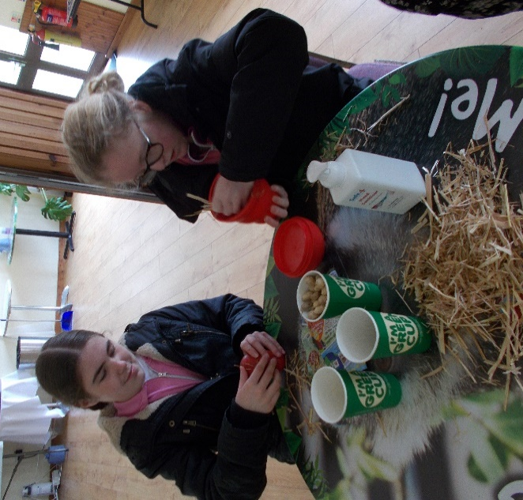
The Animal Care group took off to Monkeeworld in Dorset for their day out, where they were able to observe first hand and learn about some of the 250 chimpanzees, gibbons and orang-utans in the collection there. Students were also able to make up snacks for the animals (see photo left), consisting of seeds, raisins and, you’ve guessed it, monkey nuts! Students enjoyed a great day out and learned a great deal about the life and needs of apes.

Our Construction pathway students (photo below) received the best possible insight into a major construction project when they visited the Palace Hotel redevelopment project in Torquay, courtesy of Brady Construction. The project involves the building of 37 new 4-bedroom houses on the site of the former hotel, and the houses were all at different stages of completion which afforded the students great insight into the building process – they also learned it cost £20,000 per day to keep the site open!

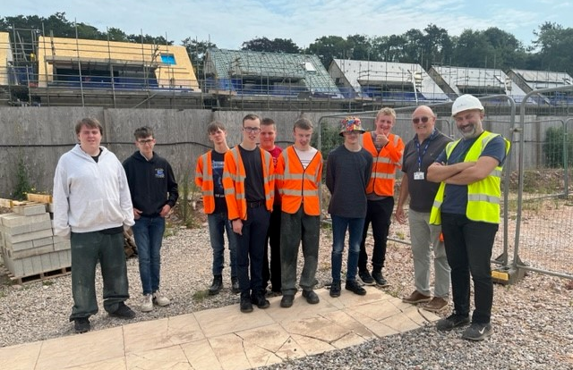
Our Horticulture group visited RHS Rosemoor in Great Torrington, North Devon, a showcase of inspirational gardening practice where students were able to see the spectacular blooms, shrubs and borders. This attraction never fails to disappoint and students were left in no doubt as to how much hard work and tender care goes into cultivating the plants, trees and shrubs they saw. A great day was had by all!

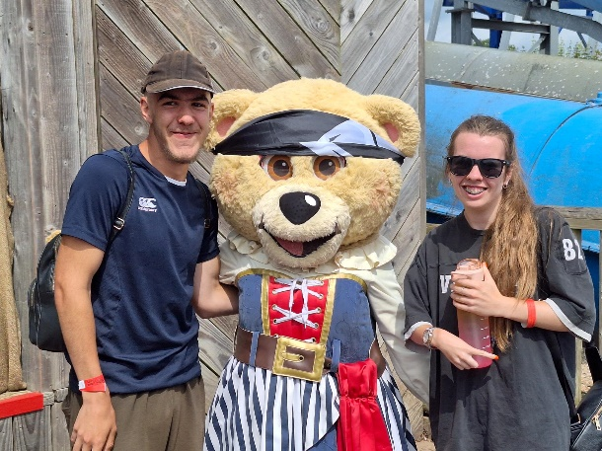
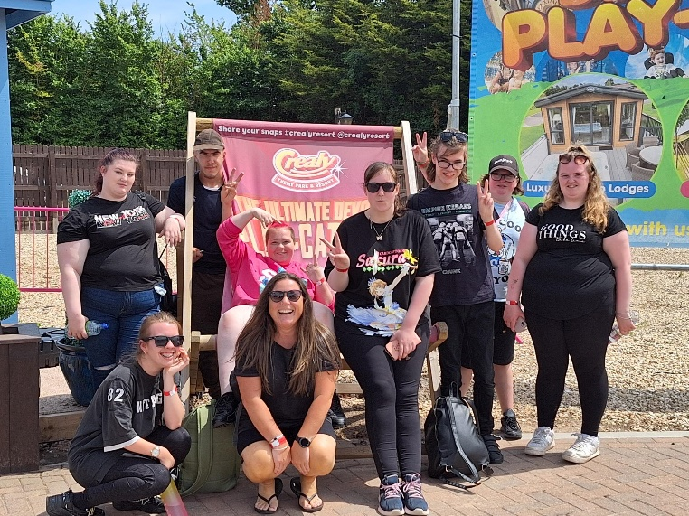
Our Care pathway students (left) took off to Crealy Adventure Park near Exeter for their inspirational trip, not to have a fun day out, but to get a behind-the-scenes tour and talk about how the park aims to engage young children. Students came away having a much better understanding of how a theme park caters for the needs of families who bring children with them.
Our Retail students visited the IKEA store at Sandy Park for their inspirational trip and learned a great deal about the behind-the-scenes operation including stock control, deliveries and pricing. The students asked a lot of questions and were complimented on their polite and interested attitude to the trip.

Work Skills students learn about fish trade
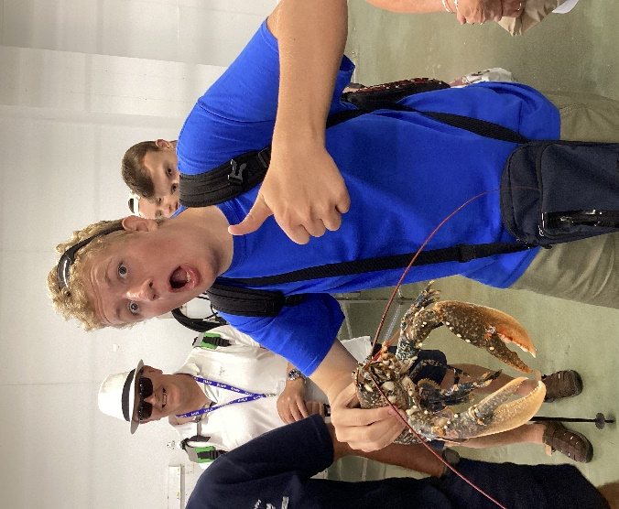
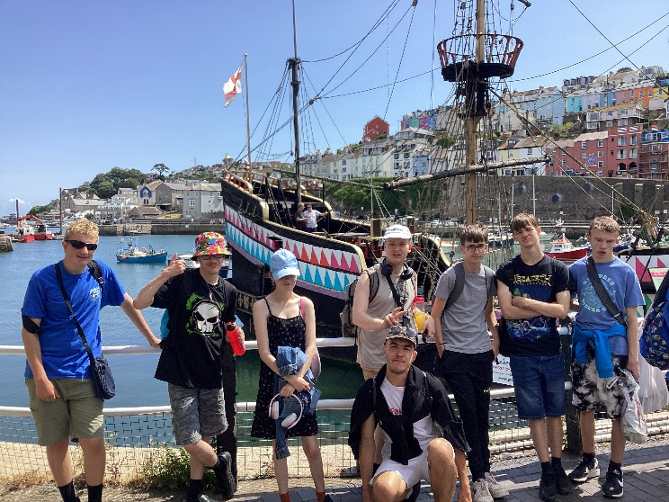
Work Skills students had a day in Brixham learning about the fishing industry and just how important it is to the local economy. Students were shown first hand samples of catch including many of the 40 species of fish caught off Brixham including bass, pollock, mullet, mackerel, bream, whiting, dab and garfish. Students learned that Brixham is the most important fishing port in the whole of England and Wales, as measured by value of catch. There was even an opportunity to hold lobsters and sample freshly caught oyster! All in all, a very worthwhile and rewarding day!

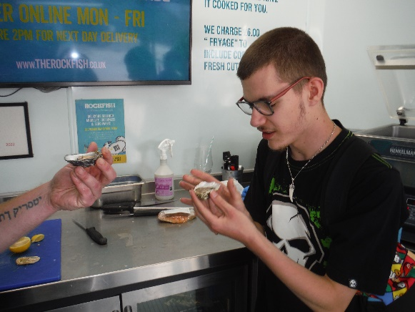

The group (above) at Brixham Harbour, Ben Barber (above right) not too sure about holding a lobster whilst Toby Redclift plucks up the courage to try an oyster!

Foreign trips a big hit!
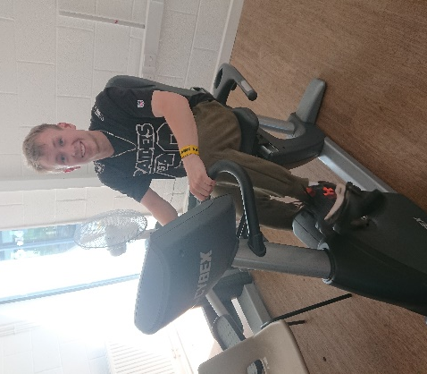
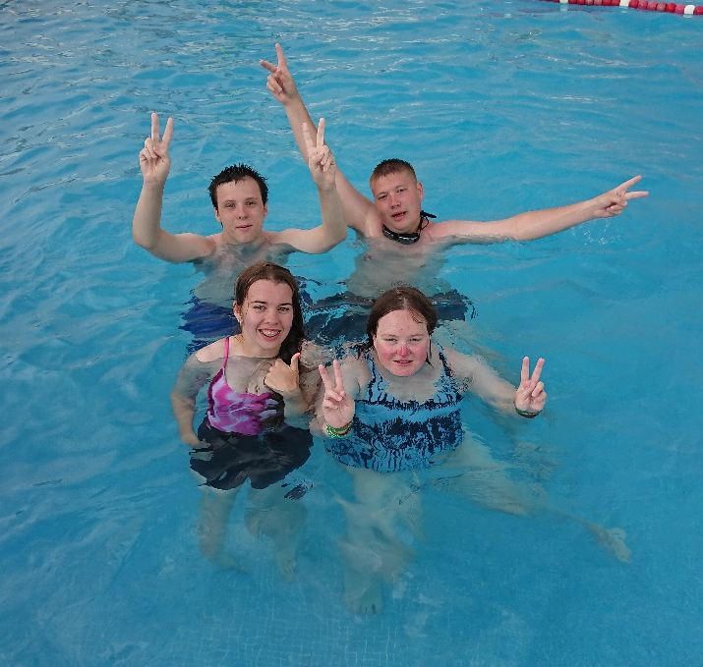
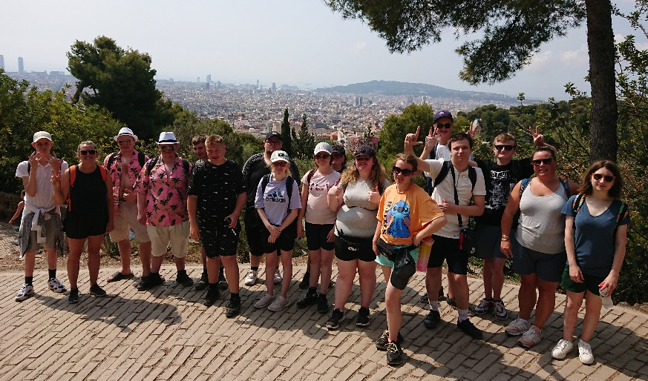
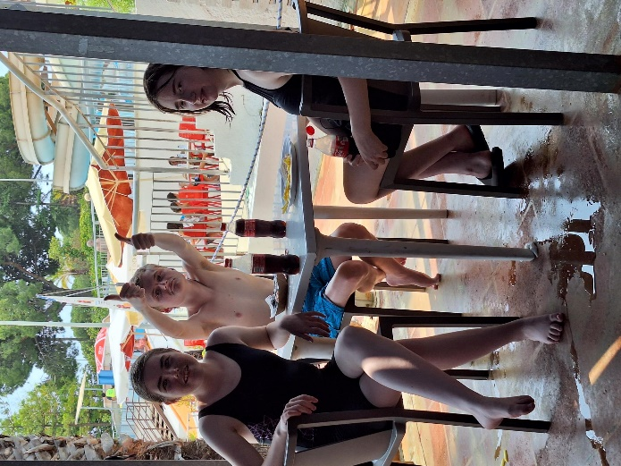
A total of 36 sixth form students went on the recent European residentials, 15 flying out to Barcelona from Bristol Airport for 5 days whilst 21 students journeyed to Paris for an extended weekend that left everyone very tired indeed! The students who went to France were able to take in some of the famous sites including the Eiffel Tower, the Arc de Triomphe and the Louvre, whilst those in Spain visited Guell Parc, Sagrada Familia and took a cable car to Montjuic Castle. The group in Spain also spent a day at the Illa Fantasia Water Park which proved very popular. Students represented the school well and behaviour proved to be very mature and age-appropriate so everyone had a good time. Before the residentials took place, students took part in a row-cycle-run fitness challenge which, together with other fundraising activities, raised a magnificent sum of just over £1000 towards the cost of the trips.

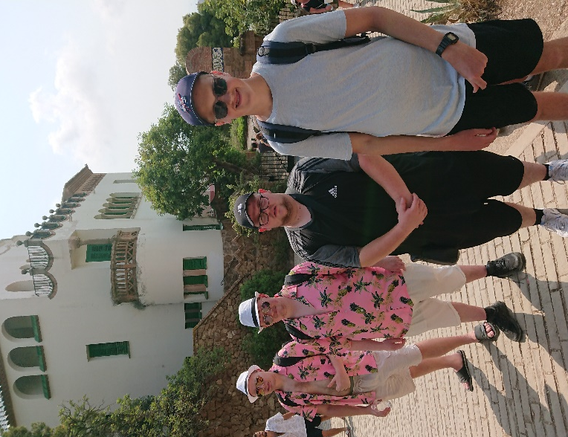

Students enjoying the hot temperatures we encountered in Barcelona (above) whilst Daniel Lock (right) is shown on the exercise bike – Dan made a major contribution to the fundraiser for the residentials.

Dawlish Gardens Trust remains popular placement
Students continue to enjoy going to Dawlish Gardens Trust for their sheltered work placements and reaping the benefits from the broad range of activities they can access there. They get to work with a variety of animals, work on the land and get to use the machinery and mini-vehicles they have there.

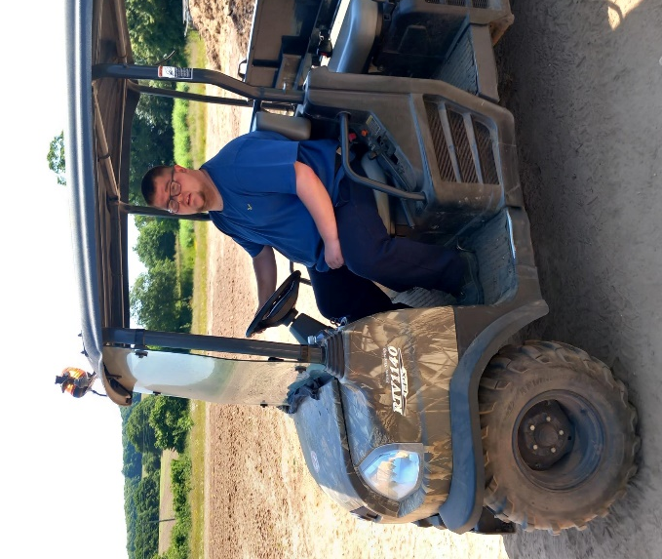
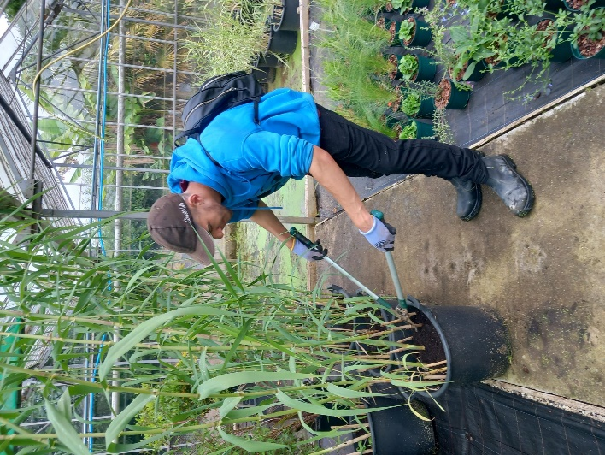

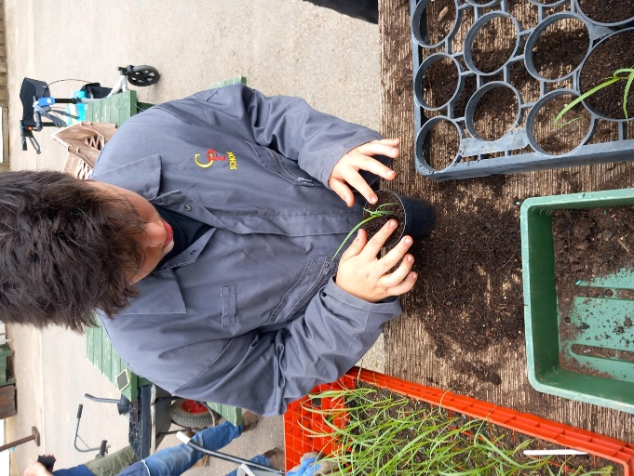
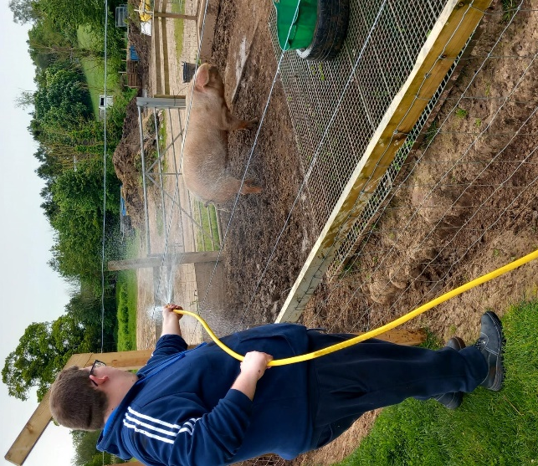

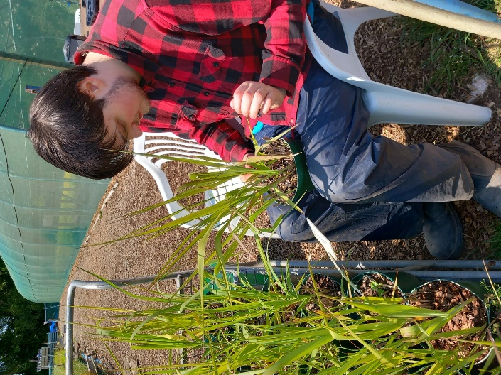

Pictured are students involved in various activities at Dawlish Gardens Trust.

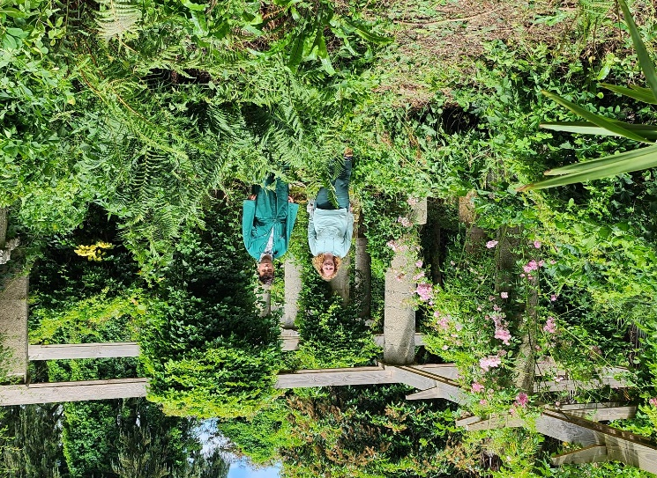

New partnerships
New partnerships are being forged as well as maintaining old ones. Next year, in addition to working with Dawlish Gardens Trust and Groundworks, we will be working at the Italian Garden near Ipplepen (pictured right) and Occombe Farm for the first time since the pandemic. These are exciting projects which bode well for the future.

Social events well supported
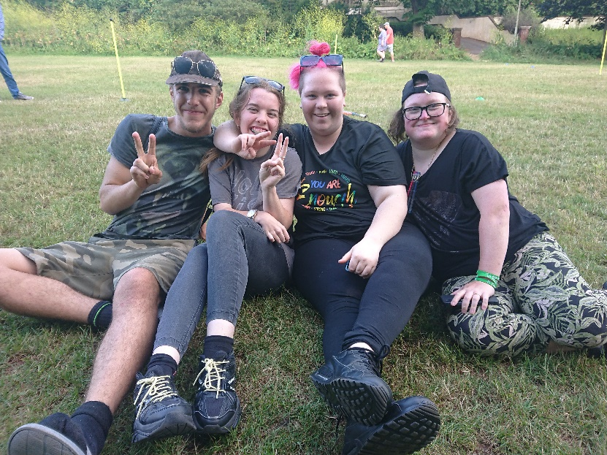
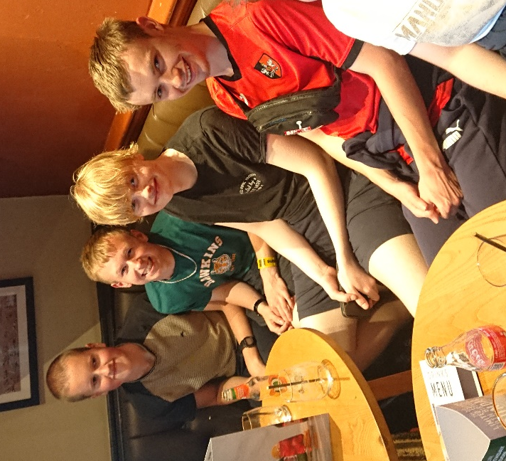
Sixth Form students continue to support the social events we arrange after the school day has ended, proving how popular they have become. Earlier in the term we held a cinema evening in Paignton where students could choose from three different films that were being shown – pictured below left are some of the students enjoying a drink at the Harvester next door before going in to the cinema. More recently, a ‘leavers’ social was organised outdoors on Meadfoot Green (see photo below) where students were able to play rounders and socialise, as well as having some food and drink in the fresh outdoors.
Kirsty and Luke on their travels
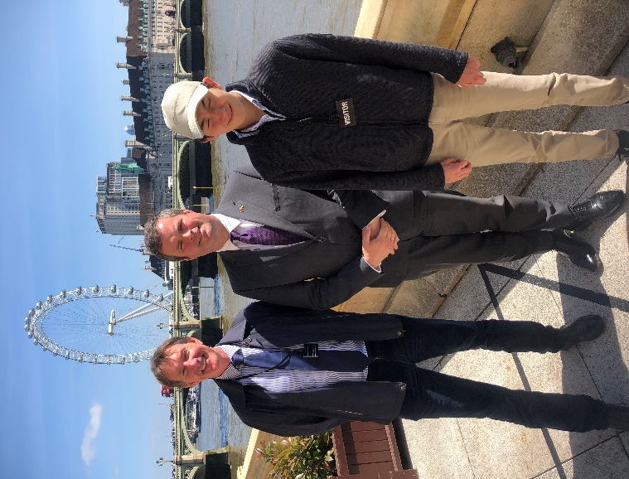
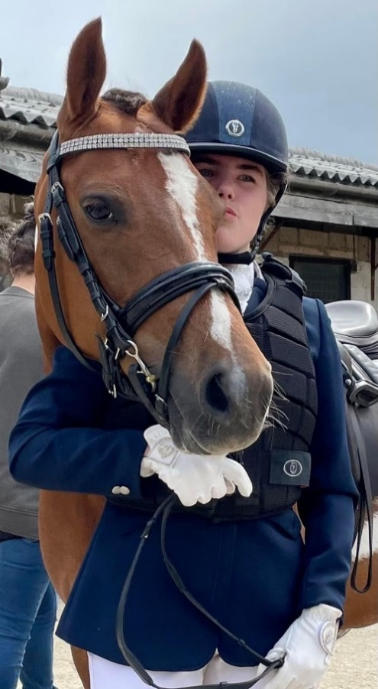
Two students who have been busy away from the normal routines of school are Kirsty Mabin and Luke Marks. Kirsty (pictured below with her horse Gift) rides with the Erme Valley Riding for the Disabled stables at Bittaford and has qualified for the national finals of the Dressage class in which she will now compete. Luke meanwhile has been off to London to see a session of Prime Minister’s Question Time in the House of Commons, courtesy of Torbay MP, Kevin Foster. Luke is pictured below with his dad and Kevin Foster in London. Needless to say, Luke really enjoyed his day out too see first hand how democracy works in action!
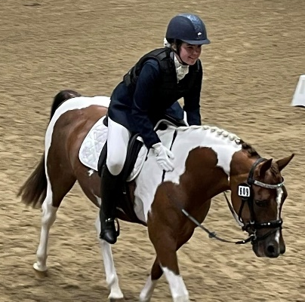

Students help out at fundraiser
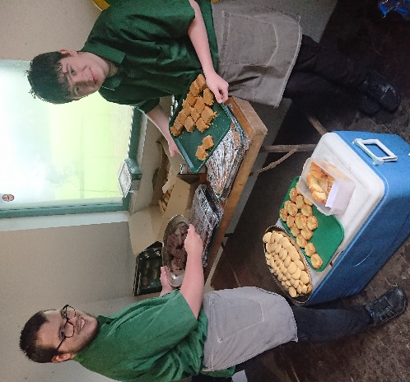
Logan Aldworth and Riley Tooley were a great help on the golf fundraising day at Dainton Golf Club this week, some of the proceeds of which are to be donated to Combe Pafford to go towards a new minibus. Despite the awful weather, Logan and Riley bravely ventured out from their refreshments hut between the 7th green and the 8th tee to meet and greet the soaked golfers, serving them cake and mini-bites, warm pasties and a variety of drinks. They did a great job at greeting the golfers and chatting to them about the school and what they did so their efforts were much appreciated. Well done to both lads!

Out with the old and in with the new


It’s all change at the top as I stand down after several years as Head of Sixth Form, and Roxanne Burness-Moakes takes over from me from September. It has been a privilege to work with such inspirational students and staff, and I am proud of the unique provision we offer which continues to evolve, but most of all I am proud of the achievements of the students – it is deeply satisfying to see the students grow into confident and able young men and women, and leave with a clear direction as to what lies next in their lives.

I very much hope you will give Roxanne the same support you have afforded me so that we can continue to work together for the benefits of the students. I will not be retiring completely however, and will continue to work three days a week in a careers capacity, so shall still get to see the students regarding their work placements.
Roxanne Burness-Moakes

Have a great summer!

Induction packs for both new students and continuing members of the sixth form will be distributed this week – these contain details of when students are required to attend in the first few weeks in September.

PLEASE READ THIS INFORMATION CAREFULLY
WHEN YOU RECEIVE IT

Have a great summer holiday and we look forward to seeing you back in September!

01803 321807

