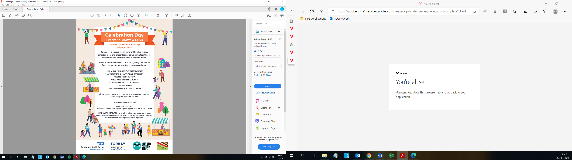
If you support a family member or friend, then you may be an unpaid Carer. Join us!

Paignton Library
Saturday 18th November 2023
10.00am – 2.00pm
(with Library’s Christmas Market)

Celebrating Unpaid Carers and helping Carers to prepare for their future

Everyone welcome!
There are information stands, Health, Adult and Children’s Social Care Services, free tasters for all and free refreshments for unpaid Carers, children’s activities, cost of living and mental health support, legal advice and much, much more.

For further information nearer the time:

Website: www.tsdft.uk/Carers
Facebook: TorbayCarers
signposts@nhs.net Tel: 01803 208455
Does someone rely on you?

Celebrating Carers’ Rights Day and launching plans for Torbay’s Young Carers Under 25
(with Library’s Christmas Market)

Family Friendly Activities
Live Music
Arts and Crafts
Information Stands
Free Coffee and Cake for Carers
Carers’ Advice and Support
and much, much more…
Everyone welcome!
For further information nearer the time:

Website: www.tsdft.uk/Carers
Facebook: TorbayCarers
signposts@nhs.net Tel: 01803 208455

