SIXTH FORM AUTUMN TERM NEWS REPORT 2022

School year gets off to a soggy start
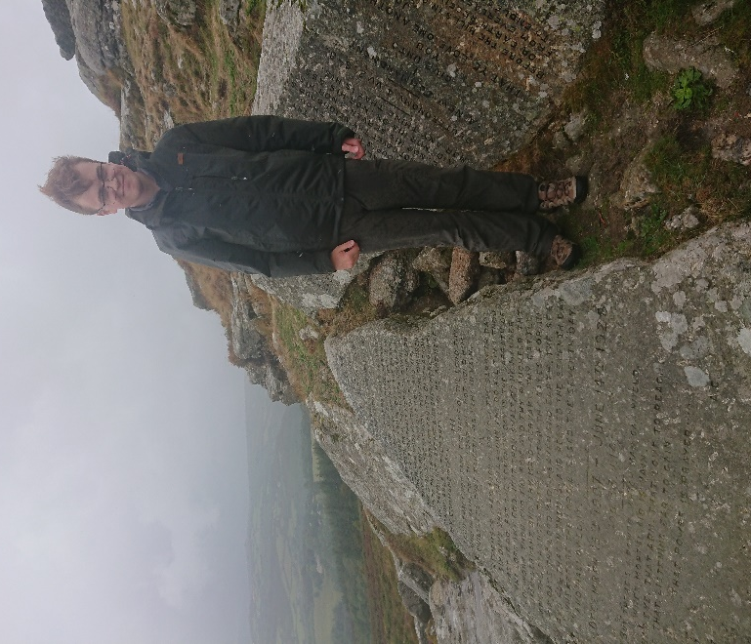
We generally have fine weather in early September for our teambuilding days on Dartmoor, not this year! Both days were dampened somewhat by more-or-less uninterrupted downpours of rain. On the first day, the conditions made the River Dart at Huccaby impassable as the stepping stones were almost completely submerged so we had to turn back. On day two, we were lashed wherever we went, so looked like the proverbial drowned rats by the end of the day. It didn’t however put a dampener on spirits within the group, and everyone made the best of it to get something out of the day. It was great to see students helping each other over the slippery terrain, and exercising a great deal of common sense in the process. Ben Waymouth is pictured here during a very brief respite from the rain, standing by the Ten Commandments stones near Buckland Beacon. Well done to all who survived the day and lived to tell the tale!

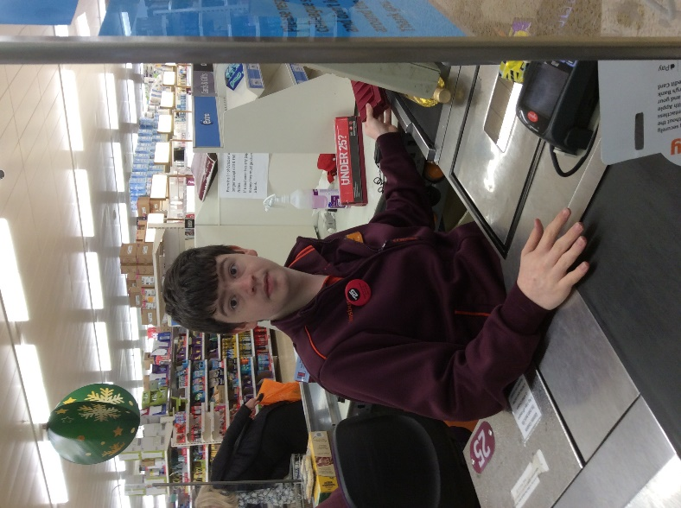
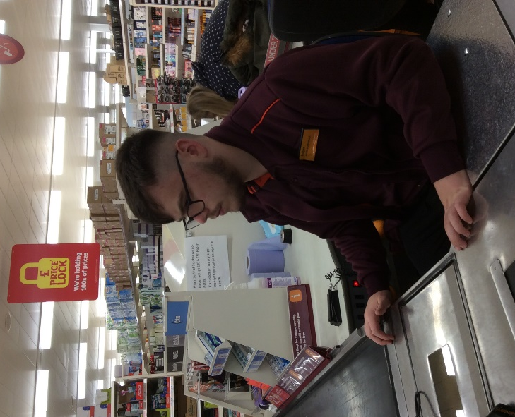
Retail students shine with their in-store training The new intake of retail students has hit the ground running with their in-store training at Sainsbury’s. The trio, consisting of Oliver Taylor, Riley Tooley and Logan Aldworth, have taken to it extremely well, so well in fact that all three have been offered paid part-time hours in the lead up to Christmas. This is a fantastic achievement after only a term of training and bodes well for their future career prospects. In addition to their till training, there are several departments within the store they have to train on as well so that, if needed, they can be called upon to help out anywhere in the store. All the students successfully got through their induction, which includes a considerable amount of background information and detail about store procedures. You never know, you may just go through their till when you are doing your last minute Christmas food shopping!
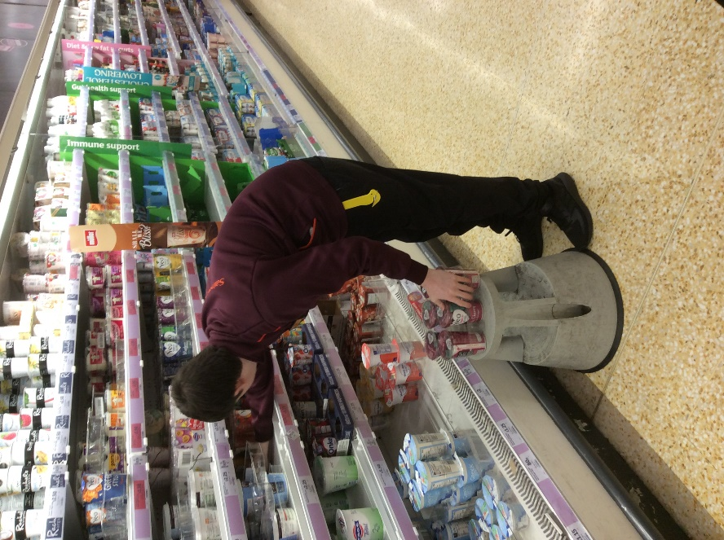
Logan Aldworth (below) and Riley Tooley (right) replenishing the shelves at Sainsbury’s at the Willows in Torquay and putting into practice all their training.
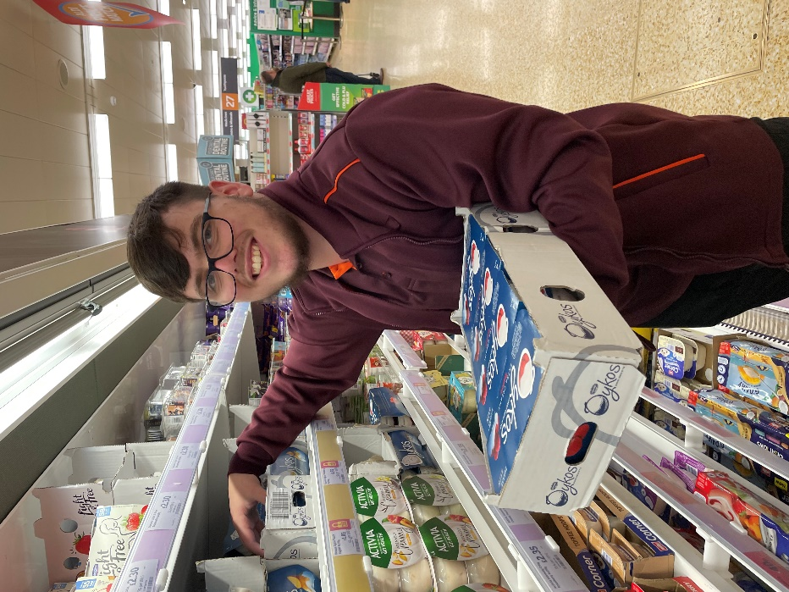
The students will be hoping that if they do well in the lead up to Christmas, it may lead to being offered more paid work at Easter and beyond. It would be great if one of them could join the ranks of several former students who work there.
Work-ready students up to the mark
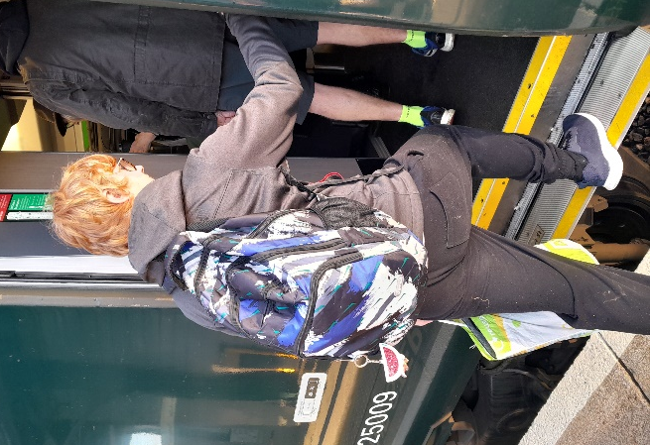
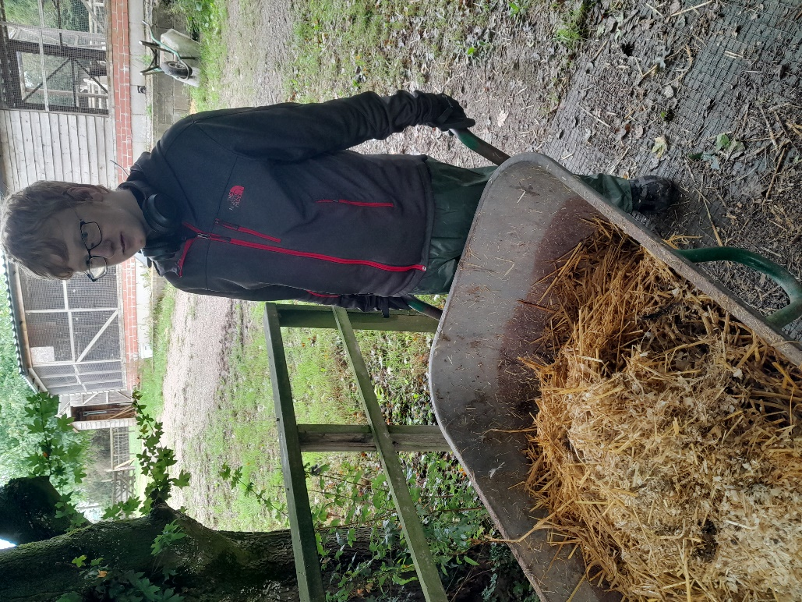
A number of work-ready students have already made a very good impression on their employers and showing much potential for the future. Harvey Barnes (below), who has been getting the train from Torre to Totnes independently to get to his work placement at the Rare Breeds Farm, has been doing particularly well and is much valued by the staff there. Harvey is very reliable and can be trusted to do the animal care duties to a good standard. As a result, he has been given some paid hours in school over the Christmas holidays to look after the school animals. Well done Harvey!

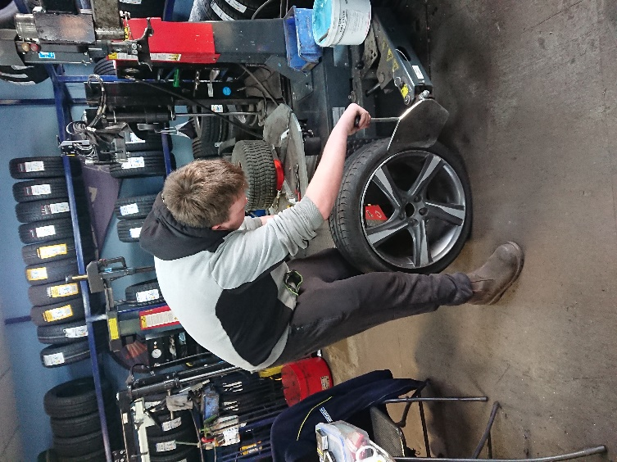
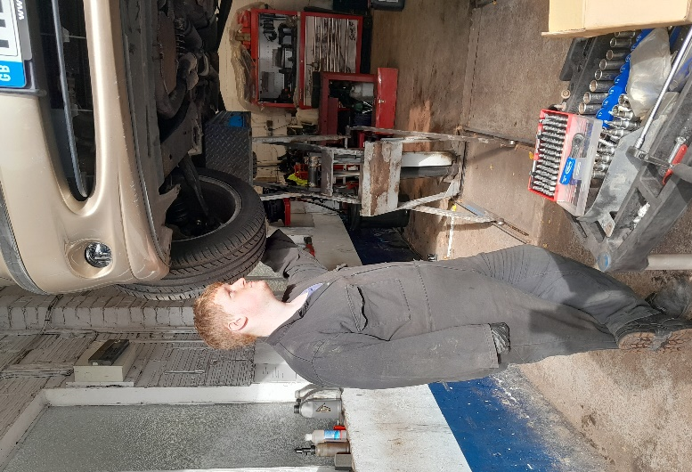
A group of four Motor Vehicle students, all working in different garage settings, have been working well and making good progress with their employers. Ryan Knapman (left) is at Sherwell Valley Garage in Chelston, Charley Ross (right) has made a great start at TTS Tyres and Exhausts in Totnes, Karl Hackett is now in his second year at Westcliff Garage in Dawlish, whilst Thomas Ralphs (below left) is working with his father in the family Landrover business.

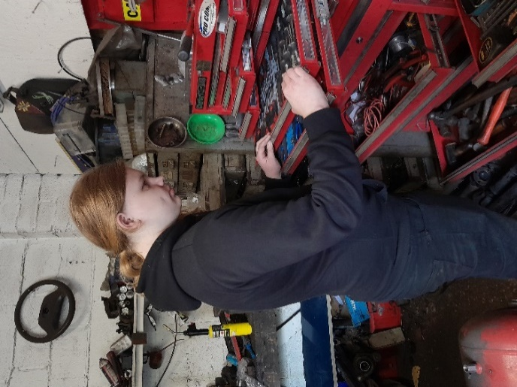
Another group of six students are performing well working in the care sector, but because of confidentiality restrictions, there are no photos available to show off their good work. Natasha Mildren is in her second year working at Southernwood Nursery whilst Chelsea Walters (Shiphay School Nursery) and Megan Mace (Highweek School Nursery) have had a really confident start to their new placements. In addition, Keisha Brookes, Bibi Thomas and Sam Redclift have been working really well with our own pupils in Key Stage 2.

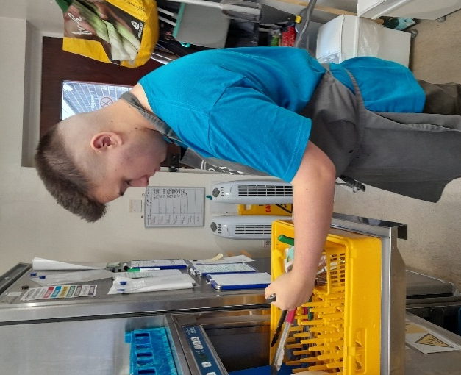
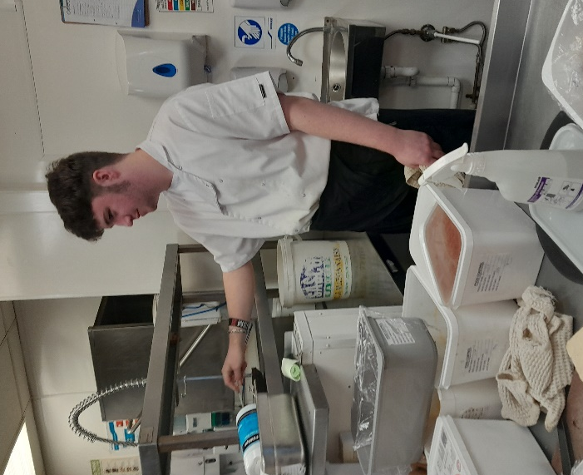
In the Hospitality and Catering sector, Teddy Pritchard (below left), who used to work in the Cary Arms Hotel, has had a successful stint at the No Limits café in Newton Abbot, whilst Morgan Quin (right) has been drawing rave reviews from his employer at Ocean Leisure in Exmouth where he also works at the weekend. Both students show a great deal of promise that we hope will translate into employment at some stage.
P students show the way forward
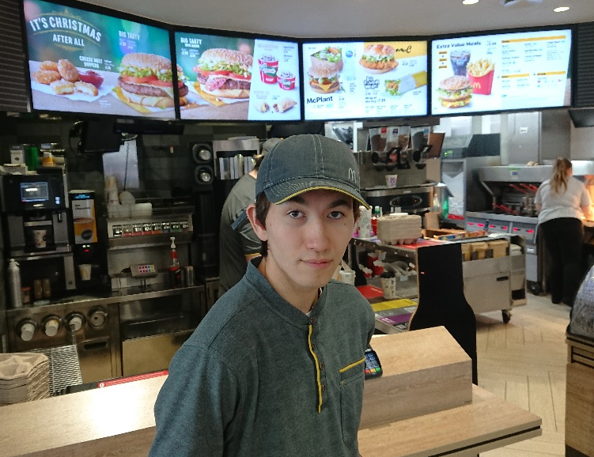
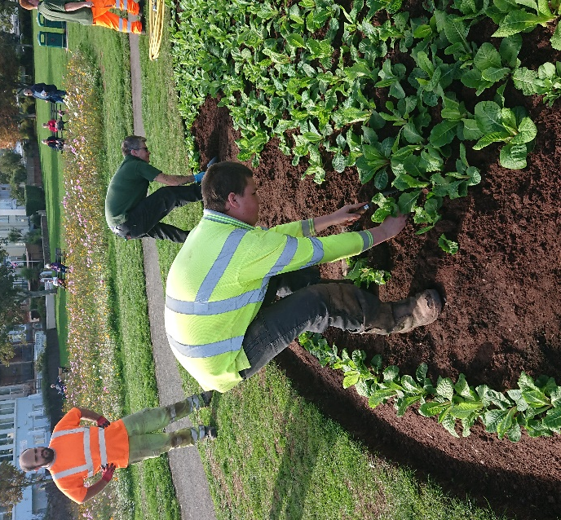
Three students on the Preparation for Working Life pathway have taken the initiative by working two days per week with an employer, which is a fabulous achievement. Joe Francis has been working with SWISCO’s horticultural team for several months now, and has received glowing reports of his work ethic and willingness to learn. Joe now has his provisional driving licence and hopes to pass his driving test as soon as possible in order to be in a good position to secure a permanent position with them.

Luke Marks (left) is actually employed by MacDonald’s on Paignton ring road two days per week, taking orders out to customers in their cars, and clearing and wiping tables, as well as taking orders in
the kitchen. Luke is highly valued by the
staff there.
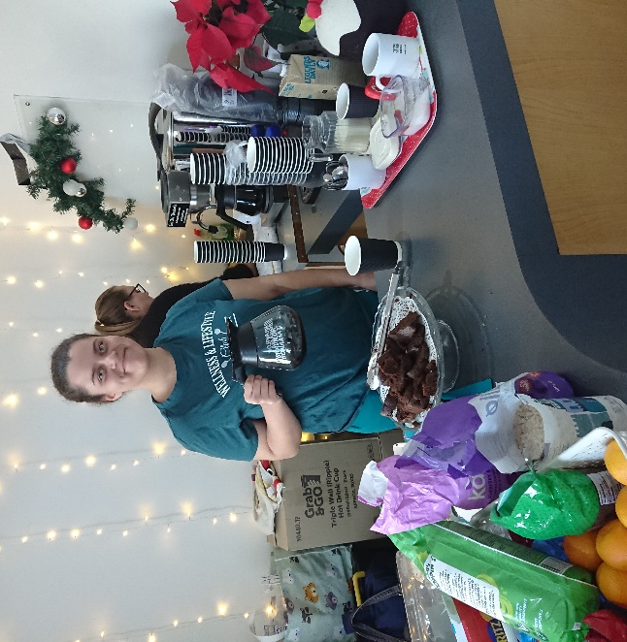
Bisi Williams (right) meanwhile, has been working at the Living Waters church in Preston where her father is the minister, serving refreshments to mums who take their children to the popular play group there. When the church finally opens its new café in the spring, Bisi is set to take a lead role in serving customers, using the till and making sure everyone is fed and watered!

Dawlish Gardens Trust still popular
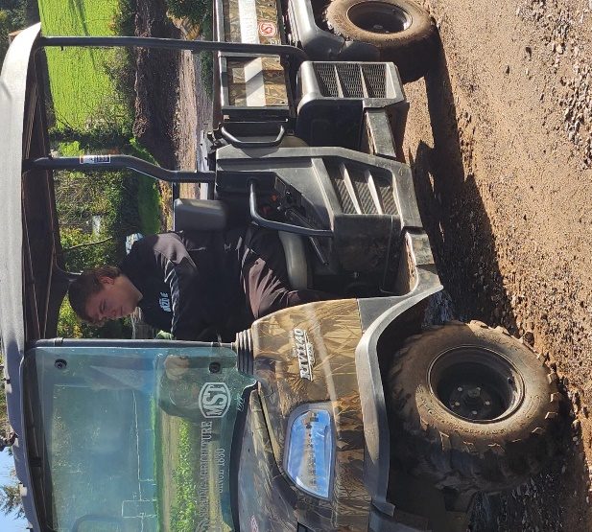
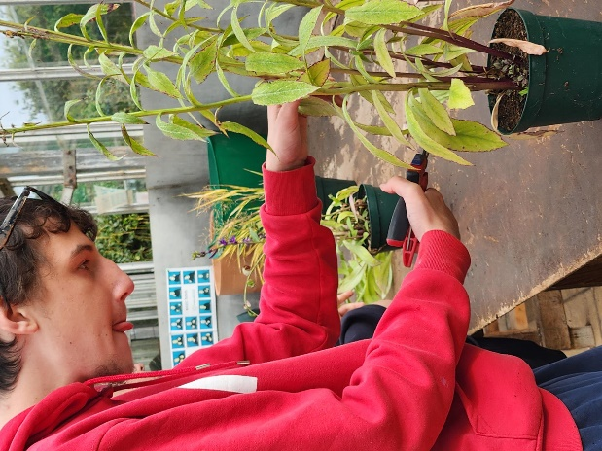
Students from W1 and W3 are benefiting from sheltered work placements with Dawlish Gardens Trust, and DGT remains as popular as ever with them! Pictured left is Jake Brimicombe tending to some planting, whilst Logan Taylor (right) can be seen driving the ‘Mule’ vehicle around the site. Students enjoy the variety and scope of the work there, not least the new challenges it brings.
Work Skills challenges bring out the best in students
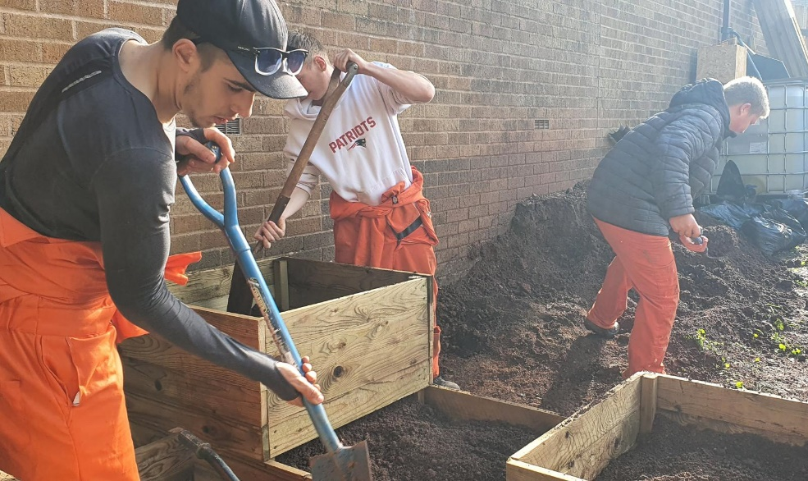
Students on the Preparation for Working Life programme have been working with Groundworks at Westerland Valley on a regular basis now for well over a year now. The projects have been many and varied and have included filling planters, planting fruit trees, and dealing with drainage issues related to Clennon Brook itself. The overall aim of the project is to improve the valley and enhance the surroundings to encourage
community use. So far the students have done a brilliant job in all weathers!

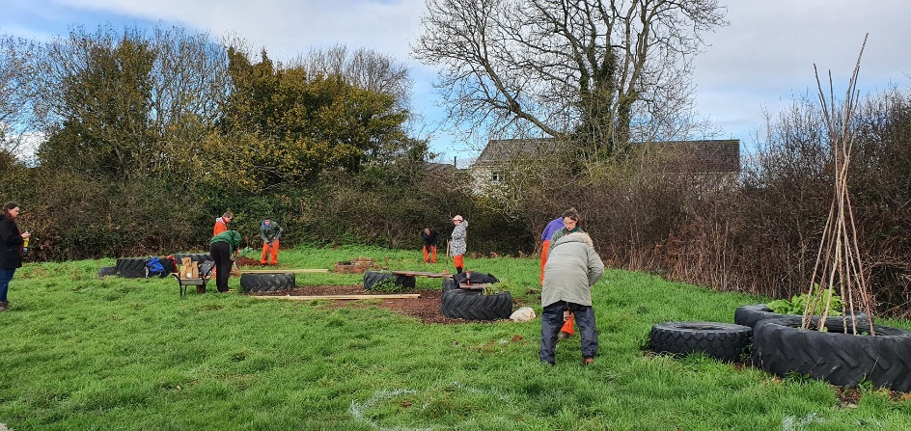
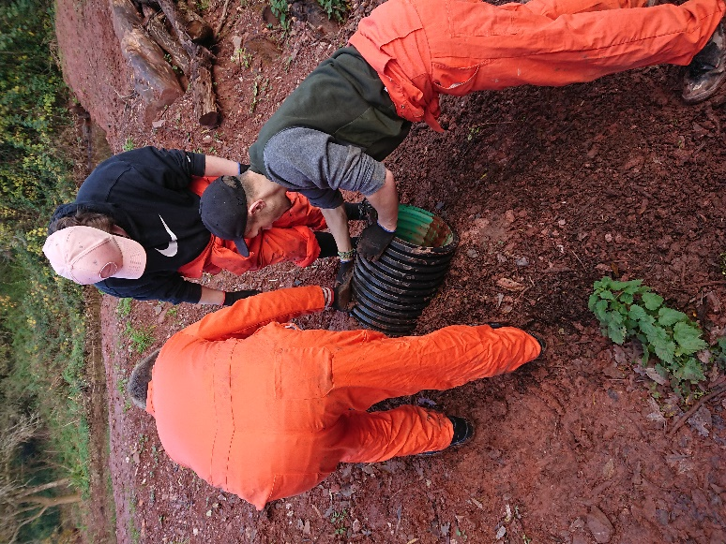
Dealing with a drainage issue (below)
The students filling planters with soil (above)

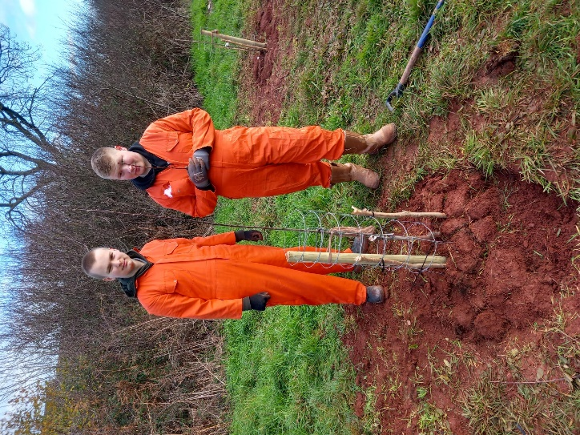
Luke Putt (left) fastening a wire shield to one of the fruit trees the students have planted.
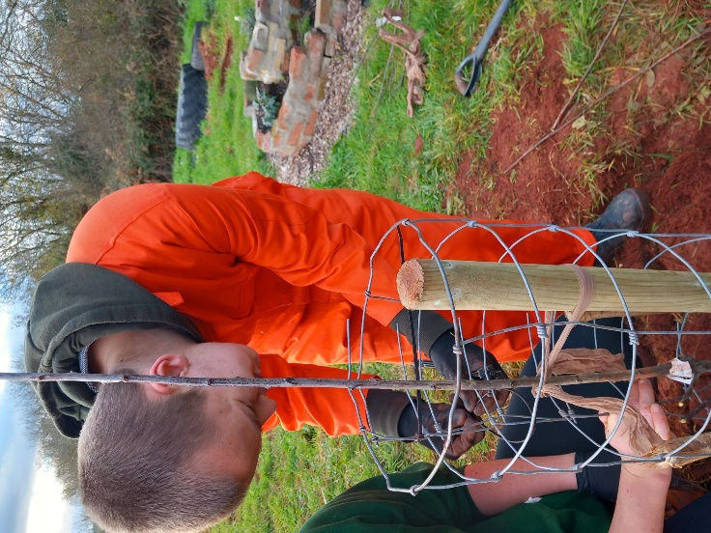

Luke and Brandon Breen (right) by one of the fruit trees they have planted and protected with wire shields.

Sixth Form students set sights on passing driving test
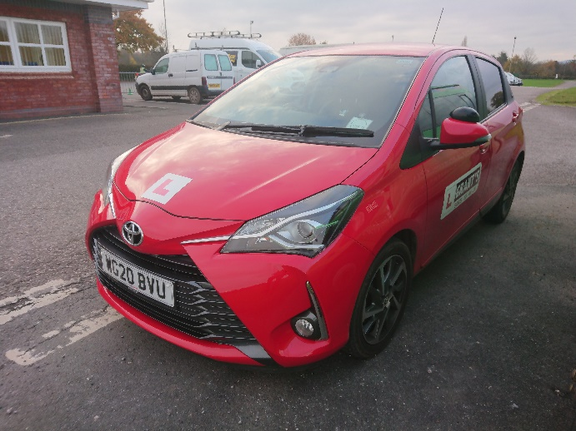
No fewer than nine students have this term been to the Devon Drivers’ Centre at Westpoint to undertake an assessment with Nick Grant from Grant’s School of Motoring to establish their readiness for driving lessons. I’m pleased to say that several of these students were deemed ready to embark on lessons, either on a manual gearbox or an automatic, and have already begun lessons or are about to. Passing your test is such a key milestone for our students as it opens up wider opportunities for employment and training. All the students referred to here have already obtained their provisional licences and are aiming to get going as soon as possible. Pictured is Nick’s car in which they have done their preliminary assessment.

Students take advantage of Fitness and Leisure opportunities
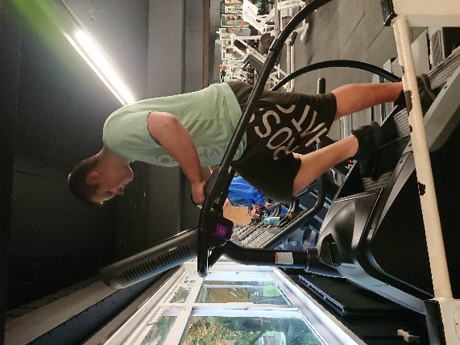
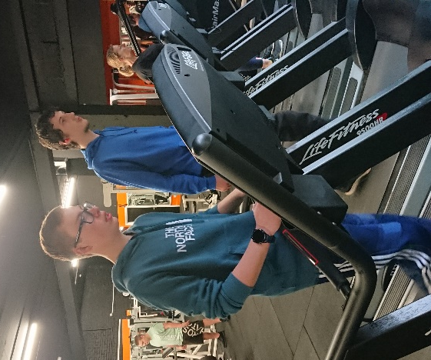
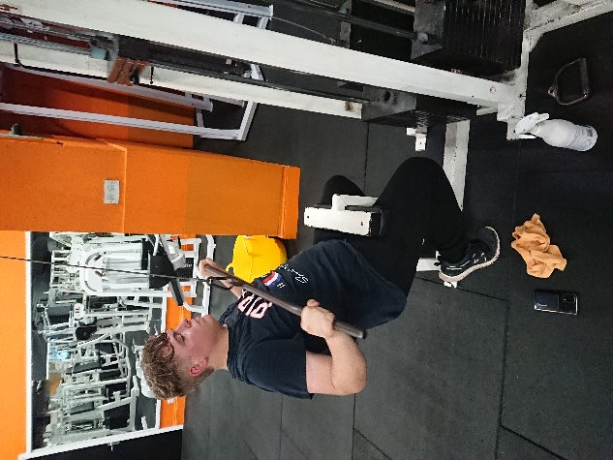
Our Fitness and Leisure programme is aimed at exposing students to physical activities available in the community that they may not have had the opportunity to try, with a view to encouraging them to take up healthy lifestyle choices when they leave school. This term the groups have opted to do certain activities from a list that has included tennis, cycling, indoor rockclimbing, swimming, golf, olympic gymnastics, and gym work.

Logan Taylor (above) working out at the gym

Bradley Kersey and Jake Brimicombe
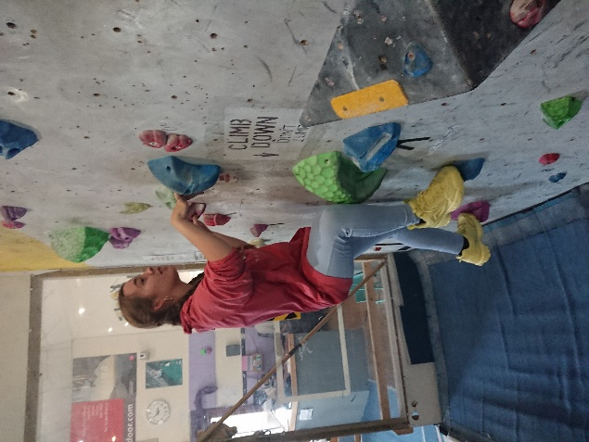
on the treadmills at Venture Fitness

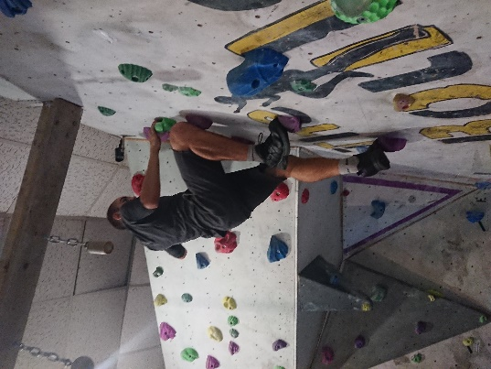

Jordan Orchard-Barker (above) on the step machine at the gym

Declan Harvey (left) and Martha Minchinton (right) rock climbing at the Boulder Bunker in Torquay
Social event at Tubers proves a big hit
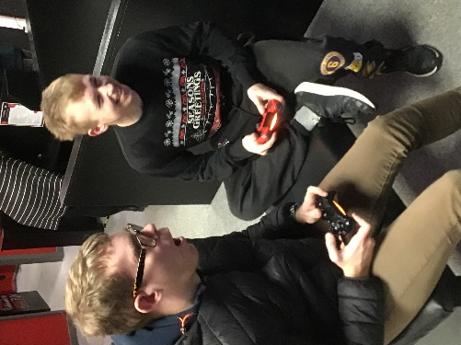
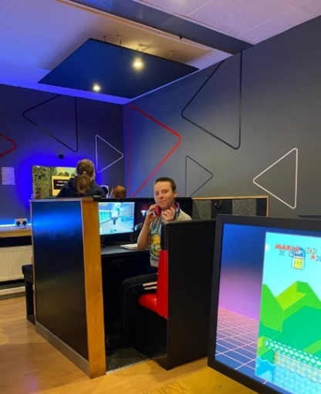
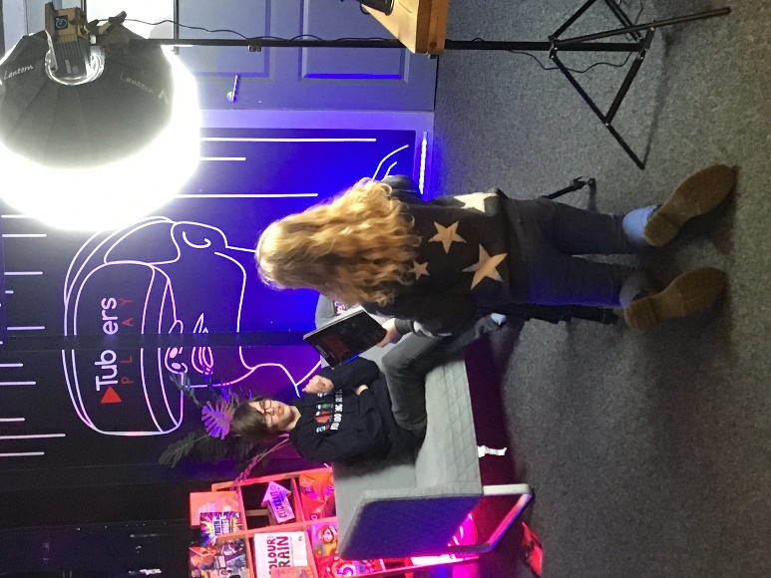
No fewer than 28 sixth formers (a record) attended the most recent social event which was an evening at Tubers, the video, computer games and virtual reality facility. This was the first event of its kind for us, and presented the first opportunity many of our students have had to visit. It proved to be a great evening for all concerned, and no doubt will be repeated by popular demand later on in the year! Our social events are run after school once every half-term to give students the chance to socialise away from the classroom, and are becoming more and more popular. Earlier in the term we went to AMF Bowling in Torquay for a game of ten-pin bowling – this was also well attended.

Students raise money for good cause
Sixth Form students raised £50 towards Children in Need in November by paying to dress up for the day to mark the occasion. Many also took the opportunity to pay 50p to soak Mr Thompson by throwing wet sponges at him! I’m always surprised by how popular this activity is!!
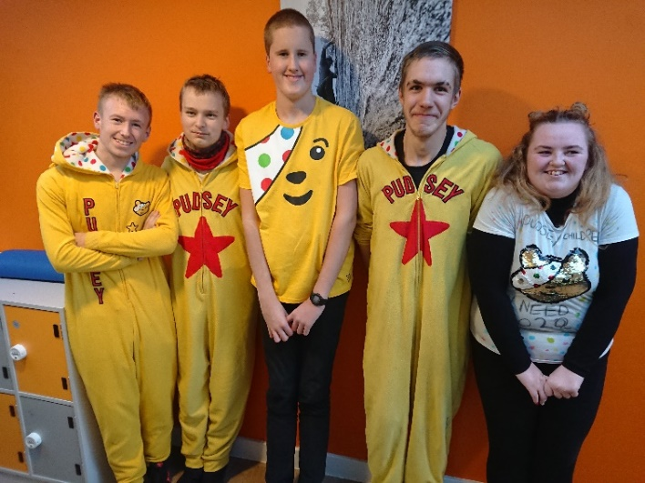
Bradley scoops award
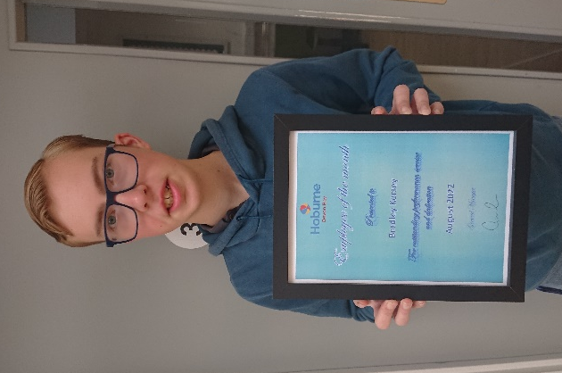
Earlier this term, Bradley Kersey, who worked at the Devon Bay Holiday Park in Paignton in the summer, picked up the Employee of the Month award for August for ‘Outstanding Performance, Service and Dedication’. The holiday park is part of the Hoburne group and clearly wanted to recognise all Bradley’s hard work – well done Bradley! Since then Bradley has been making an equally good impression on his employers at his current work placement, Coyde Construction. He has been working at various construction sites including a new build estate at Ashburton. He has also picked up a few days of paid work with a local builder which is a great achievement after only one term.

Ben makes the right kind of impression
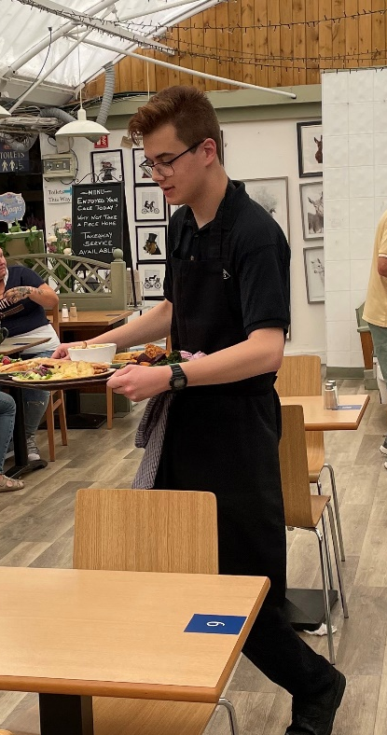
Ben Waymouth (left) was outstanding in Sainsbury’s at the Willows in Torquay last year; this year he has transferred his wonderful customer service skills to his new work placement at Fermoy’s Garden Centre where he has been working in the café. So impressed have the staff been with Ben that his supervisor has given Ben a permanent one day contract which he works at weekends. We have known for some time that Ben was highly employable, and now he is starting to provide us with the evidence to prove it!

Ben is not the only student to have obtained paid work during the course of this term - a number of students have paid work at weekends or seasonal work in the holidays to earn some money. Chelsea Walters works long hours at weekends at the MacDonald’s on Torbay ringroad, whilst Ryan Knapman works at Primark in Torquay to earn some cash. Others, such as Luke Marks, Bradley Kersey and Morgan Quin, have already been featured in this newsletter. We hope more students will gain sufficiently in confidence over the coming months to follow in their footsteps.

Students row to France (and back)!
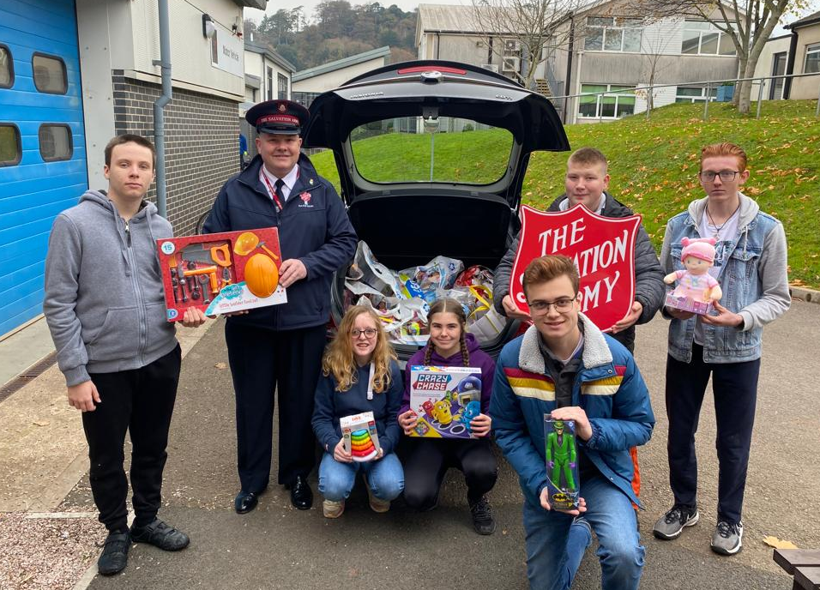
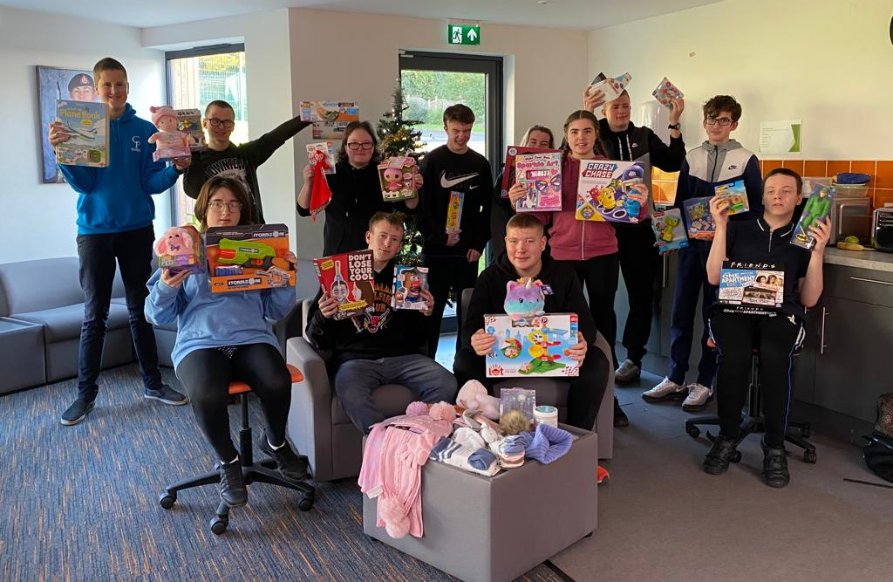
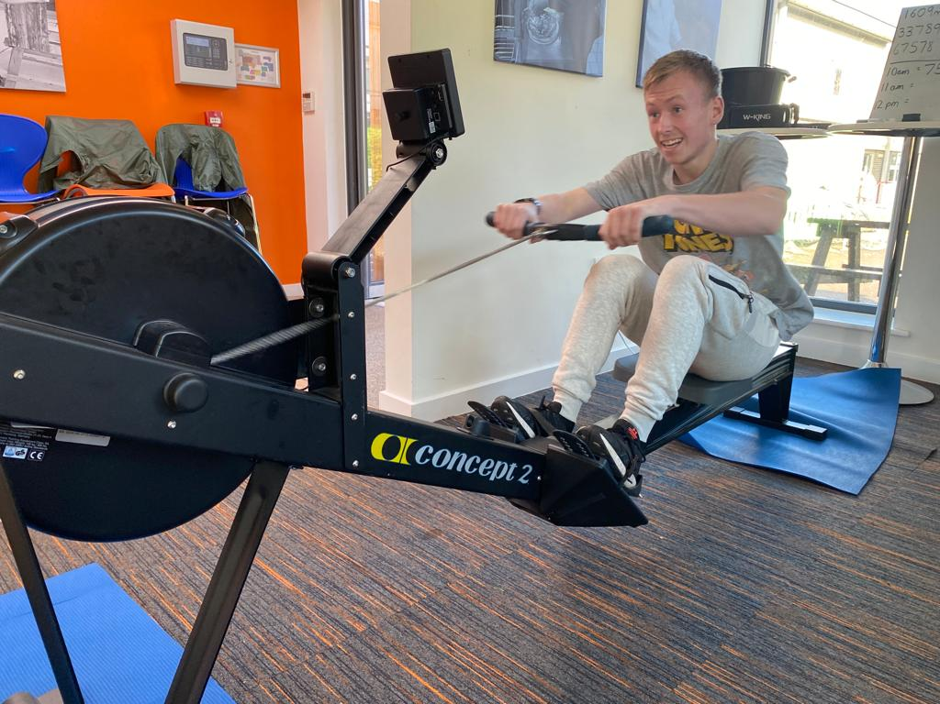
When students in P1 and P2 had the idea of ‘rowing’ to France using a rowing machine to raise money for the Salvatian Army, it seemed a tall order. With a little help from staff however, and a team approach to taking turns on the rower, the group not only rowed the 21 miles to France, but they rowed back again, raising a whopping £402.24! This fantastic achievement, all achieved within the school day one Tuesday, is testament to the students’ staying power. Following the mammoth effort, the group then went out and spent every single penny they had raised on toys for the Salvatian Army appeal for needy children. A few days later, they were able to present the toys in person to a grateful officer from the Salvatian Army. Well done to everyone who took part – simply amazing!
HAVE A GREAT CHRISTMAS EVERYONE– SEE YOU BACK IN SIXTH FORM IN THE NEW YEAR!

Edward W Thompson
(Head of Sixth Form)

